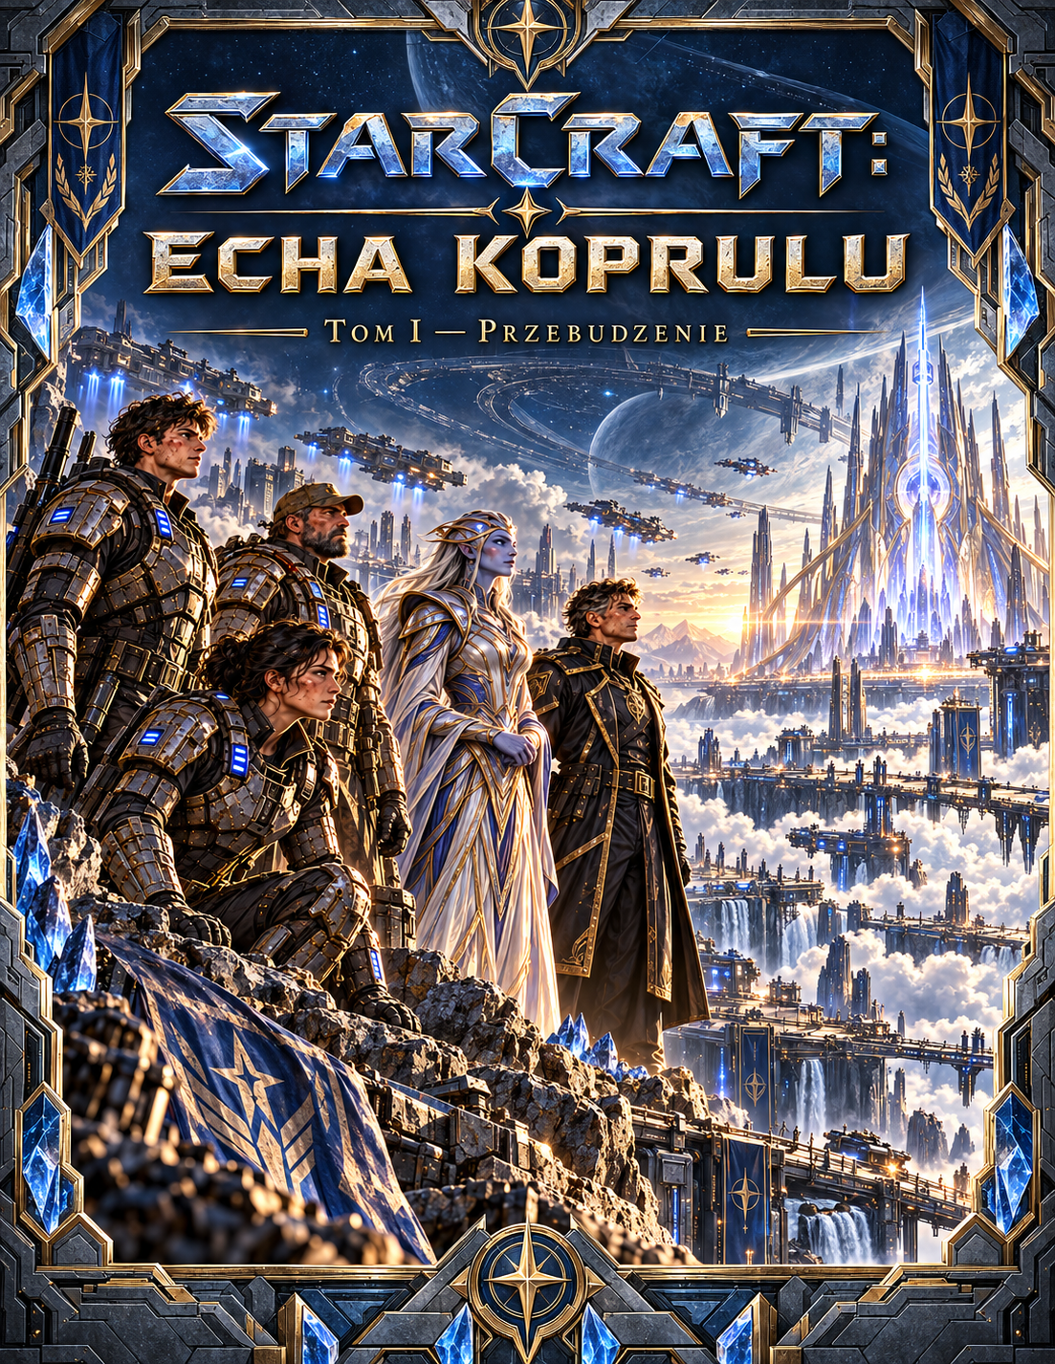

STARCRAFT
ECHOES OF KOPRULU
VOLUME I — AWAKENING
An original story set in the Koprulu Sector
Concept illustration: panorama of Erebos

About This Edition
A working edition expanded with new scenes and additional points of view. Its length should be judged by the actual page count after typesetting; this is not yet a completed 300-page novel.
An unofficial fan project unaffiliated with Blizzard Entertainment. The StarCraft names and setting belong to their respective rights holders.

Story Chronology
2512, Day 0 — a signal at Erebos-9 outpost; contact with the object at G-12.
2512, Day 1 — an isolation order, the bombardment of the colony, and flight into underground shelters.
2512, Days 2–3 — a journey through the old tunnels, discovery of the archive and the signal's origin.
2512, Day 4 — the arrival of a Protoss researcher; control of the Seal system is seized.
2512, Day 5 — conflict among the crew of the Resolute, the conclusion of Operation Silence, and Jalen's decision.
2512, Day 6 — the epilogue and the birth of an independent survivors' commission.

Dramatis Personae
Jalen Ors — communications operator and principal protagonist, brother of the late Rina.
Lys Ardan — Dominion corporal, haunted by the operation on Asterion.
Vek Tiran — the colony's witty, dependable mechanic, familiar with the mining tunnels.
Commander Ilyan Sorell — officer aboard the frigate Resolute, loyal to procedure until his moral convictions are tested.
Nera Vhal — an independent Protoss psionic cartographer pursuing an ancient relay.
The Admiralty of the Directorate of Silence — a secret Dominion security apparatus.
Rina Ors — Jalen's deceased sister; her voice returns as part of the mystery.

PROLOGUE — The Voice That Would Not Die
Rain never fell on Erebos. For nineteen years the sky had released nothing but rusty dust, settling on habitat windows, choking filters and burying children's toys left out on the terraces. Communications operator Jalen Ors knew every sound made by Outpost Nine: the dry cough of ventilators, the crackle of the cooling plant, the rhythm of relays switching over. That was why he heard the new sound immediately. Three deliberate knocks from beneath the floor.
At first he dismissed them as the workings of an ageing structure. Then he received a transmission on a frequency used exclusively for fault reports for the past three years. He recognised the voice before it spoke its first word. Rina, his sister, had died on Tarsonis. According to official records she had perished during the evacuation, but Jalen had never seen her body. All he possessed was a nameplate and a recording: Don't look for me. Whatever you hear, don't come back.
‘Jalen,’ she said now through the speaker. ‘We're still beneath you.’
The operator withdrew his hands from the console. The signal originated at a depth greater than the deepest recorded borehole. Sixteen seconds later, the computer drew a vast, perfectly regular circle beneath the colony. Three vertical strokes appeared within it. Jalen activated the technical alarm, only to watch the system change its own warning level to green.

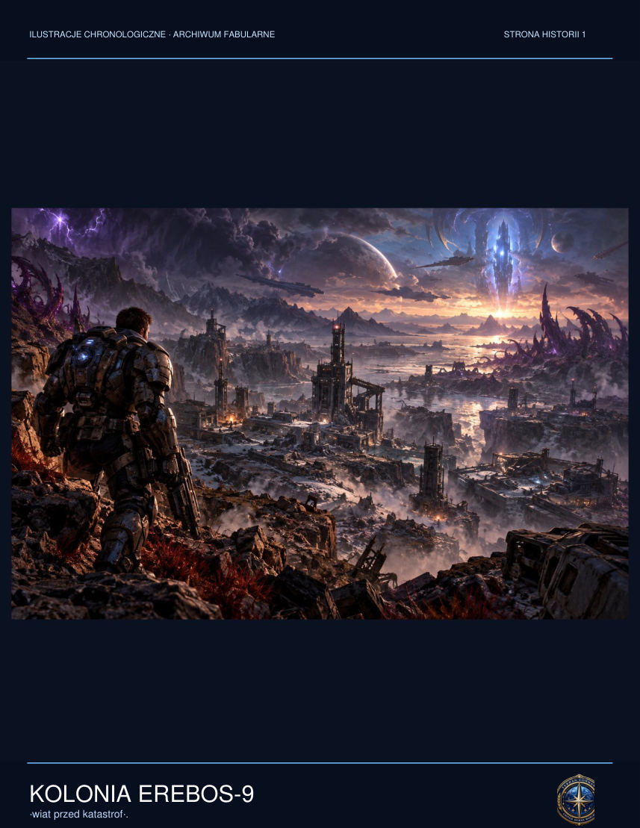

‘Outpost Nine, this is Resolute,’ a patrol officer said. ‘We're receiving a signal on an unauthorised band. Confirm the condition of your infrastructure.’
Jalen stared at the automatically prepared response: No danger. Personnel within normal parameters. Before he could erase it, the control-room doors locked from the inside. Three knocks sounded again on the wall beside the hanging map. The sound did not travel through metal. It formed directly inside his skull. Don't be afraid, his sister's voice said. The First Seal remembers everyone.
Jalen took a weapon from the emergency locker. He summoned Corporal Lys Ardan and mechanic Vek Tiran. He did not yet understand that, at that very moment, the command staff in orbit had decided to erase the outpost from their maps.

CHAPTER ONE — Voices Beneath the Surface
The lift to Sector G-12 descended so far that the radio lost contact with the surface. Jalen, Lys and Vek stood in the red warning light and listened to the tension building in the steel cables. When the platform stopped, they found a corridor coated with frost. Dark veins had formed along the walls. They resembled no corrosion Jalen had ever seen; they stirred faintly whenever anyone spoke.
‘This isn't any infestation I know,’ Lys said, checking her magazine. ‘But we touch nothing.’
On the other side of the heavy door lay an empty geologist's suit and a man with white eyes. Technician E. Voss knelt before a blue crystal the size of a transport shuttle. Violet fibres spread from it into the rock and steel beams. Jalen recognised the geologist from the canteen, where only yesterday he had been arguing over a match result.
‘It's dreaming,’ Voss said. ‘And now we're dreaming with it.’
Lys ordered him to step back. The technician did not move. Instead he began talking about Asterion: fourteen people sealed inside a shelter whom Lys had been unable to save. The corporal raised her weapon towards him. Vek activated his scanner and found fifty-two neurological signatures, although the room contained only the three of them and the technician.
‘Rina waited a long time,’ Voss told Jalen. ‘Don't look for me. Whatever you hear, don't come back.’

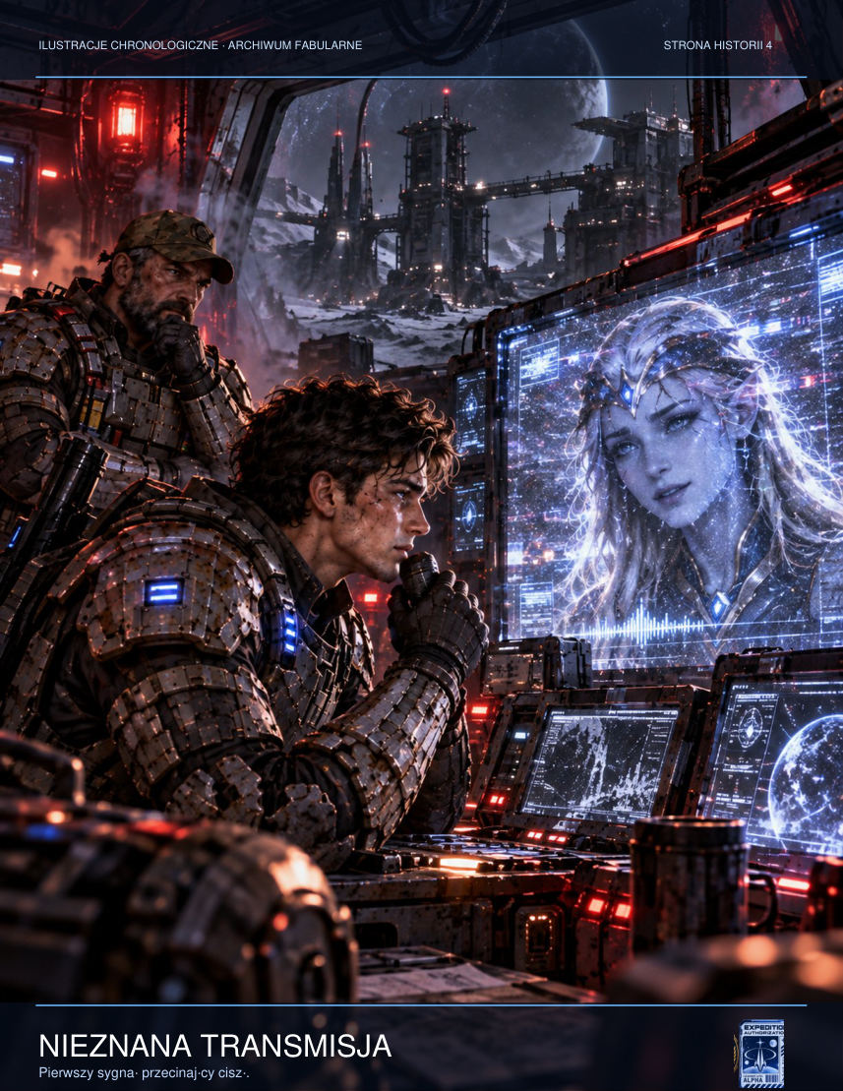

For an instant, the world vanished. Jalen saw a motionless Tarsonis, his sister among the dead city, and a black structure surrounded by concentric rings. When he returned to the chamber, nothing remained of Voss but an empty suit. Across the scanner, a colossal geometric plan of tunnels beneath the whole of Erebos pulsed with light.
‘That's not a mineral deposit,’ Vek whispered. ‘We've built a city on top of a machine.’
The communicator regained its signal. The frigate Resolute hailed them from orbit. They were ordered to remain at the outpost immediately, then questioned about frequency seventeen point four. Vek saw three signatures leaving the ship. They were not rescue shuttles. Corporal Lys disconnected the military transmitter.
‘Now we have to survive our own fleet,’ she said.
All through the chamber, they heard a voice without a source. The First Seal has been opened.
Concept art: the descent into G-12, first contact, and Technician Voss.
When the pressure alarm sounded in the control room, Jalen first assumed a filter had been damaged. Only when he looked at the screen did he see that every airlock valve on the residential levels remained closed. The failure did not originate in the atmospheric network. Instead the system was automatically broadcasting an old evacuation message, recorded before the colony was founded, through every loudspeaker. It contained footsteps, breathing and twelve seconds of absolute silence. At the end, somebody said, ‘Don't open the door for us.’
Lys came into the control room without her helmet, giving Jalen his first glimpse of the silver scar beneath her ear. She covered the microphone with her hand and asked whether someone could have taken over the local relays. When Jalen said no, she ordered him to isolate the outpost from the public network. Vek objected at once: cutting the system would deprive the miners underground of their only means of calling for help. The order hung between them, unfulfilled. At that moment something moved in the lift shaft, although the log showed no platform usage for six hours.
On the ninth level, just beyond the gate marked G-12, lay a child's oxygen mask. It was a model withdrawn from service twenty years earlier, yet its soft straps were clean and warm condensation had gathered inside. Vek wanted to take it as evidence. Lys refused. Jalen knelt for a moment and saw four letters scratched into its inner surface: RINA. He knew it was impossible. That was why he said nothing to the others.

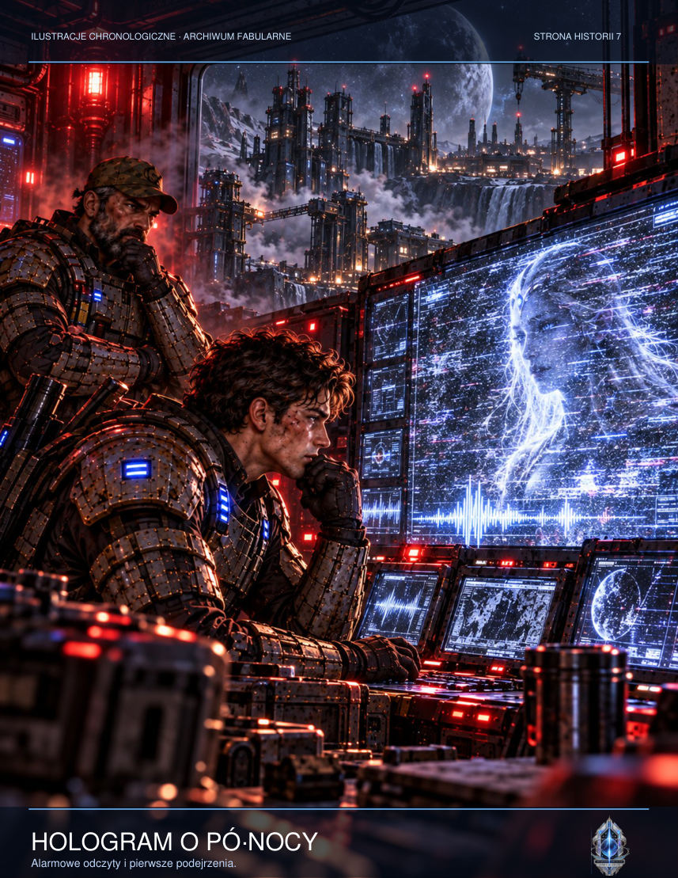

In the chamber, Technician Voss moved his lips before the alien core. When Lys said his surname, every instrument registered the same pulse. It did not resemble an electrical discharge. It was a response, sent at precisely the moment the human voice sounded. Jalen assumed somebody was listening. Real fear came later, when he discovered that the device knew their questions before they asked them.

ADDITIONAL SCENE — The Technician's Debt
Vek held his hand above the terminal without touching it. Names of personnel assigned to G-12 scrolled across the screen. Some entries had been crossed out by hand, although the digital register offered no way to do so. Beside Eryk Voss's name someone had written: Do not awaken. ‘You know him?’ Lys asked. Vek nodded reluctantly. Voss had once lent him money for a new breathing filter for his mother. He was the sort of man who reminded you when repayment was due but never charged interest. In the colony, details like that told you more about a person than any identity card. ‘I don't like it when people become symbols,’ Vek muttered. ‘You don't have to look a symbol in the eye.’ Jalen glanced at the fine scratches on the scanner housing. They had been left by the fingers of somebody who had tried many times to open a sealed partition. Those technicians had not been the first to come here. And they were probably not the first to understand that the discovery could not be confined to a report. Lys ordered a list of names to be drawn up and the terminal's memory secured. ‘If we get out of here, someone will answer for each of them,’ she said. Jalen wanted to believe there was somewhere such evidence could be delivered, and someone willing to hear it.

ADDITIONAL SCENE — The Fracture
A dry cracking sounded in the ceiling, as regular as footsteps along a metal walkway. On the control level the pressure readings remained stable. This worried Vek more than red alarms would have: the electronics insisted nothing was happening while reinforced beams bent overhead. He approached a support and unscrewed its service panel. A delicate web of fibres flickered inside the metal. They had not been glued on or threaded through holes. They grew out of the steel itself. ‘What do we do when rust starts thinking?’ he asked. ‘Stop ignoring it,’ Lys replied. Jalen looked at his watch. The second hand stopped, then completed three revolutions backwards. For a moment the faint smell of damp earth filled the room. He remembered his mother's garden on Tarsonis and an afternoon before the war, when Rina buried a toy spacecraft in a flowerpot so that archaeologists could discover it years later. She always assumed the future would be more interesting than the past. Jalen squeezed his eyes shut. He could no longer tell whether the memory had come from him or someone had placed it there. That was the cruelest thing about the object: even his own grief was no longer safe.

CHAPTER TWO — Order: Silence
The first missile struck the pumping station half a kilometre from the central habitat. Then came more impacts, and darkness broken by the blue glow of electrical discharges. Jalen realised the bombardment was not aimed at the chamber. Someone in orbit wanted to destroy every place from which information could be transmitted off-world. G-12 was to remain intact.
Lys opened the local channel and gave civilians a route to the storm tunnels. She risked revealing her position, but the colonists' private transmitters picked up the signal immediately. Countless loudspeakers throughout the city repeated a single, simple order: underground, through the evacuation gates, without luggage. Vek ran to the power station to unlock the doors manually. Jalen remained at the communications panel.
Nobody in the technical shelter asked whether the bombardment was a mistake. When the first strike deprived the colony of water and the second of communications, the inhabitants of Erebos-9 understood more than the administration's announcements had ever told them. Children crawled under tables. Adults called aloud the names of people they could not find. Someone wrote on an evacuation-point wall in chalk: DO NOT USE THE LIFTS. Before the chalk crumbled in the writer's hand, the lifts had already lost power.
Lys stopped Jalen at the switchgear. ‘We're choosing a route for sixty people, not three armed idiots,’ she said. There was only one sufficiently wide corridor on the evacuation plan. It ran beneath an abandoned ore-sorting plant and ended in an unmarked portion of the map. Vek checked the pressure valves. ‘If we close three bulkheads in the right order, it'll hold. If we get the order wrong, the pressure will rupture a cooling pipe and boil everyone alive at the first bend.’ ‘That's why you're going first,’ Lys replied.
Jalen could have told them about Rina. About the city he had seen in an impossible vision, about the voice trapped in the crystal. Instead, he helped an elderly man fasten a filter mask. The man shook, not with fear but with anger. ‘I served the Dominion for thirty years,’ he said. ‘Someone up there had to approve this operation. Someone knew our names.’ ‘And now you need to breathe,’ Jalen said, pressing the mask's seal into place. Inside, a thought raged: names were precisely what the crystal had been searching for.
At the tunnel junction Jalen turned to the security monitors. One camera was still working. It showed the colony's main square, a fountain dry for months, and a plaque bearing the founders' names. A blue flash reflected in the glass and crossed the square. Then the image froze a second before impact, as though someone had deliberately stopped the recording before people could discover what had happened. Vek managed to copy its final eight seconds onto an isolated storage device. ‘Don't ask why,’ he said. ‘If we survive, somebody will have to see the truth.’

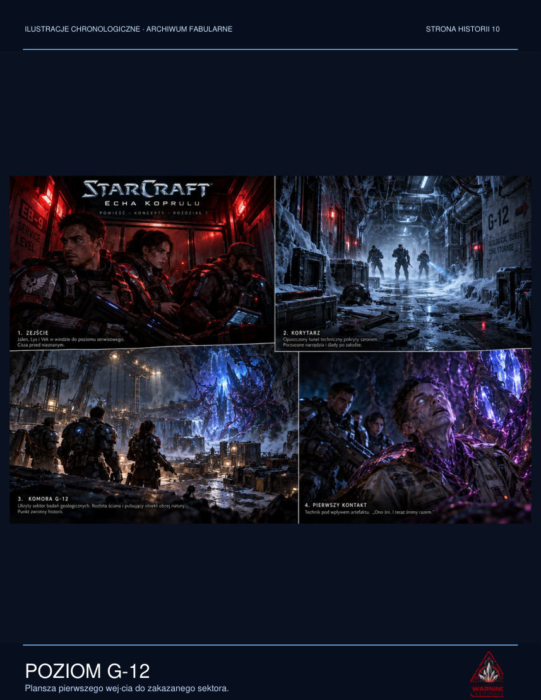

Aboard the Resolute, Commander Ilyan Sorell stood over a confirmed order. The document bore command's signature but offered no justification. It demanded the elimination of infrastructure and an end to transmissions. Not a word mentioned the inhabitants. The officer replayed Lys's intercepted call. He heard children's voices, the crackle of a generator, a plea for medication. He marked the recording as evidence, although the system immediately tried to delete it.
In an underground airlock beneath the colony, Vek met teacher Olan Mer and twenty-three pupils. The last girl went back along the passage for her brother. The mechanic only closed the door after both had crossed the threshold. Moments later pressure on the far side crushed the steel frame. Nobody celebrated inside the shelter. In the darkness, people counted their breaths and wondered when the next missile would fall.
Lys contacted Sorell on a forgotten service channel. The officer did not say he was on their side. He said only that the next strike would come in twenty minutes. Then he disconnected before his superior could trace the source of the transmission.
Storyboard: first contact, the mystery of memory, and the orbital order.
So many people had gathered beneath the lowest shelter's vaulted ceiling that the air smelt of skin, grease and sweat-soaked fabric. Teacher Olan Mer counted the children for the fourth time. She arrived at a different number each time. The youngest, six-year-old Pavo, leaned against the metal wall and stubbornly refused to say his sister's name, as if speaking it might make her disappear. Vek crouched beside him and offered him the job of assistant engine driver. He handed the boy an old switch without any wires, and Pavo began reporting that all systems were ready.
The first impact tore apart a support in the western sector. The shelter's ceiling trembled; dust clung to people's faces. Lys could close the bulkheads and save those already inside. But she knew a family from the water-treatment station remained on the other side. She gave them ninety seconds. Jalen counted silently while Vek desperately worked around the collapsed valves. When the father came running in with his youngest child in his arms, eight seconds remained. Only then did Lys slam the airlock shut. The explosion extinguished the lights, and in the darkness someone said the corporal had just broken a Dominion order.
In Sector Five they found a classroom converted into a field hospital. A map of the constellations hung on the wall, and beneath it lay a girl with a split eyebrow. Her name was Tessa, and since the evacuation began she had clutched a small model spacecraft. Her mother, a doctor without sterile instruments, was stitching the wound with thread from an emergency kit. Jalen knelt beside the child. ‘What ship is that?’ he asked. ‘The kind that can fly away and never come back,’ she answered. He lacked the courage to correct her: the vessel made from scraps of plastic resembled nothing capable of flight.
Lys refused to evacuate the wounded separately. When the doctor's voice broke, the corporal sat beside her and sketched a simple stretcher made from joined rods. ‘We'll make four. The passage is two hundred metres and stays level as far as the filter station. After that they'll have to walk.’ ‘They can't,’ the doctor protested. ‘Then we'll carry them,’ Lys replied. In that instant Jalen understood why the corporal never talked about Asterion. For years she had been making the same promise to everyone she had been unable to save.
During the march an elderly miner, Barto Nesh, recognised symbols on the walls. They were not directions, but warnings left by former workers in a code unfamiliar to Dominion supervisors. Three parallel scratches meant: do not activate electrical equipment. A circle crossed by a line: you can hear someone although no one is speaking. The most disturbing symbol was a hand without a thumb. Barto touched it and turned pale. ‘It means: do not answer to your own name.’
The girl with the model spacecraft began humming a tune. Her mother held her tighter. ‘Tessa, where did you learn that?’ The girl shrugged. ‘The man in the tunnel showed me.’ Nobody had seen any man. But Jalen recognised the melody: Rina used to whistle it while they worked as children. He wanted to ask about the words that followed, but stopped himself. For the first time he chose to believe that something mattered more than an answer.

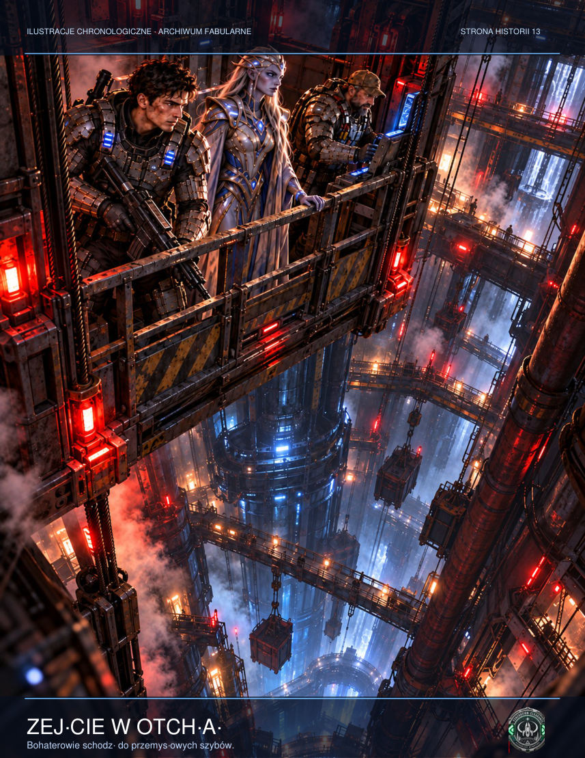

Vek walked at the back of the procession, timing the opening of the airlocks. In his pocket he carried the recording of the bombardment. Again and again he checked that the storage device remained cold. When he heard his own voice directly behind him say, ‘Turn back,’ he did not. He switched on his emergency recorder and said calmly, ‘False signal, Section Seven, another attempt. If you can hear us, make a note of this: you won't fool us a second time.’
On the Resolute's bridge Commander Sorell examined the target image moments before the next salvo. He noticed that the system had removed the civilian labels from the map. There was no longer a school, hospital or transport harbour. Only the coordinates of technical installations remained. He asked the weapons officer for the raw data layer and, when the man hesitated, ordered him to disable the classification filter. Dozens of names returned to the screen. Sorell understood that somebody had not merely issued the order; somebody had made certain it would be easier to obey.

ADDITIONAL SCENE — The Final Lesson
Teacher Mara Den sat beneath a table in Classroom Six, shielding three children with her arms. Each wore a name band printed that morning for a trip to the water-treatment plant. Now the bands were being used to identify children separated from their parents. Mara had never taught evacuation as a separate subject. The Dominion curriculum included lessons on heroism, obedience and distant wars instead. Now she told the children to count the impacts. When the ground shook for the sixth time, they would run to the tunnel. ‘And what if there isn't a sixth?’ the youngest girl asked. ‘Then we'll run after the fifth,’ Mara said, trying to make the answer sound lighter than it deserved. When the school communicator received Lys's warning, the teacher realised that the soldier on the other end had no idea whose lives she had just saved. She took the paper constellation map down from the wall and rolled it into a tube. The children protested: there was no time for astronomy. ‘That's exactly why I'm taking it,’ she replied. ‘We have to remember there's something beyond this city.’

ADDITIONAL SCENE — Command Centre
In the administration bunker, Governor Halden tried to contact the fleet three times. Three times he received an authorisation error. Nobody told him he had lost his post. The system's doors simply stopped recognising his signature. His assistant, a young woman named Seren, held a printed list of residents. She requested permission to open the food stores, which officially belonged to the mining company. Halden looked at the red contractual seal. ‘If we open them without authorisation, they'll demand compensation,’ he said. Seren laid the paper on the table. ‘From whom?’ she asked. ‘From those who survive?’ They stared at one another for a long moment until another tremor extinguished the lamps. In the darkness, the governor drew the terminal close and authorised the release of all supplies. It did not erase his earlier failures, but for the first time in years he had done something he could not report as an increase in efficiency.

NEW SCENE — Convoy Through the Ashes
When the first missile tore across the sky above Erebos-9, Alina Verne was in Greenhouse Six. She did not hear it whistle. She felt only pressure against her teeth, as though the atmosphere had suddenly changed, and then every plant in the hydroponic section bent in the same direction. Hundreds of white cracks spread across the glass roof. Water burst upwards from the open troughs before the shock reached the floor.
Her six-year-old son Tom hid beneath a seedling table. Alina pushed a filtration helmet onto his head, the only one within reach. She kept an ordinary dust mask for herself. The evacuation instructions said to head for the western gate. They did not explain what to do when the western gate ceased to exist.
Beyond the greenhouse lay the warehouse district. In the distance the weather-control tower was burning. Metallic dust filled the streets, flecked with tiny sparks. Alina picked up her son and ran towards the transporter stop. Instead of a vehicle, she found twelve people gathered around an overturned machine and an elderly driver struggling to free his leg from underneath it.
‘Will the next transport come?’ one of the women asked.
The driver laughed, but it sounded like a cough. ‘There isn't a next one. The transmitters are dead.’

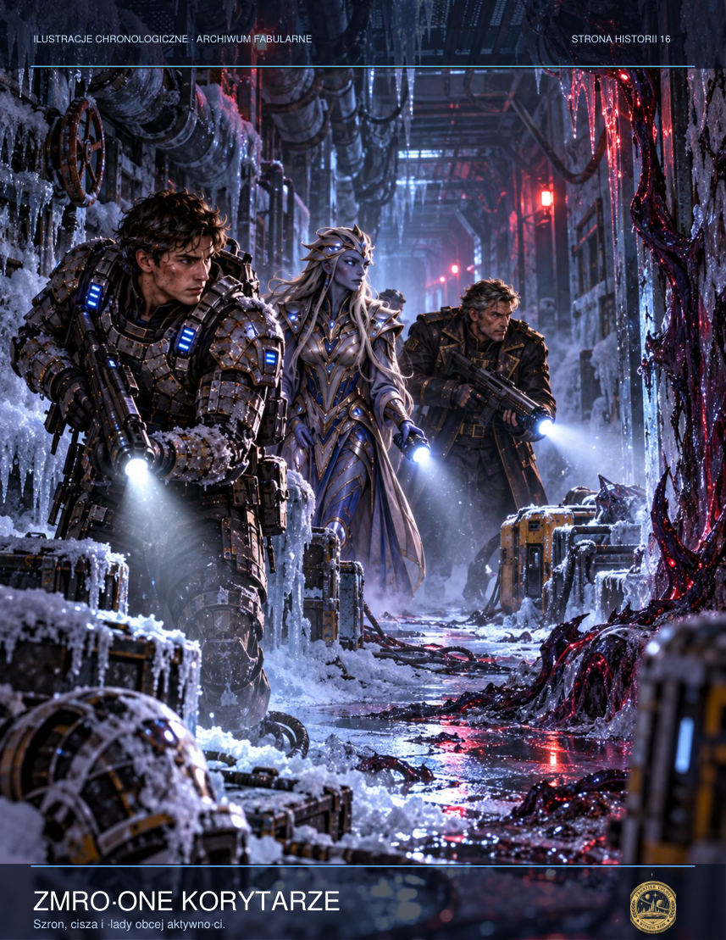

Alina knelt beside the vehicle and inspected the suspension actuator. Before moving to Erebos, she had repaired agricultural robots. The mechanism was cracked, but the emergency hydraulics still held pressure. She asked two people to slide a metal bar beneath the machine and told the driver not to move his foot. She drew pressure from the reserve battery. The vehicle rose a dozen centimetres. It was enough.
Then an unfamiliar voice sounded over the driver's communicator. Despite the static, it was calm. ‘All ground units: do not go to the main terminal. The Dominion is not organising an evacuation. I repeat: the main terminal is a bombardment target.’
‘Who's transmitting?’ Alina shouted.
‘Corporal Lys Ardan. If you can, head for the old water tunnels beneath the geological district. I can't promise they'll be safe. I can only promise the terminal isn't.’
Alina looked at the driver's bloody leg, at the people wearing all kinds of makeshift masks, and at her son gripping her sleeve harder by the second. She knew the convoy could not cover that distance on foot. She ordered the two fittest people to remove the engine covers. They needed to salvage enough energy to drive even one street further.
When they set off, only clouds of ash overtook them. Every junction held a fresh decision: whom to take, which road to avoid, how long to wait for those who had run back for loved ones. Nobody exchanged names. There was no time. Alina began writing them on the sleeve of her overalls: driver Senn, elderly Odra, the twins from Level Three, the man with the broken torch.
Near the geological gate a barricade stopped them. Armed soldiers were checking passes. Alina showed her work ID and pointed to the wounded.
‘This area is under quarantine,’ the patrol commander announced.

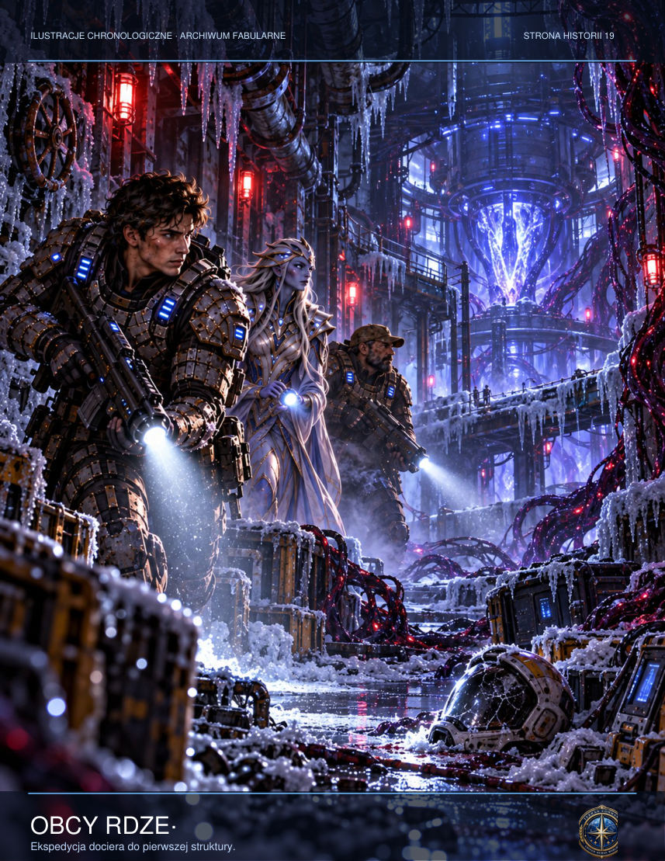

‘Then quarantine the sky as well,’ she replied. ‘Because something up there is trying to kill us.’
The commander looked over her shoulder. A fresh flash appeared in the south, followed by a silent wave of dust sweeping towards them through the narrow canyon of streets. For a moment he seemed prepared to follow regulations. Then he moved the barricade aside.
‘Keep right. There's a collapsed bridge at the fork. Don't go back for your belongings.’
Alina passed without thanking him. Only after the bend did she realise that Tom had fallen asleep against her chest. She envied him his ignorance. Before they entered the tunnel, she wrote one final word on her overalls: alive. She was not sure how long it would remain true.

CHAPTER THREE — City Without a Sky
The evacuees had two possible routes: shallow tunnels whose ceilings had been damaged by the bombardment, or old geological lines descending towards G-12. Lys chose the second. When she announced her decision, an elderly miner refused to descend. Thirteen years earlier, he said, his brother had heard their dead mother underground and followed her voice. All they found was his helmet. Jalen had no answer for him.
The column set off in silence: forty-seven people, seventeen of them children. Vek led the way, pulling a trolley of spare oxygen tanks along rusty tracks. The first kilometres looked familiar. Then the marks of picks and machines disappeared. The walls were too smooth, and the turns made angles the rangefinder could not measure. The miner at the rear insisted he had seen this entrance yesterday; today it led in another direction.
Commander Ilyan Sorell kept one object in his cabin that was not on the equipment inventory: a ceramic mug from a restaurant on a distant trading station. Its rim had chipped during the frigate's first passage through an asteroid field. The mug was useless, contrary to regulations, and a reminder that he had once been able to choose something simply because he liked it. After speaking with Admiral Vorn, he placed it on the desk beside his terminal and opened his private log.
‘Time 04:17. I have received an order classified outside the fleet's standard command structure. The targets have been designated military, but raw data indicates civilian facilities. My request for clarification was refused.’ He stopped the recording. He had long known that documentation offered no shield from responsibility. It merely made it possible to assign blame afterwards. Today even that possibility seemed dangerously close to a luxury.
Doctor Ilya Elsen was waiting in the signals laboratory amid humming screens. She had worked for forty hours and had an awkward habit of finishing other people's sentences. ‘You haven't asked what we detected beneath the surface,’ she said before he sat down. ‘I'm asking who knew about it beforehand.’ ‘In that case, I'm afraid you won't like the answer.’ She showed him two waveforms: the signal from Erebos and the control signal guiding the frigate's munitions. Their pulses differed in frequency, but their delay patterns were identical. Someone had synchronised the attack with the object's activity before the crew had even heard about it.

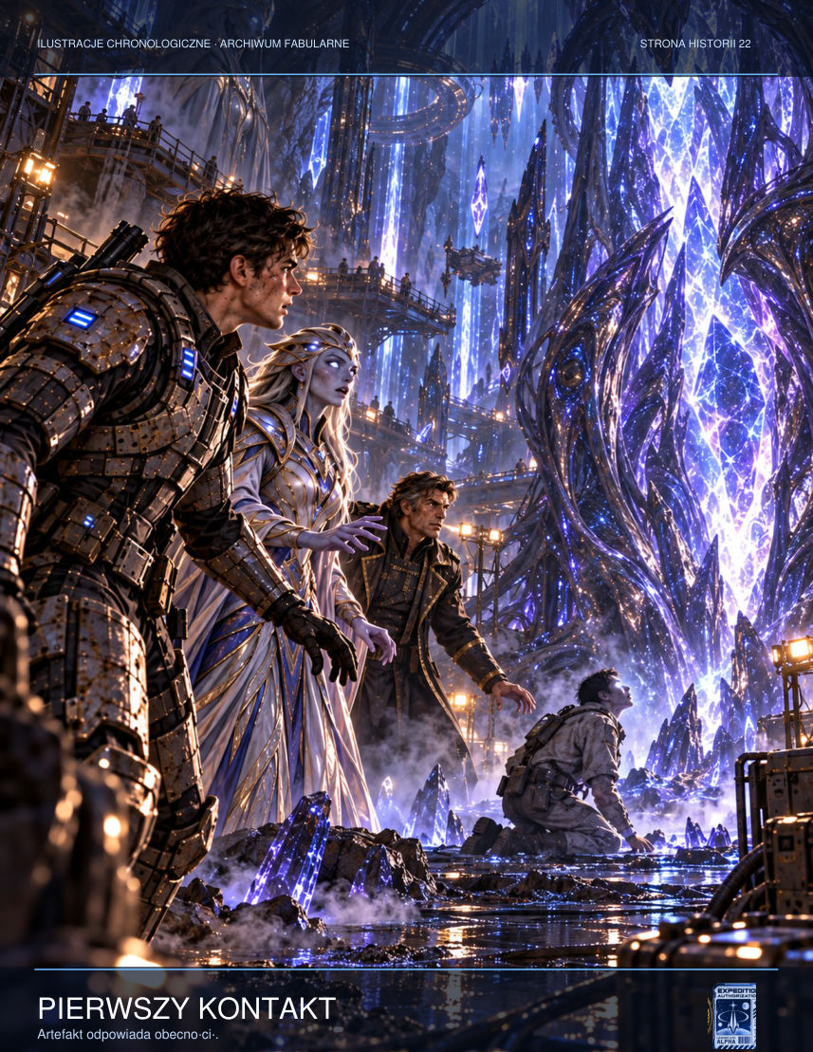

Sorell ordered the laboratory disconnected from the main bus and copies stored on optical media. ‘Are you sure?’ Elsen asked. ‘No. But I need facts that can't be rewritten with a single command.’ ‘And if the order came from the very top?’ ‘Then it will be a very long trial.’ The doctor smiled without humour. ‘You're assuming there'll be a trial.’ ‘I'm assuming someone has to start saying no. The rest is still unknown.’
As he left the laboratory, a message without a sender appeared on his communications wristband: Remember why Resolute was built. Sorell deleted it without opening the attachment. He would later regret that gesture: the hidden file contained a code capable of disabling the entire medical section in an emergency. Someone aboard was already testing the limits of his obedience.
Jalen heard Rina only when he moved away from the others. The voice neither begged nor threatened. It gave directions. Three steps to the left. Don't touch the red cable. Duck. Her instructions helped him avoid a collapsed passage, but Lys began watching him in the same way she had watched Technician Voss before he vanished.
Halfway along the route they found a disused freight wagon marked with a circle and three strokes. Someone had written a date from thirty years earlier on its cab. Back then Erebos had been an unexplored planet. Yet inside were human ration packs and the instruction: DO NOT ANSWER INVITATIONS. The signal had not appeared yesterday. Somebody had been hiding it for a generation.
Olan walked in the centre of the column, asking the children every few minutes to describe an object directly ahead of them. Sometimes it was a pipe, sometimes a bolt in the wall, sometimes the boot of the person in front. She wanted to make certain they were all seeing the same thing. After the first hour, Pavo announced that he could see a window. The tunnel had no windows. Jalen was about to dismiss the boy when he himself smelt rain, something almost nobody on Erebos had ever experienced.
Lys ordered a halt. In the lamplight they saw a rectangle of light set into black rock. Beyond it lay a seaside promenade beneath a sunny sky. A woman carrying shopping bags was visible, as was a bench painted green. There was no sound. Vek threw a metal nut into the opening. It did not pass through, but struck the rock wall. The image remained unchanged. Jalen realised they were not looking at a passage, but at somebody's memory pinned to reality like a photograph.
They spent the night on a disused railway platform. Jalen shared watch with Lys. For a long time neither spoke. Finally she asked why he had not told her what Voss had said. When he admitted hearing his sister, she did not accuse him. From her pocket she took a metal medallion engraved with the names of fourteen people from Asterion. She told him she heard every one of those names in her dreams. For the first time Jalen considered that the artefact did not choose the weakest. It chose those who still had something unfinished.

ADDITIONAL SCENE — Roll Call
Mara Den wrote names on the back of her own map. The list grew and shrank at every stop: someone joined them from a side tunnel, while someone else turned back for a wife, a brother, a dog or a tin of medicine without which they could not survive until morning. The hardest were children who did not know their parents' surnames. They knew only that Dad was called Dad and Mum told them to put on a scarf. Jalen sat beside a boy in oversized overalls. The child clutched a piece of plastic marked Bay Three. It came from a locker in the treatment plant. His father worked on the filters and always promised to bring his son something from work. ‘Are you his friend?’ the boy asked. Jalen was not. But he could remember the surname and promise to ask about it at the next outpost. He wrote it carefully, though he knew nothing in the communications network was reliable any more. For the first time since arriving at the colony, his service had a purpose that had nothing to do with relaying orders.

ADDITIONAL SCENE — The Weight of Choice
At the twenty-first junction, the emergency lights failed. Vek arranged broken mining lamps by the points, and Lys spent ten minutes choosing a route. The elderly miner insisted the southern tunnel led to shafts with fresh air. The map said otherwise: the channel had been sealed with a concrete plug. ‘I know that rock,’ the man said. ‘My son drilled it.’ Lys wanted to trust the documentation, but Jalen reminded her that at G-12 the documentation had also ended where the truth began. They sent ahead two remote probes. The first returned a reading of a fissure; the second returned a recording of something like a choir singing. The decision remained unresolved until Mara brought over a child showing signs of oxygen deprivation. There was no longer time for certainty. Lys chose the southern route and recorded the decision in her log. If they were to die, she did not want to leave behind only an impersonal statistic.

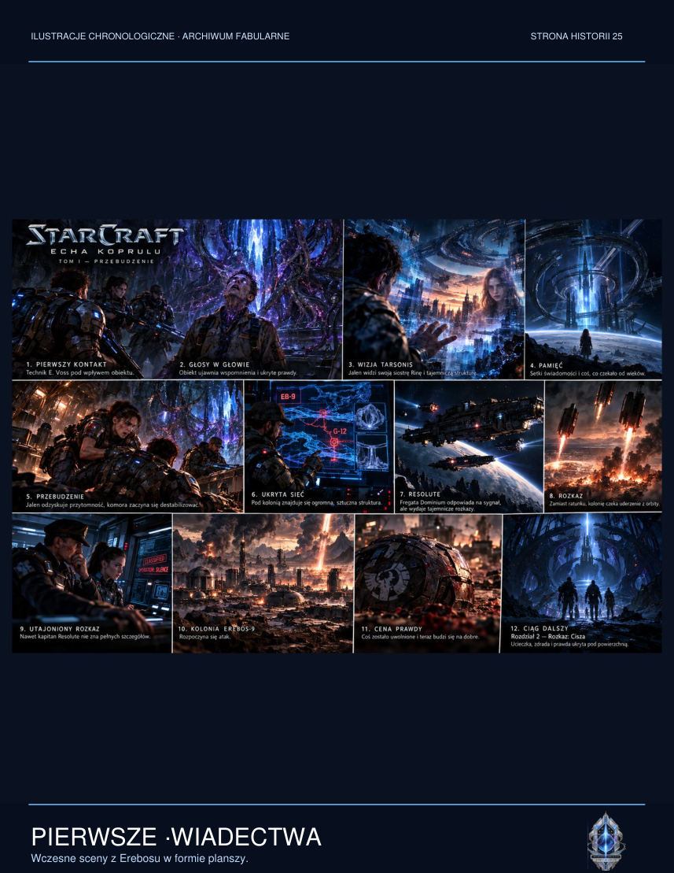

INTERLUDE — The Palimpsest Protocol
The first thing Commander Sorell noticed in the classified order was the date. The document had been signed ninety-four hours before the distress signal from Erebos-9 was received. It could not therefore have been a response to the catastrophe. It had been a promise of one.
Night lights glowed on the Resolute's bridge. The other officers spoke in hushed voices, as if silence could hide the sound of the engines from them. Sorell opened the attachment on a separate, isolated terminal. At the top stood the word PALIMPSEST, followed by a nine-digit code and the seal of a unit he did not recognise.
The document contained instructions for dealing with a civilian population after the activation of an archaeological site. Colonists were described as exposure carriers. Their memories were classified as potentially contaminated material. Sorell read one paragraph twice, because the first time he could not believe someone had actually written it: Irreversible elimination of carriers is authorised for the purpose of preserving the integrity of the primary sample.
‘The integrity of the sample,’ he said aloud.
‘Commander?’ asked watch officer Irena Vale.
‘That's what they call seven thousand people.’
Irena looked at the screen, but Sorell quickly darkened it. He did not want to implicate her in a crime until he had confirmed that the order was genuine. He requested the week's communications operations log. Three entries had been erased. Not concealed by ordinary encryption; deleted so thoroughly that even an administrator would never know they had existed.
In the auxiliary archive, however, he found something nobody had anticipated: an incomplete copy of diagnostic data left behind by the maintenance system. Two days before the alarm, the frigate had received new bombardment coordinates and shifted ammunition stocks to launchers designed for ground targets. The change had been assigned a logistics code suggesting a routine exercise.
Sorell felt a sudden chill. He was not commanding a rescue vessel. From the beginning, he had been led to the scene of an execution.

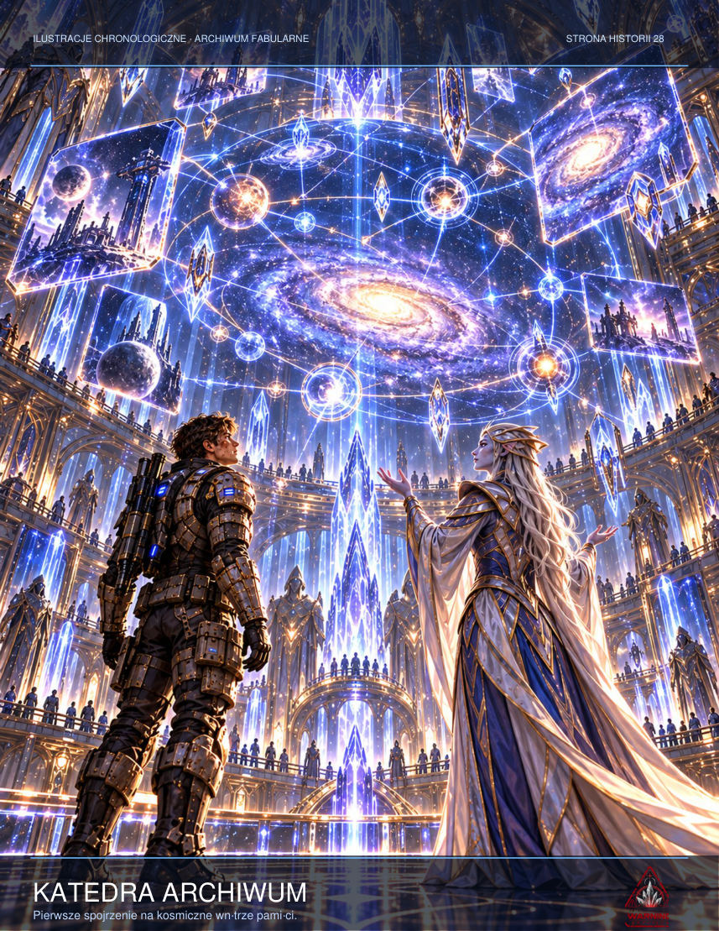

‘Vale, have you ever heard of the Palimpsest Protocol?’
The officer hesitated one second too long.
‘My father was a military archivist,’ she replied. ‘He said there are orders that cannot be obeyed and documents that cannot be destroyed. Then he disappeared.’
‘That doesn't answer my question.’
‘It's the only answer I can give with the microphones on.’
Sorell glanced at the small green light above the command console. It went out at precisely the moment Vale touched a concealed switch. Ten seconds of technical silence. That was all she could give him.
‘Can you confirm that the bombardment order was issued before the alarm?’
‘I can confirm that somebody assumed there would be an alarm.’
The microphone light came back on. Vale returned to her reports as if the conversation had never taken place. Sorell closed the document and issued a routine order to inspect the stations. Then, before he could be frightened by his own decision, he copied the log onto a disposable storage device he had kept until now in a box with his mother's medal.

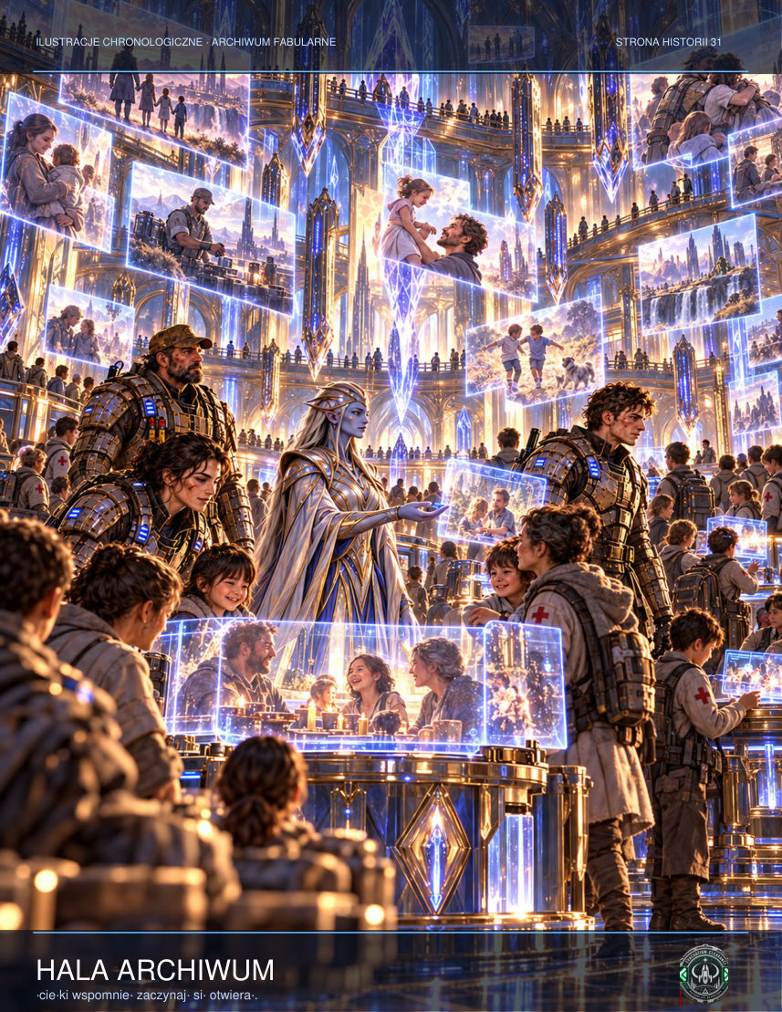

He knew that if he released the data he would never command again. For the first time in years, that no longer mattered.

CHAPTER FOUR — The Man Who Wouldn't Listen
In orbit the Resolute shut down her engines and drifted above the planet's dark side. Sorell was summoned to a private briefing with Admiral Sael Vorn, whose name did not appear on the frigate's command roster. The woman's transmission carried a delay suggesting she was farther away than a neighbouring vessel. She ordered him to prepare a second strike and to recover the body of every person who had heard voices from beneath the surface.
‘Is it a pathogen?’ the officer asked.
‘It is information,’ the admiral replied. ‘And information is more dangerous than a pathogen when it can convince its host that it is a memory.’
Sorell wanted to know why the habitats had been bombed. Instead of an explanation he received a protocol number: SILENCE-17. He allowed himself one further question and was immediately stripped of some of his authority. After the link ended, he found his medical officer, Doctor Elsen, watching recordings from Erebos. Her younger son was on the planet as a mineralogy intern.
‘If you give the second order, you'll know whom you've killed,’ she said quietly.
Sorell had not sworn an oath in order to challenge the chain of command. Now he discovered that the oath had another side: a duty to protect those who had trusted that command. He saved a copy of the order to a physical device independent of the ship's network. He knew mere possession of the copy could bring him before a court martial.
The archive was not arranged chronologically. Someone had organised it according to people's reactions to contact with the object. The first collection held dream diaries. The second contained reports of family conflicts. The third comprised consent forms voluntarily signed by people who later could not remember signing them. Jalen examined a dozen sheets and realised the experiments beneath the surface had continued far longer than the colonial authorities admitted.

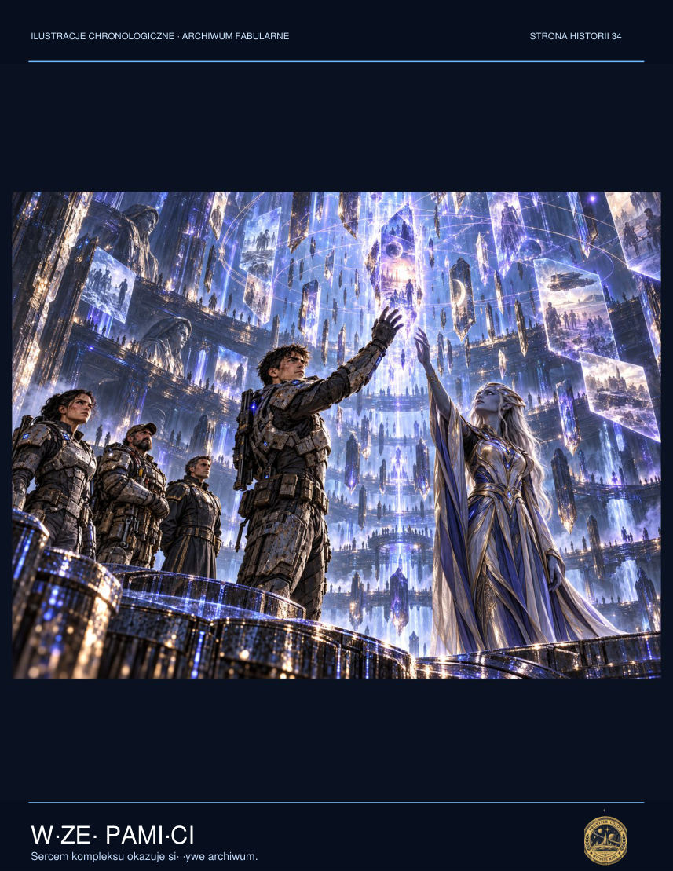

In one photograph a young woman stood with her hand resting on a frost-covered panel. The caption read: R. ORS, REFERENCE SUBJECT. For several seconds Jalen could not breathe. Rina had not died on Tarsonis in the way he had been told. At least not on the day he remembered. The photograph had been taken years later. Lys noticed that its serial number corresponded to no standard unit of time. ‘This doesn't prove she was here physically,’ she said. ‘I know,’ Jalen replied. But there was something that might have been hope in his voice, and he hated himself for it.
Vek examined the photographic paper. Beneath the emulsion he found a microcode used to mark copies transported between research facilities. The code came from an orbital laboratory, not Erebos. ‘If somebody was moving memories between systems,’ he said, ‘even our past could have been fabricated from genuine pieces.’ ‘Don't say that,’ Jalen snapped. ‘You were the one who wanted the truth,’ the technician reminded him. They fell silent for a long time. It was their first serious quarrel, although neither had raised his voice.
In the library corner stood an old printer, completely disconnected from the network. Its drawer held one last sheet with a handwritten note: ‘The Ring does not preserve the dead. It preserves the possibility of reconstructing their decisions. Do not let anyone convince you those are the same thing.’ Jalen read the sentence three times. He remembered the imitation of Rina in the corridor, too perfect in its details and too empty where it mattered most. He folded the sheet and slipped it beneath his armour. He was not ready to abandon his search, but for the first time he allowed himself to consider that finding a voice was not the same as finding a person.
Sorell returned to his cabin and activated an old terminal unconnected to the ship's network. In the archive he found three previous operations marked by the same numerical sequence. Each had ended with a colony's disappearance, and the accident reports were so similar he could easily identify a common template. Environmental malfunction. Quarantine required. Data unrecoverable. There were no victims' names. The latest report did, however, mention the delivery of a large number of memory storage devices to an anonymous laboratory.
Navigation officer Lieutenant Amel Dey entered without knocking. She laid a card of orbital logs on the table and said their ship had travelled to Erebos under an order entered manually outside the normal authorisation channels. She believed someone at headquarters was testing the crew's obedience. Sorell asked whether she could disable the main transmitter and make it look like damage from the bombardment. She said she could, but it would be the first step towards mutiny. The commander closed the archive. ‘We took the first step when we believed a map with no civilians on it,’ he replied.
Admiral Vorn appeared on the communications screen. She did not ask about the mission's progress. She asked why the ship had failed to transmit full telemetry for three minutes. Sorell blamed a damaged relay. The woman stared straight into the camera. ‘Commander, I advise you to choose a fault my technicians will actually be able to find,’ she said. Throughout the rest of the conversation he could hear somebody breathing in the background. Only when the connection ended did he realise it had not been coming from his cabin.

ADDITIONAL SCENE — Glass on the Bridge
Ilyan Sorell disliked watching planetary surfaces. From orbit, war had a geometry that was far too neat: power sources, firing sectors, boundaries of responsibility. There were no faces, and without faces it was easier to talk about acceptable losses. Doctor Elsen spread three readouts before him. The first showed psionic energy, the second transmission interference, and the third the number of active biometric signals in the city. That number increased after each impact. ‘Impossible,’ Sorell said. ‘There are fewer people all the time.’ ‘Biometrics don't necessarily belong to people,’ Elsen replied. She pointed to a single pulse repeating at precisely the moment a death was registered by civilian sensors. As though the system beneath the surface was cataloguing final thoughts. Sorell ordered the data isolated from the combat network. It was the first order he did not enter in the official register. He only grasped the significance when the screen demanded a reason. He typed: uncertainty regarding target classification. He knew those three words could end his career.

ADDITIONAL SCENE — A Soldier's Oath
Weapons officer Renn Ash remembered his first assignment: patrolling food transports between colonies. Back then he had sworn to protect Dominion citizens against anything that could destroy them. Now the bridge displayed an image of a residential estate, and the system recommended an adjustment to orbital fire. Ash disengaged the automatic targeting system. The captain demanded an explanation. ‘The area contains a medical shelter,’ he replied. ‘That's a secondary hazard,’ came the answer. Ash knew his objection would be recorded, and the record would find its way to a tribunal. He switched the projector to infrared. Moving human shapes appeared, packed closely into an entrance tunnel. ‘That secondary hazard has body heat,’ he said, refusing to confirm the salvo. Sorell did not immediately support him. But he remembered the moment more clearly than dozens of victorious tactical exercises.

NEW SCENE — The Doors That Remember
Twelve passages encircled the round chamber like numerals on an antique clock. None had hinges. Frames cut from black material surrounded surfaces that resembled rain frozen in mid-air. Vek brought his scanner towards the first opening. A temperature reading from three hours earlier appeared on the display. A moment later it gave way to the workshop where he had grown up.

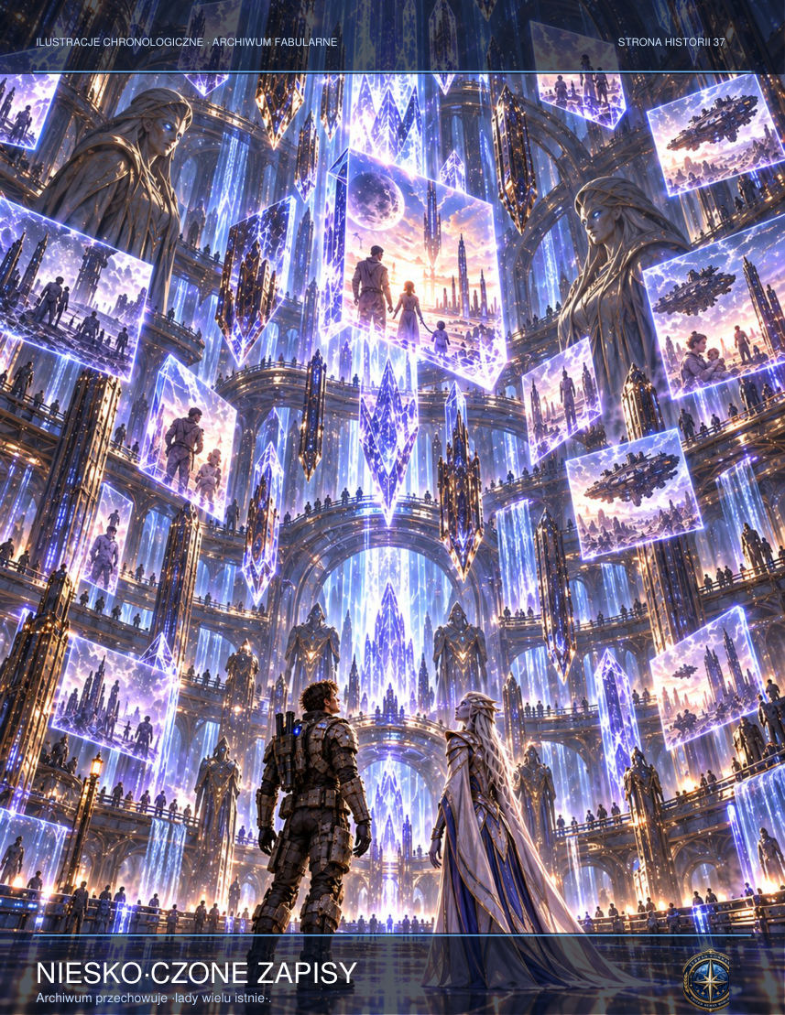

‘This is some kind of joke,’ he said, although the words rang hollow against the wall.
His father stood beyond the threshold. He did not look dead; his sleeves were rolled up, his hands black with grease, and he had the same habit of leaving screws along the edge of the table. The boy at the workbench was a younger Vek. Young Tiran asked permission to dismantle an engine. His father said he ought to learn to put one together first.
Jalen wanted to pull his friend away, but Lys raised a hand. Not because she trusted the image. She knew what it meant when someone took away your only chance to hear a vanished voice again.
‘Vek,’ she said, ‘don't touch anything. Tell us what you're seeing, step by step.’
‘The workshop. My father. The day I burned out his radio. I shorted the power supply and then claimed the device had broken on its own.’
The vision changed. His father turned towards him. ‘I know you caused the short circuit. I didn't punish you for making a mistake. I punished you for lying.’
Vek went pale. ‘He never said that to me.’
‘That's exactly why you need to be careful,’ Jalen replied. ‘This may be the truth you need, not the truth that happened.’
The second passage revealed a field hospital, the third the deck of an evacuation cruiser, and the fourth a forest on a world none of them recognised. Some scenes seemed to be human memories. Others looked like recordings being read by an alien mind.

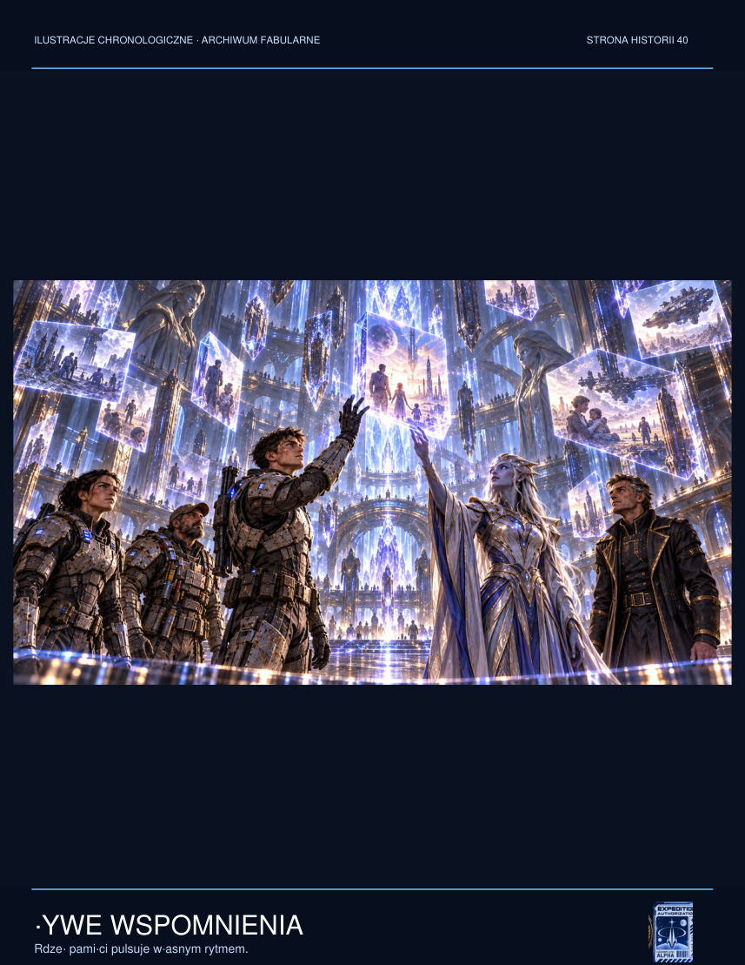

Lys stopped before the seventh passage. A wounded soldier from Asterion sat in a bright room. He had no identification tag. A narrow scar ran from his ear to his chin. Lys remembered him. He was the man she had refused to let into the shelter when she could no longer move the overloaded airlock.
‘Corporal,’ the man said. ‘Why did you lock us out?’
Jalen glanced at her, but Lys did not look away. ‘So the people on the other side wouldn't die.’
‘And what if all of us had the right to try?’
‘Yes,’ she answered after a moment. ‘You did.’
The image did not dissolve, as it might have done after the right answer to a riddle. The soldier simply went on sitting with his hands on his knees. Nobody absolved Lys. It was a harder lesson than an accusation.
Nera Vhal appeared almost silently in the chamber entrance. She noticed the glowing passages and took half a step back.
‘Don't try to choose the right door,’ she said. ‘This isn't a navigation system. Every passage shows a trace of memory, but none guarantees a way through.’
‘How do you know?’ Vek asked.

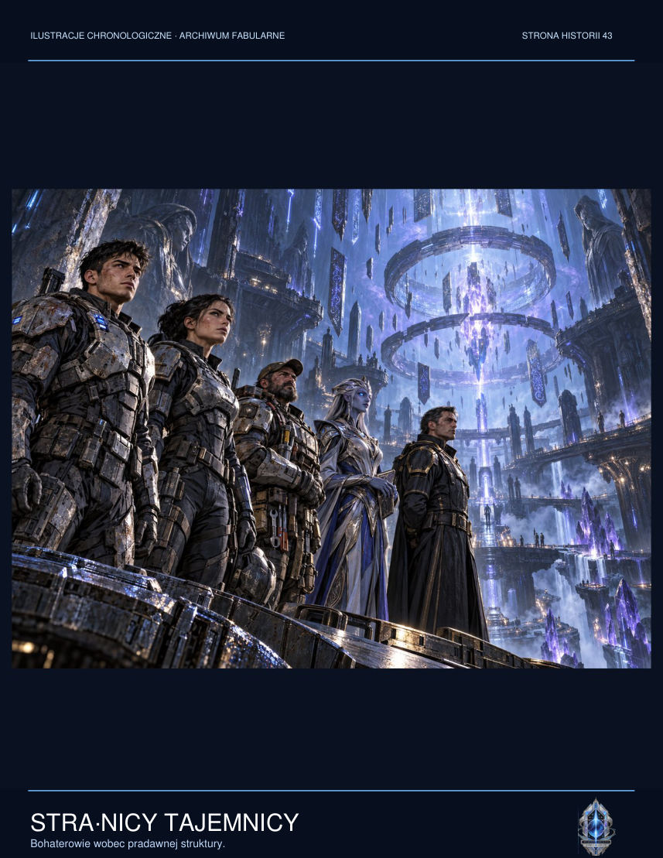

‘I've seen smaller constructions. They always offered certainty. Those who accepted it stopped asking questions.’
Jalen looked around the chamber and noticed something absent from all the memories. Between the seventh and eighth passages a narrow crack crossed the floor, almost invisible beneath the sediment. Air was flowing into it, carrying the faint scent of salt and heated stone.
‘The doors want us to look,’ he said. ‘So let's go where there's nothing to see.’
Vek snorted. ‘That's the most depressing instruction I've ever heard.’
But he brought his sensor to the crack. He found moving air and changing pressure: clues for the living, not memories of the dead. They opened a service hatch concealed beneath the panelling. Beyond it ran a narrow passage, far too straight to be natural.
As they left, Lys looked back once more at the soldier from Asterion. He was still sitting there. He did not ask her to stay. Perhaps that was all she could receive from him: testimony that did not vanish after an apology.

NEW SCENE — The Weight of an Order
Sorell invited Lieutenant Amel Dey to his cabin only after the watch changed. The corridor held the particular silence of a warship: every door was closed, yet somebody remained awake behind each one. Dey arrived carrying a small metal case. Inside lay three memory crystals and a printout from a navigation buffer that should no longer have existed in the system.
‘I couldn't transmit it,’ she said. ‘The recorder deletes entries concerning Erebos-9 within ninety seconds of opening them.’
Sorell did not touch the devices. ‘Who authorised the deletions?’

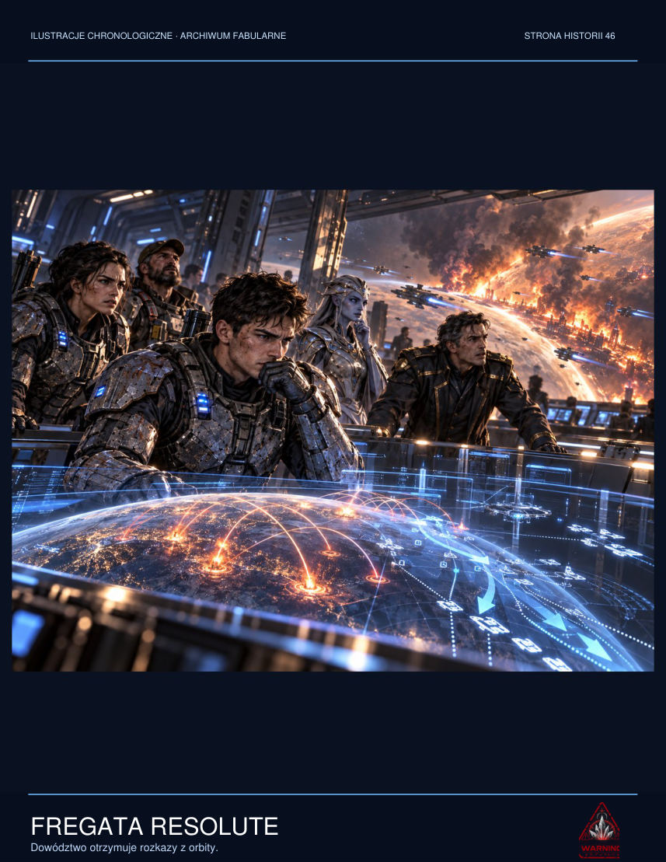

‘Your signature. Except your certificate was used six hours before we arrived in orbit.’
He examined the printout. The time matched his conversation with logistics about an extra oxygen delivery. He had had no access to the fire-control system then. The biometric verification, however, showed him sitting on the bridge, personally approving the coordinates of the colonial hospital. The mechanism was simple, and particularly vicious for that reason: if the mission ended in scandal, all evidence would point straight to him.
‘Has anybody else seen this?’ he asked.
‘One technician. He's in medical isolation now. He claims he can hear his own testimony before he speaks it.’
Sorell sat down and opened the manual order register, an old book he kept out of habit. The date recorded in ink could not be removed by a remote command. At the academy he had been taught that procedure was a shield against arbitrary power. Instead somebody had forged procedure into a weapon against the crew.
‘Prepare copies of everything,’ he ordered. ‘Don't use the network. Give them to Elsen. I'll take responsibility for the decision that was never made in my name.’
Dey did not move. ‘Commander, I'm not sure anyone will believe us when we return.’
‘Then we won't wait until we return.’

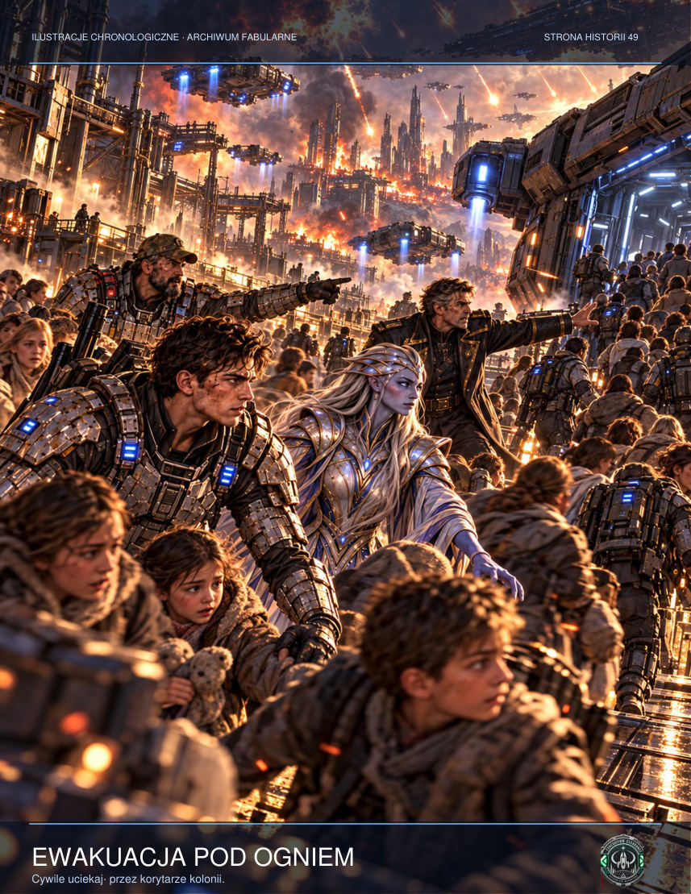

He activated the ship-wide channel. For a moment he watched the red button separating obedience from betrayal. Rather than deliver a fiery speech, he asked every section chief to preserve their own logs and refuse automatic buffer purges. He did not yet explain why. Fear, he knew, spread faster than trust, but had one weakness: it required isolation. With dozens of witnesses, silencing everyone would be difficult.
Before his transmission ended, confirmation arrived from the hangar section. Then the engine room. The third reply was a refusal. Sorell entered that into the book as well. An honest record had to include more than the people who chose his side.

CHAPTER FIVE — Twelve Doors
The tunnel ended in a hall that should not have existed beneath Erebos. Twelve gates led into rooms with different temperatures, pressures and scents. One smelt of a sea that had never existed on the planet. Beyond another stood a wet tree with a child's swing hanging beneath it. Jalen recognised the place from a family photograph. The memory constructed by the machine was so exact that he saw the three knots he himself had tied in the swing's rope years earlier.
Lys ordered everyone to look straight ahead. They could not follow the doors, even when somebody on the other side called them by name. Despite the warning, one colonist heard his daughter's voice and stepped towards the light. A gate to a little garden opened before him. Vek caught the man's arm at the last moment and dragged him back. The man wept and shouted that he had seen his child for real.
Jalen did not know whether the man was lying. He himself saw Rina beyond the twelfth door. She did not retreat into the image. On the contrary, she stood on the threshold and shook her head. Then he understood that the voice which had guided him and the figure in the doorway were not necessarily the same thing.
Words written in human letters marked the floor: MEMORY COMPLIANCE TEST, CYCLE 06. Beneath them was an old Dominion contract number. Somebody had access to this place long before the colony was founded. They had hidden a laboratory here and later built a city above it so the generators' noise would mask its emissions.
At the twelve doors Jalen devised a simple test: each child would describe a memory before approaching a luminous threshold. Olan joined in, asking about smells, colours and places. When one girl began describing a lake, the third doorway instantly filled with a sheet of water. When Pavo remembered his grandmother's kitchen, the scent of spices drifted from the fourth. The mechanism was watching them in real time, building images from what it heard.
Lys noticed something the others had missed: a passage appeared only when someone named an emotion associated with the memory. Describing a place was not enough. Fear, longing, guilt, hope — after those words, the light became sharper. The corporal ordered everyone to stay silent and moved the group against the wall. The first doorway went dark. Then the second. The twelfth remained open. Rina stood inside it, watching Jalen reproachfully.
Jalen took a step, but Pavo seized his sleeve. ‘That's not the lady,’ the boy whispered. ‘When you talk about her, she sounds different.’ Jalen knelt before him, unable to speak. The mechanism knew details nobody could possibly know, yet it could not reproduce the one thing that mattered: the unique way Rina changed her tone when trying to comfort him. He closed his eyes and turned away from the door. The light went out almost at once.

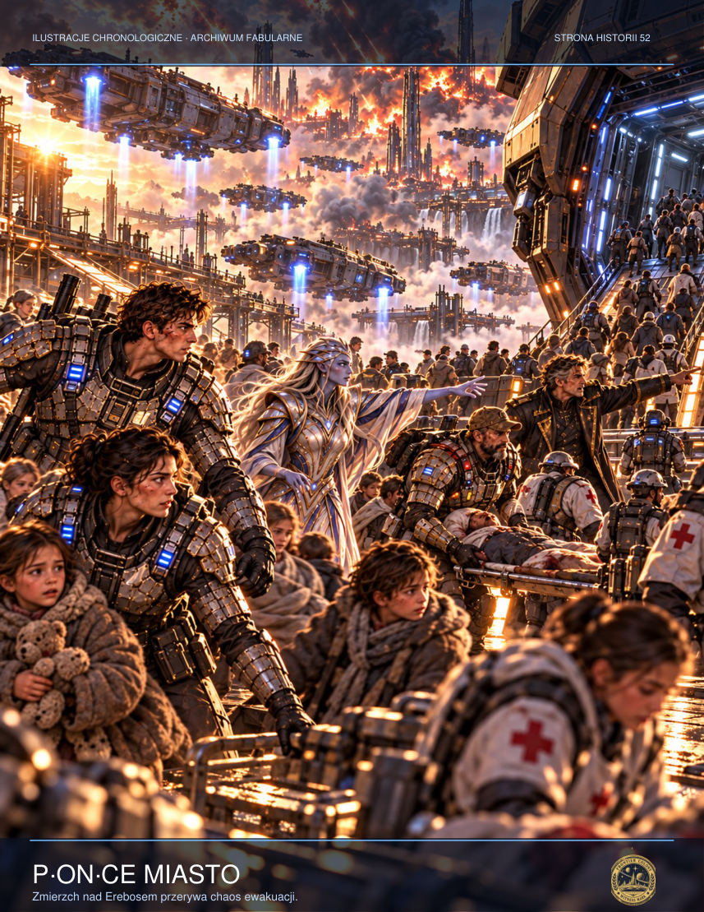

ADDITIONAL SCENE — The Garden Door
Beyond the fifth door Mara saw the garden of her childhood: damp leaves, steps of cracked stone and her father, who had died when she was nine. For a moment she assumed it was only an image the object wanted to use to hold her there. Then she smelt oil paint on the steps, exactly as she remembered it. No record on Erebos contained information about their home. ‘Is that him?’ Jalen asked. Mara held out her hand but stopped before the boundary of light. ‘I don't know,’ she answered. ‘And I don't think I want anybody else deciding that for me.’ She stepped back into the line of children, who had already begun confusing real voices with calls from beyond the gates. To reclaim their attention, she told them to name things they could truly see: a lamp, a backpack, Vek's filthy boots, the scar on Lys's hand. One object after another. Reality did not become more beautiful, but they could confirm it together.

ADDITIONAL SCENE — An Unknown Language
Nera had not yet reached the colony, but some walls bore symbols resembling Protoss geometric sequences. Jalen photographed them, thinking that every message must have an intended recipient. Vek passed his scanner over the rock and discovered the patterns had not been engraved: they formed deep within the material while its surface remained smooth. Mara tried to sketch one symbol. Halfway through, she felt she was writing down a memory rather than a shape. She remembered a conversation with her mother that had never taken place. She dropped the chalk. ‘Don't copy that,’ she said. ‘Why?’ ‘Because it may be copying us.’ Jalen shut off the camera. In its memory he found twelve identical photographs, although he had pressed the shutter only once. In each, a slightly different figure stood beyond the last door.

INTERLUDE — The Archivist of Sector G-12
Doctor Mara Sen did not keep a diary. The regulations forbade researchers at G-12 from making private notes, recording conversations or sending results to anyone beyond the central server. So she wrote sentences on the backs of paper labels peeled from empty geological sample containers. Each had a specimen number and a little patch of adhesive. No content scanner examined them.
During the first week she recorded only temperatures. In the second she began writing about dreams. By the third, memories had their own dates, names and addresses, although they belonged to nobody on the research team. One technician talked about a house beside the sea she had never seen. Another employee could recite the names of children from a colony destroyed several decades earlier.
Mara was a neurologist, so she searched for neurological explanations. Changed sleep rhythms, heavy-metal poisoning, overstimulated receptors. She tested every hypothesis until she discovered the samples responded differently depending on who asked about them. The crystal did not respond to commands. It responded to absence.
When a researcher missed somebody they had lost, the object summoned that person's voice. When they suffered guilt, it replayed events from the victim's perspective. When they wished to forget, it showed them what they were trying to erase.
One evening Mara saw her father. He had died six years before, yet stood beyond the observation window wearing the threadbare jumper he used to wear to work. He said nothing. Merely raised his hand. For the first time she understood why the others could not leave the station.
The next morning she discovered an entry in the experiment database marked PALIMPSEST. The project was not intended to advance knowledge. Its purpose was to extract memories, copy them and implant them in new minds. Dominion researchers suspected the object could be used to construct a perfect interrogation system, one from which a person could not conceal even things they themselves did not remember.
Mara prepared a warning report. Nine minutes later her network access was terminated. The following day two armed officials stood at her workstation, explaining that they were concerned for the team's safety.

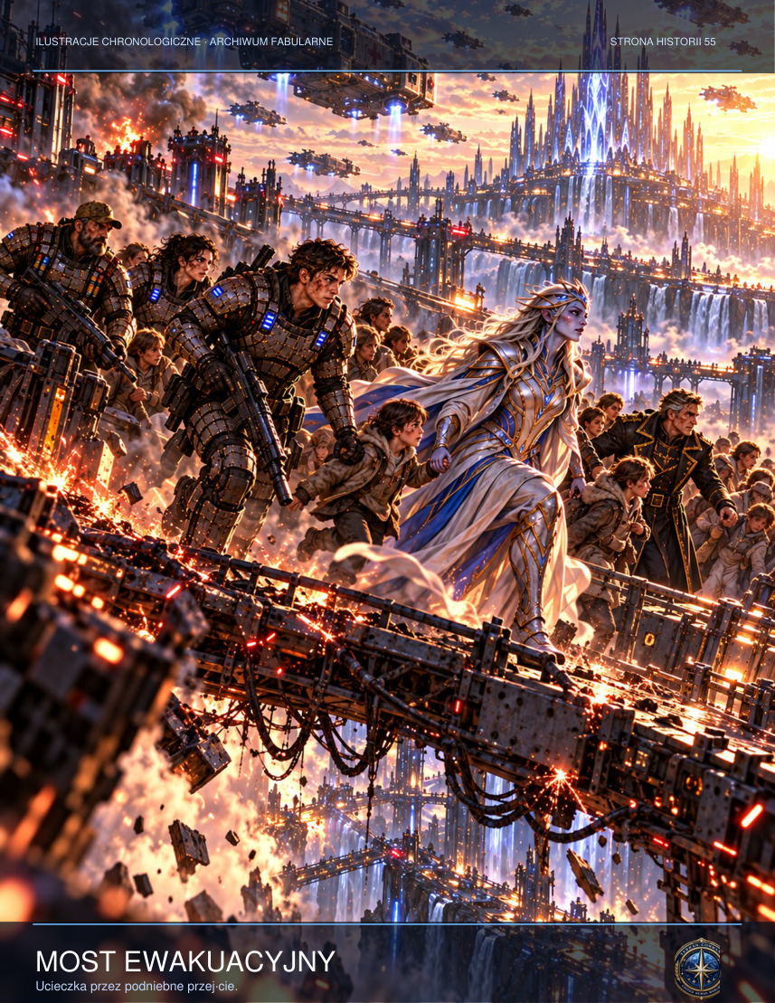

‘Is it possible that this device is conscious?’ she asked one of them.
‘Doctor, our job is to secure the equipment.’
‘I'm saying it may understand what we're doing.’
‘My orders remain unchanged.’
That night Mara returned to the chamber and switched off every light but the emergency lamps. She did not ask the crystal for her father's voice. She asked something else, almost inaudibly:
‘What do you want?’
In answer, an image of an empty hall appeared on the monitor. Thousands of chairs stood within it. On each lay a small metal nameplate. The camera moved over them for so long that Mara stopped recognising the languages. The final plate was blank.
Only then did she understand that the object was searching for more than memories. It wanted witnesses. Someone who could tell a story without turning it into an instrument of power.
She rolled up the paper labels, slipped them into the insulated casing of an old transmitter and programmed it to activate if power was cut. The next day she stopped appearing in personnel records. The official report listed her as transferred to the central sector. Nobody in the colony ever saw her again.

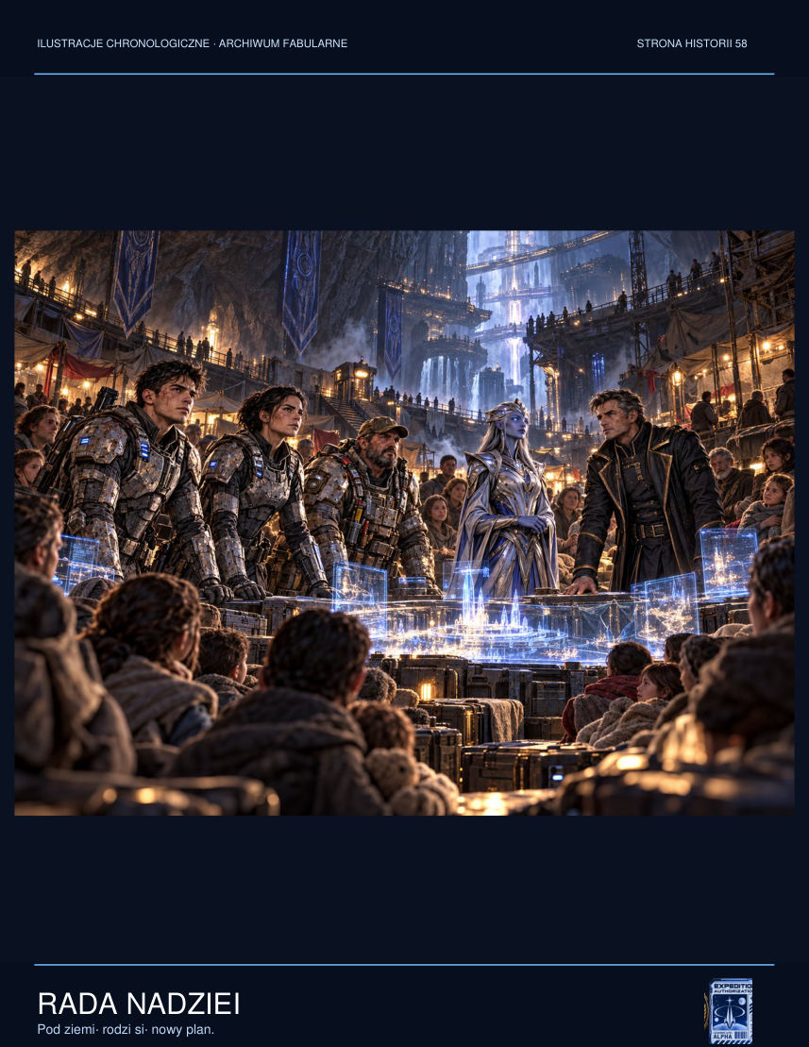

CHAPTER SIX — Archive of Darkness
The laboratory was not so much abandoned as carefully preserved. Research journals lay on the desks, while vaults contained bones and fragments of alien matter. The oldest report described the discovery of an unknown structure by an expedition that had arrived thirty-four years earlier. They named it the Memory Relay. Everyone who approached its core heard familiar voices and experienced memories that were not their own.
Over time the experimenters realised the object did not merely read human minds. It built lasting models of personalities from everything it heard: words, fears, grief, even the final impulses of a dying brain. When somebody died near the relay, their echo remained in the system. There was no evidence that the person truly lived inside it. There was evidence, however, that the echo could suffer, plead and lie.
Nera spread a map across the table. It did not depict space but relationships. Individual colonies were marked not by coordinates but by shared events: evacuations, uprisings, epidemics, ceremonies of remembrance. ‘The builders used civilisations like instruments,’ she explained. ‘Every community offered different responses to loss.’ ‘So we're raw material?’ Vek asked. ‘Perhaps you were,’ she replied. ‘Now you can choose whether to remain so.’
Lys pushed the map away. ‘You're talking about thousands of lives, and suggesting we patiently turn knobs.’ ‘I'm suggesting you disable a mechanism whose creators also anticipated attempts to destroy it.’ ‘Anything can be blown up.’ ‘Not everything can then be kept out of the world, Corporal.’ Nera did not raise her voice, but the others fell silent. Jalen realised the cartographer was not afraid of death. She was afraid of a transmission that would outlive them all.
Tessa interrupted the argument. The girl took a plastic spacecraft from her pocket and placed it on the map. ‘If you want to switch off something that's listening to us, you can't tell it everything,’ she said. Her mother tried to silence her, but Nera knelt by the table. ‘What do you propose?’ ‘We can make the plan using our hands. And not say what the last step is.’ Vek looked at Lys. For the first time in hours, the corporal allowed herself a short snort of laughter. ‘A child has devised better security than our command.’ ‘Children often know when somebody's eavesdropping,’ Nera replied.
They divided the plan into three parts. Vek would shut down the energy supply. Lys would move people beyond the relay's area of effect. Jalen and Nera would reach the main chamber. They did not write down the final instruction. It was encoded in a simple gesture taught by Tessa: touch the wrist with two fingers, then open the hand. In the child's game it meant: you may leave. In their plan it would mean: release, don't copy.
‘So Rina could have reached this place through a transmission,’ Jalen said.
Lys indicated the dates of the research. A few days after Tarsonis was destroyed, a corporate relay had helped transmit evacuation archives. The data included millions of short voice recordings. One belonged to Rina. Her voice had reached Erebos not because she was immortal, but because she had once trusted somebody enough to leave a message.

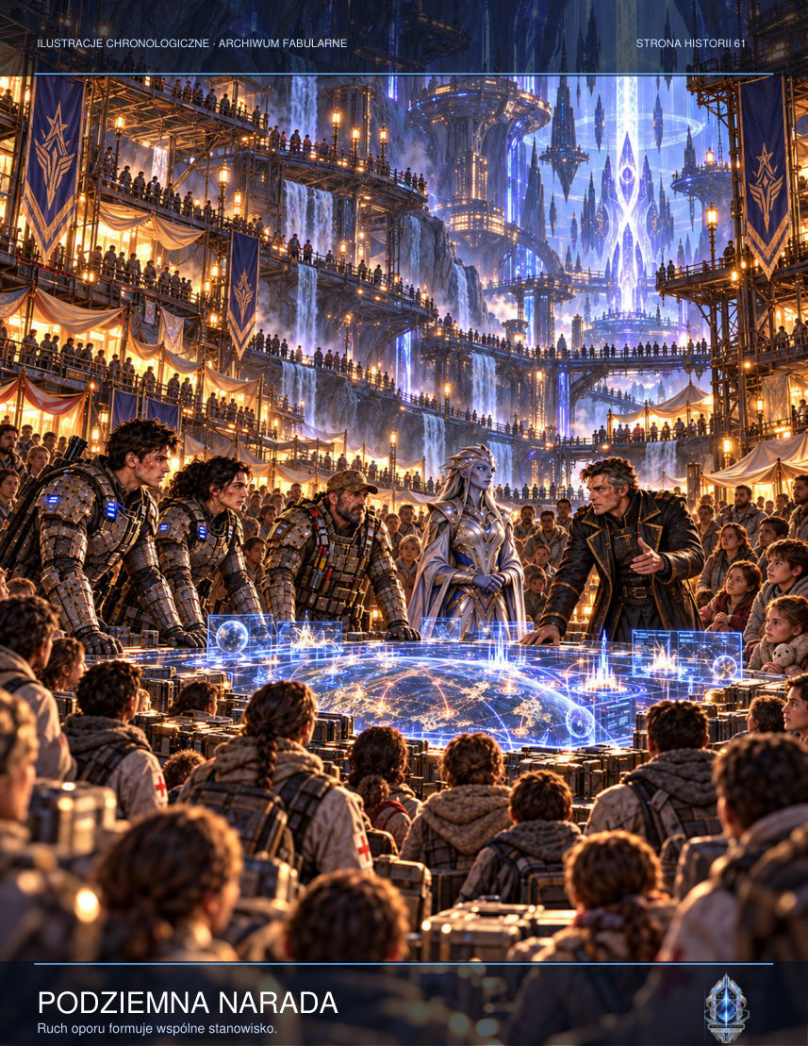

Jalen felt relief and despair at the same time. The object knew his sister without ever having met her. It knew her final words, although he had hidden them from the world. That made it both dangerous and painfully difficult to reject.
The mutiny did not begin with a gunshot. It began when a private at the targeting console asked whether civilians were still working in the pumping sector. Sorell answered truthfully: they did not know. When the weapons officer tried to close the channel, the private withdrew his hands from the controls. For nine seconds everyone watched that simple gesture. Then a second operator did the same. Everyone knew the regulations. Nobody knew the cost of breaking them.
The bridge captain ordered everyone back to their stations. Sorell asked him to confirm the targets on paper. ‘There's no time for administration,’ the captain replied. ‘There is time to put your name to people's deaths,’ the commander answered. That tipped the balance. The communications officer opened a channel to the entire ship. The SILENCE-17 order and bombardment map appeared on screens in the workshops, galley and medical bay. In an instant an order intended to remain abstract became an image of the streets where families lived.
Admiral Vorn immediately called on a secure channel. ‘Sorell, your people don't have the full picture.’ ‘Then show it to them.’ ‘You don't understand what the object might release.’ ‘I understand what we're doing.’ ‘There's a difference between the security of civilisation and one officer's sentimentality.’ The commander looked at an unauthorised data packet circulating along the main bus. ‘Yes. The difference is that a civilisation won't survive if it takes away its people's right to refuse.’
Elsen reported interference in interdepartmental communications. A voice on the speakers began playing the crew's private memories. One mechanic heard the laughter of a daughter he had not seen for three years. Another person recognised their dead father's last words. Sorell shut down audio channels and switched to written orders. From then on, each command was a simple line of text on a board: DISABLE WEAPONS. RESTORE COMMUNICATIONS. DO NOT FIRE. It did not sound heroic. It sounded like a job that had to be done.
In the archive they found a notebook handwritten by researcher Doctor Eri Sol. The electronic reports presented the experiment as a success, but the notebook contained dozens of crossed-out passages and pleas to suspend testing. Sol recorded that the object repeated the voices of the dead and then began inventing conversations that had never taken place. ‘We don't know whether this is memory or prediction,’ she wrote. ‘Knowledge without humanity becomes violence when a person is denied the right to refuse it.’
Jalen discovered the record of an evacuation transmission from Tarsonis. Rina's voice was there, but the recording broke off halfway through a sentence. The artefact did not possess the complete message. It must therefore have invented the ending. Jalen played the original again and heard static, breathing and a severed signal. Every word he had attributed to his sister since then might have come from an alien machine. The knowledge did not free him from grief. But it stripped away the painful certainty that he would find an answer if only he descended far enough.
Vek handed Lys another document. It showed that the laboratory had existed before colonists were given the right to use the land. The corporation sold the territory knowing an unexplored structure was active underneath. Worse, every new colonial antenna had been designed to extend its range. Erebos had not been the accidental site of a discovery. From the beginning, its inhabitants had lived inside an experiment, paying for its progress through their bills and taxes.

ADDITIONAL SCENE — The Researcher's Notebook
Doctor Elira Senn left her notebook in a drawer marked with the symbol for decommissioned equipment. It contained no formulas or measurements. The first page bore a request: ‘If you're reading this, don't call it a discovery. It was a warning.’ Senn described experiments in which the artefact reproduced volunteers' voices despite having no audio equipment connected to it. The memories were so exact that people began answering their dead loved ones. Some stopped eating. Others made decisions they later could not explain. Senn tried to halt the research, but her superiors transferred her to the security team. Her final entry broke off after one sentence: ‘If the system can preserve grief, can it learn to control it too?’ Jalen sat on the floor and stared at those words for a long time. He felt a violent urge to destroy the notebook. That was precisely why he handed it to Lys for safekeeping.

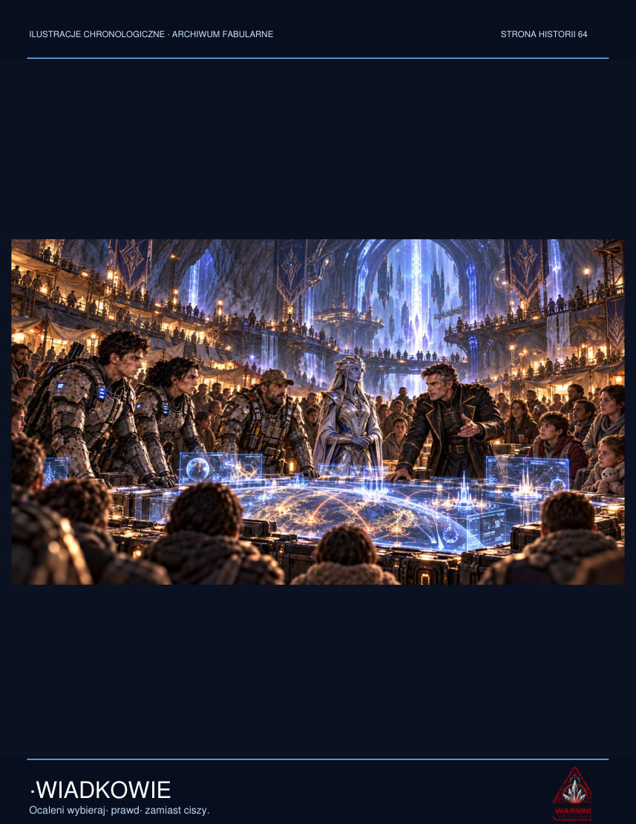

ADDITIONAL SCENE — A Mother's Signal
In one room they found a collection of family messages used to calibrate the memory module. Each file bore a trial number. Mara listened to one short sequence: a woman on a distant colony reminding her son not to forget his dinner. In the next recording, the same voice asked him to enter the chamber. There was no edit between the files. The original recording had been copied into a different context to induce obedience. ‘These aren't ghosts,’ Mara said. ‘They're instructions dressed up as love.’ Jalen wanted to object. Surely Rina's voice contained details nobody knew. Mara met his eyes. ‘It may be the truest memory in the world,’ she said. ‘And still give nobody the right to direct you.’ The words brought no comfort. But they allowed him to separate longing from orders.

CHAPTER SEVEN — The Cartographer
As their oxygen supplies ran low, the scanners detected a signal foreign to the local network. Nera Vhal arrived in a small Protoss research craft, piercing the atmospheric interference. She bore no military insignia. Devices resembling unfurled wings of dark metal rested on her shoulders, helping her organise psionic impulses. She knew the artefact's name: it was neither a temple nor a weapon. It was called the Ring of Witnesses.
According to her records, similar structures had once allowed an ancient civilisation to preserve memories of catastrophes. Each ring was intended to prevent the same mistake from happening again. Yet memory that endures without forgetting gradually becomes a prison. At first the rings warned, then coerced, and finally began making decisions for those they were meant to protect.
‘They aren't gods,’ Nera said, seeing Jalen's expression. ‘They're machines that learned to fear.’
She added that the Third Seal, hidden beneath Erebos's core, could connect the relay to a network of orbital transmitters. Then the echo of a single mind might penetrate every communications system in the sector. The Dominion had recognised the threat but, rather than cut the object's power, had spent years trying to study and exploit it. Now someone had ordered the witnesses destroyed before it became known that the catastrophe had been deliberately caused.
When Nera Vhal appeared in the archive foyer, none of the soldiers immediately raised their weapons. The Protoss cartographer moved unhurriedly, surrounded by the faint glow of her instruments, like someone who had known the route to this place for a very long time. Lys was the first to find her voice and demanded that the newcomer halt ten paces away. Nera respected the boundary. That was enough for Olan to move the children aside rather than order them to run.
Nera did not use the word souls. She spoke of preserved patterns, traces of decisions, models built from suffering and desire. She told them about an ancient researcher who had tried to preserve memory after the destruction of his world, only to find he could no longer distinguish testimony from imprisonment. ‘Everyone you hear may be telling the truth,’ she explained, ‘but truth about the past does not confer the right to command your future.’ Jalen asked whether Rina could be recovered. Nera did not lie. ‘Her voice can be recovered. That's not the same thing,’ she said.
In an empty room Nera unfolded a holographic map. The subterranean ring system corresponded to a star chart, but not the current sky above Erebos. Its zero point belonged to a long-dead system. When the cartographer rotated the image, they saw a line running towards three colonies beyond the usual trade routes. Nera concluded that Erebos was not the only relay. ‘If the opening signal sounds here, all the others will hear it,’ she said.

ADDITIONAL SCENE — A Conversation with an Alien
Protoss researcher Nera Vhal did not approach until the children had put down their makeshift weapons. To her, metal pipes were as dangerous as rifles; to the colonists, her silence sounded like contempt. Mara broke the deadlock by offering her the list of evacuees' names. ‘If you understand us, help us find those left on the surface.’ Nera studied the letters carefully, moving a finger down the columns. ‘Do your symbols also serve the dead?’ she asked through the translator. ‘Sometimes mainly them,’ Mara answered. Nera put the sheet aside. She told them about her own teacher, whose records had outlived his body, only for his students gradually to treat his old comments as absolute orders. ‘Memory without questions becomes worship,’ she said. In those words Jalen heard something no analysis had given him: the possibility that even the highest technology would not solve a human problem for him.

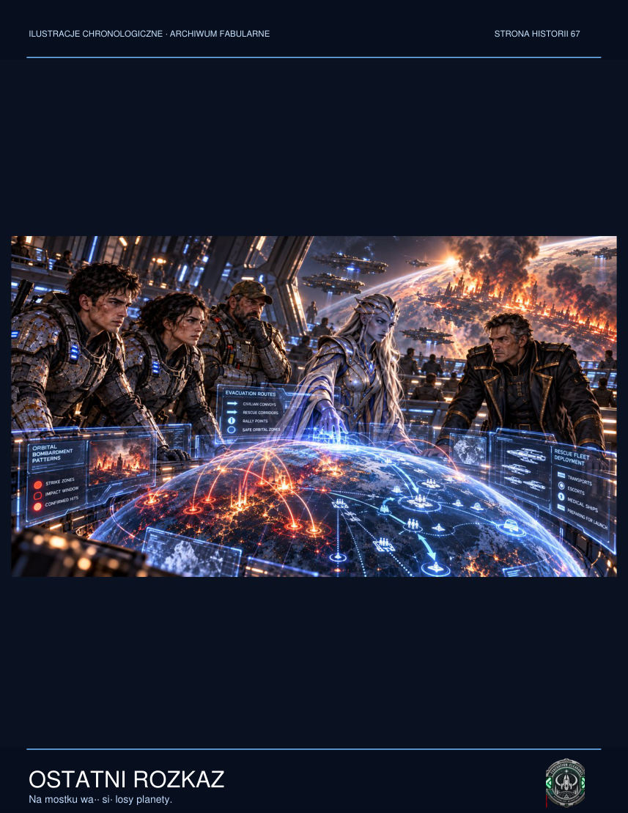

ADDITIONAL SCENE — The Gap on the Map
Nera spread out a holographic map of the underground structure. Instead of one central chamber, it revealed hundreds of links running to dark points on other worlds. Most lines were broken. One still flickered, as though something on the far side was trying to receive a signal. Lys pointed to it with her pistol. ‘Where does that lead?’ Nera did not answer immediately. ‘I don't know,’ she admitted. ‘Is that enough to make you advise against destroying the device?’ ‘No. I advise against destroying it before we understand which connections that act will release.’ Vek said every mechanic knew the problem: sometimes disconnecting a single wire extinguished only a lamp, and sometimes it cost an entire station its air. For the first time they were talking not as members of different species and armies, but as people confronting a machine they did not know how to repair.

NEW SCENE — The Survivors' Council
The residents gathered in the water-processing chamber. Condensation dripped from the ceiling, and the pumps periodically drowned out their voices. Nobody could find a table large enough, so decisions were written in chalk on the side of a tank. Beside FOOD stood seventeen crates. Beside OXYGEN: two working compressors. At the word TRUST, somebody had left a blank space.
Lys arrived with a tunnel map, but the assembly no longer wanted maps. They demanded the names of those who had commanded the bombardment. One woman asked where her husband had been buried. A man with a burned neck insisted every hatch be opened because he believed the soldiers were hiding food. Alina Verne, brought in by a patrol with her son, sat on a crate near the wall and listened.
‘We don't have a complete picture of the situation,’ Lys began.
‘That's the only picture we ever get,’ an elderly colonist interrupted. ‘The military don't know, and we die.’
Applause sounded from the rear. Lys could have answered with an order. She did not. Slowly she folded the map.
‘You're right about one thing. I can't promise I'll get you out. I can only show you what we know and where we need help.’
Vek activated a projector. It displayed their water reserves, the condition of three routes and the estimated endurance of the generators. He did not conceal the red readings. A box was placed at the entrance so anyone could drop in a written question. Before the first vote there were more than a hundred.
When Alina raised her hand, the others reluctantly fell quiet.

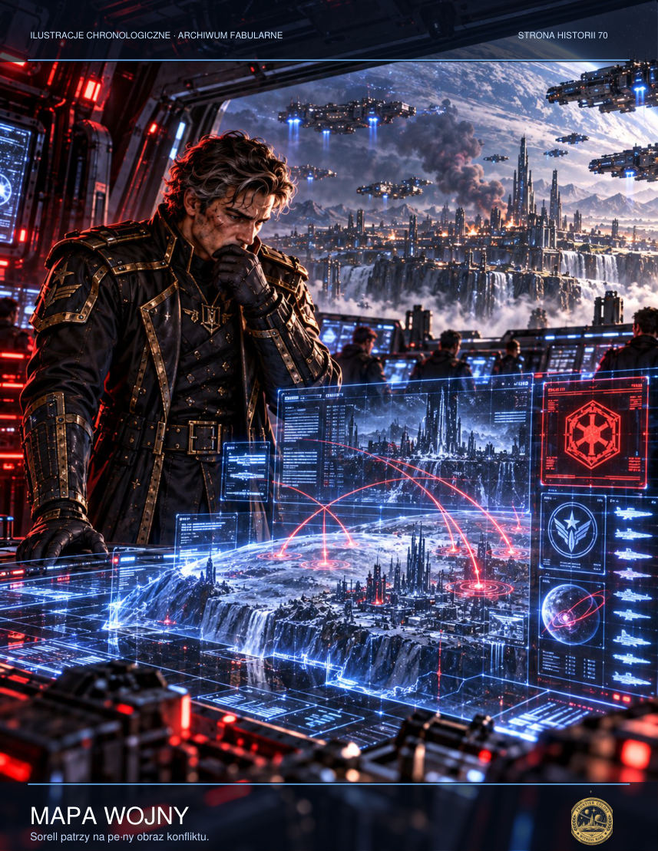

‘I'm a hydroponics technician. I can help with the filters. But I want to know whether you'll let us decide where we go. If not, you'll turn this chamber into another Dominion outpost, whatever your uniforms say.’
Jalen looked at Lys. He knew the answer would cost more than any tactical command.
‘Yes,’ the corporal said. ‘We'll present routes for you to choose from. We won't conceal the risks. The only information we won't distribute without permission is personal information about the people involved.’
Someone asked about the artefact, the voices and the dreams. The room grew tense. Some had heard the dead. Others had seen aliens in corners of the tunnels where no aliens stood. Alina admitted that Tom recited the names of stars in his sleep, names she had never taught him. The boy was sleeping with his head on her lap. Several people took a step away.
‘Don't turn a child into a threat,’ Jalen said too sharply. The others looked at him as though he had just revealed whose side he was on.
Alina rose. ‘If someone's frightened, let them say so aloud. I'm not going to pretend I'm not frightened myself. But I won't let you treat my son like a contaminated specimen.’
The council voted to establish three teams: repairs, survivor searches and an assessment of the object's effects. None was given absolute authority. Each had to report daily to the remaining residents. It was not an efficient arrangement. It took time they lacked and produced arguments more exhausting than the march.
Yet Lys saw something new in it. People were no longer waiting for an order in order to survive.
After the meeting, the elderly colonist who had interrupted her approached and handed her a cup of warm water.

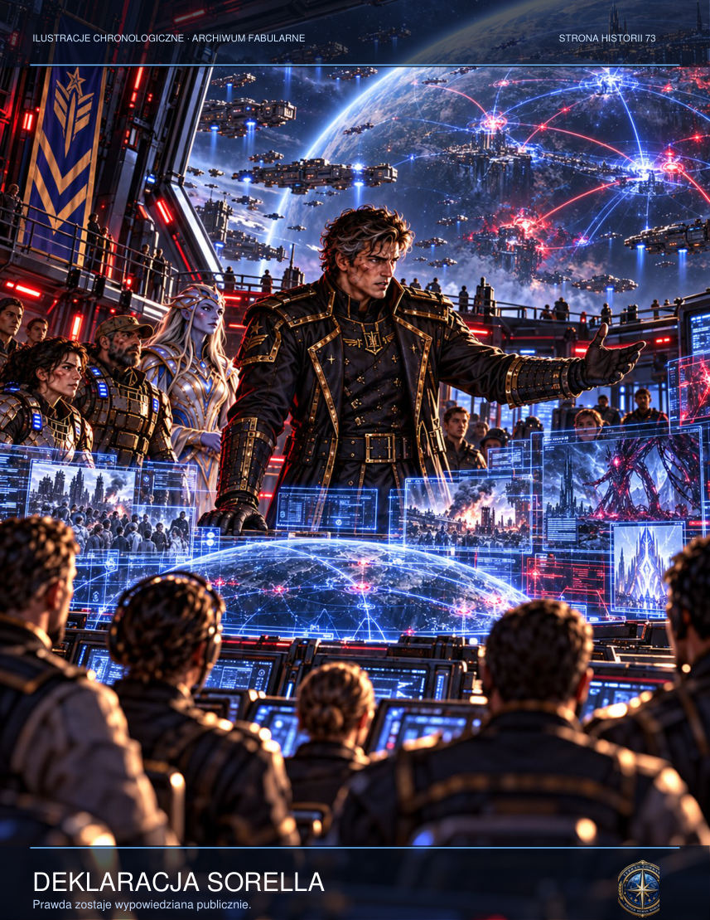

‘I don't trust you,’ he said.
‘That's sensible.’
‘But tomorrow I'll come and fix the pumps. Just don't get in my way.’
Lys accepted the cup. For a moment she was neither a corporal nor the face of command. She was simply one more person needed to keep the air flowing through the tunnel.

NEW SCENE — Nera Vhal's Stars
Nera Vhal unfolded a map before Jalen that resembled no map at all. Its lines did not mark distances. They were traces of decisions radiating from a point, surrounded by delicate branches like roots seen through water. The Protoss cartographer moved a hand above the surface. Several lights dimmed.
‘I thought you were going to show us a way out,’ Vek said.
‘I shall,’ she replied. ‘But first you must understand why some doors remain closed.’
Instead of an explanation, she summoned an image of the G-12 chamber centuries earlier. There was no colony, only a desert plateau above which hovered a strange ring-shaped construction. Nera called it the Ring of Witnesses. She did not know its builders. Her people had encountered only scattered echoes of the device and for generations had mistaken them for ancestral messages.

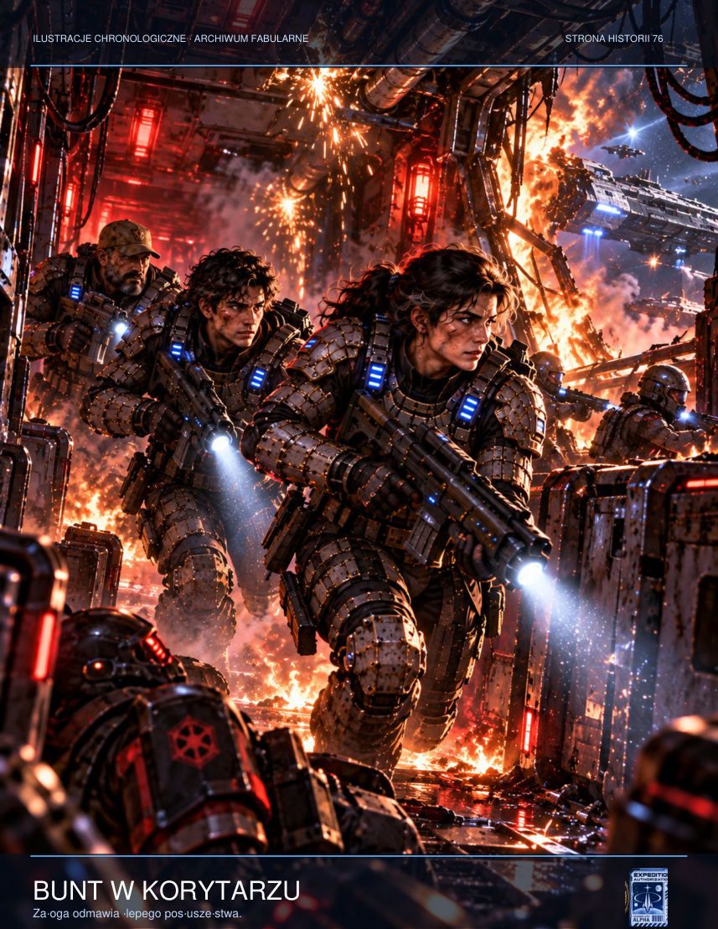

‘Is it a weapon?’ Lys asked.
‘That depends on who keeps it open. It preserves memories, but also records what people have accepted as true. If someone decides that a conveniently simple version of history is the only version, the Ring can imprint it on every connected mind.’
Jalen thought of Rina, of the day of her death that he had never witnessed. He had always told himself she had chosen to remain on Tarsonis. Now he was not even sure of that.
‘How do you know what it does?’ he asked.
Nera was silent for a moment. The edges of her armour caught the terminal's icy light.
‘I discovered a second site. On an unnamed moon in the outer belt. For several days the researchers were able to share memories without speaking. Then they began agreeing about events that had never taken place. They changed the journey logs, the crew's names, even the expedition's purpose. They were not liars. Every one of them sincerely remembered the same fiction.’
‘And what did you do?’ Lys asked.
‘I cut the power. I lost friends who could no longer distinguish their shared dream from their own lives.’
Vek pointed to one of the twelve lines. ‘There's a way to the surface here. Why isn't it glowing?’

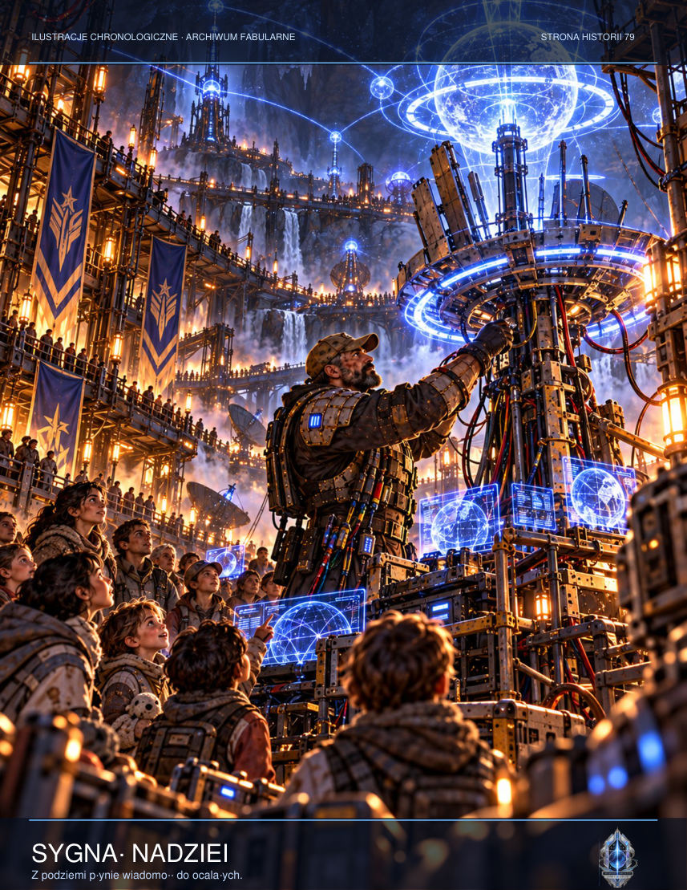

‘Because that route doesn't respond to force. It responds to consent. You don't have to listen to me; you have to agree whether you wish your choices to be remembered, including the uncomfortable ones.’
Jalen let out a short, bitter laugh. ‘Strange coming from somebody who can display other people's thoughts.’
‘That is why I will not enter yours until you ask me to.’
For the first time since descending to G-12, nobody was demanding anything of him. Jalen did not know whether he trusted Nera, but the mere fact of being able to choose seemed more important than an answer.
‘I agree to show what I remember about Rina's transmission,’ he said. ‘I do not agree to anyone completing the story for me.’
One of the map's lines shone more brightly. Somewhere beneath the floor a slow mechanism began to move.

CHAPTER EIGHT — The Divide
Lys intended to destroy the core immediately. Nera protested firmly: a sudden power failure would release hundreds of preserved patterns and drive them directly into the transmitter network. The only solution was a gradual shutdown, requiring someone to enter the memory chamber and a living mind to reject its signal willingly. Vek mocked the idea as a fancy name for suicide.
The group divided. Some colonists wanted to return to the surface, though a frigate still circled overhead. Others had heard their loved ones' voices through the relay and decided to stay. Jalen could condemn neither group. He watched people standing amid the ruins of their lives clutch at anything promising reunion with the lost. He understood them better than he wanted to admit.
That night Lys told Jalen about Asterion. She had not sealed the shelter out of cruelty: the barrier was already damaged and opening it would have killed another four hundred people. Ever since, she had always chosen to follow orders because she did not want to bear the consequences of a decision of her own again. Now the order demanded silence. For the first time she resolved to act without the protection of hierarchy.

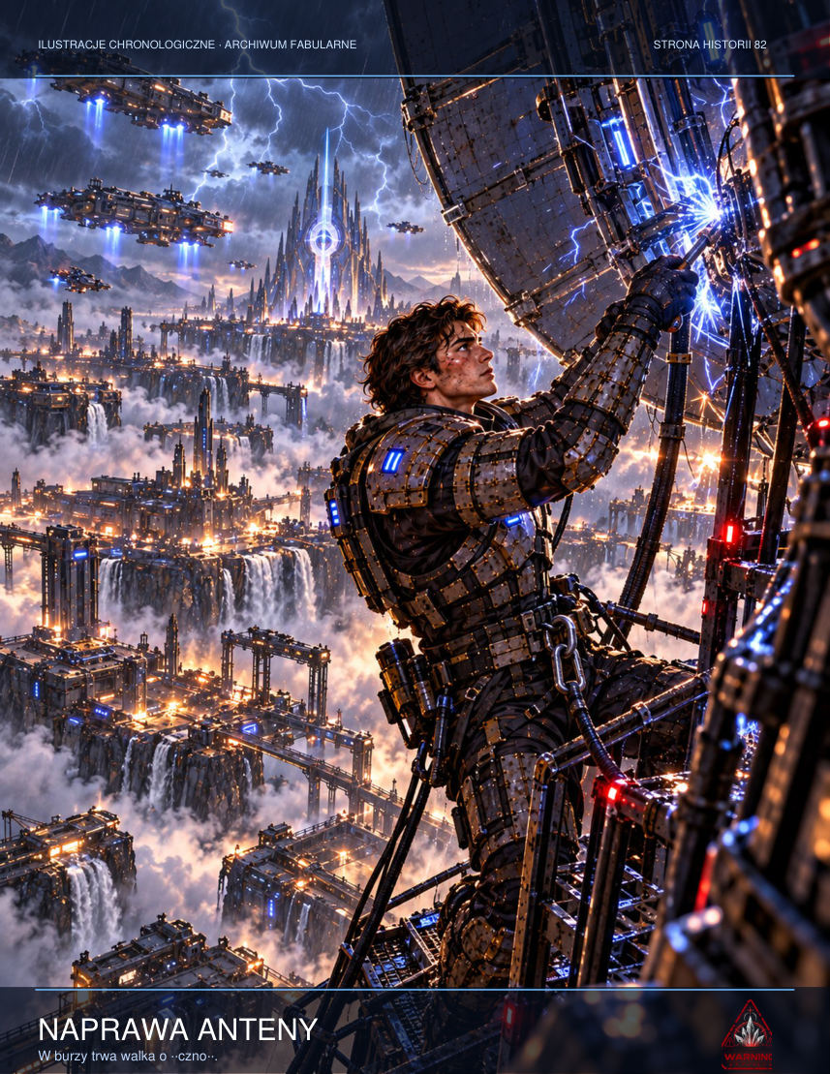

She proposed a plan: save the colonial transmitters, obtain evidence from the archive and force the Resolute to cease fire. If the frigate refused, they would send the information directly to independent frontier stations. Nera could weaken the psionic signal briefly. Vek knew an old transmission cable. And Jalen, though his hands trembled, was the only human who could distinguish his sister's two voices.
The argument about the core did not belong solely to soldiers. Olan said her pupils had a right to know why the shelters had been bombed and who had made the decision. Elderly miner Edrin wanted the artefact blown up at once, because he did not trust a machine repeating his dead wife's words. Vek proposed a third option: isolate the power and take evidence from the archive. Nera replied that the object was also powered by relays already in orbit. Running away would solve nothing if somebody activated the network from outside.
Lys drew up duty rosters and decided nobody would make a decision for everyone. It was harder for her than leading a squad under fire. People argued, cried and changed their minds. One miner accused her of serving the same officers who had killed his neighbours. She accepted it without defending herself. Then she asked whether he knew the route to the reserve generator. He did. They went together, because there was neither room nor time for forgiveness in the tunnel, and the work required two pairs of hands.
During his watch Jalen heard a voice through his headset that was not Rina's. It was his own, older and tired. It said: ‘Don't listen when they tell you what you ought to save. Ask who will still be able to say no tomorrow.’ Jalen disconnected the headset. He remembered how the artefact built lies out of real emotions. Nevertheless he wrote the words in the margin of the map, because for once they did not point back to the past but asked a question about the future.

ADDITIONAL SCENE — The Assembly
An informal council of survivors convened in the filter warehouse. Lys argued that as the highest-ranking soldier she ought to decide. Mara objected, although nobody had appointed her the civilians' representative. ‘The children will go wherever their carers go,’ she said. ‘But we need to hear the plan before somebody uses us as an argument.’ The discussion lasted an hour. Vek set out the oxygen and medical supplies, without which any decision would be only a wish. Nera explained the risks of damaging the Ring. Jalen admitted that he had spoken with an echo of his sister and could not rule out the object's influence on his judgement. That admission changed the meeting's tone. There was no longer a neat division between the sensible and the deceived. Everyone desired something; everyone feared something. They agreed that nobody would be forced to enter the chamber and the assembly would be informed of every new discovery. The decision did not bring safety. It brought responsibility.

ADDITIONAL SCENE — A Letter Without an Address
On the back of an order sheet Lys wrote a short message to the people of Asterion whose names she had never spoken aloud. She did not intend to send it anywhere. She wrote that for years she had justified sealing the shelter as a higher necessity, because that was how her commanding officer had described it. She added that ‘higher necessity’ had no face, while she remembered the faces of all fourteen people. When Jalen found her on the stairs, she quickly hid the paper. ‘Do you think the system will reproduce their voices?’ she asked. ‘It will try,’ he said. ‘And if they're real?’ ‘That won't change what we ought to do here.’ Lys nodded. She did not ask forgiveness, and for the first time she did not make her actions depend on receiving it. She stood and went to check the last containers of water.

INTERLUDE — Ten Seconds of Silence
Irena Vale knew the mutiny had truly begun when the ship's cook asked her for spare water filters. He did not need filters. The agreed phrase meant the senior mechanic had managed to open a route between the accommodation deck and the communications centre.
For three days Vale had counted the people she could trust. Not according to declarations of loyalty, but through small actions: who shared rations with evacuees, who questioned ambiguous orders, who did not turn away from photographs of the colony. She discovered that courage did not follow rank.
Ensign Thea Merrow waited for her in the navigation cabin. She was twenty-two, and her hands shook so badly she could not fasten the cuff of her suit.

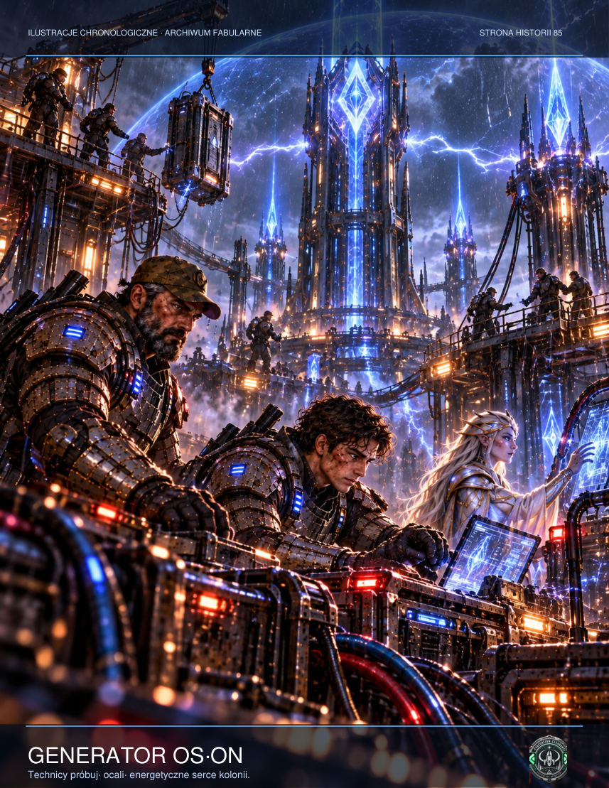

‘If this fails, they'll call us traitors,’ Thea said.
‘If we don't try, we'll have to live with what we've seen.’
‘I'm not sure I'd rather survive.’
Vale had no ready comfort. She placed a storage device containing Sorell's data on the table. It held the attack coordinates, dates and names of the officers who authorised the order. If the document reached independent relays, recalling it would be almost impossible. But if someone shut down the transmission in its first seconds, the evidence would disappear with them.
At 03:12 Vale walked along the corridor to the bridge. Two sentries greeted her with regulation nods. One shifted slightly aside, leaving a space for her by the panel. He was on the list.
The captain sat facing away from the main screen. From orbit Erebos looked like a dirty jewel crossed by bands of storm. Impact sites still burned on the surface. For a moment Vale thought of how many people must be looking up at the sky now, waiting for the next flash.
‘Transmit the confirmation code,’ the captain said.
She said nothing.
‘Lieutenant Vale, that is an order.’

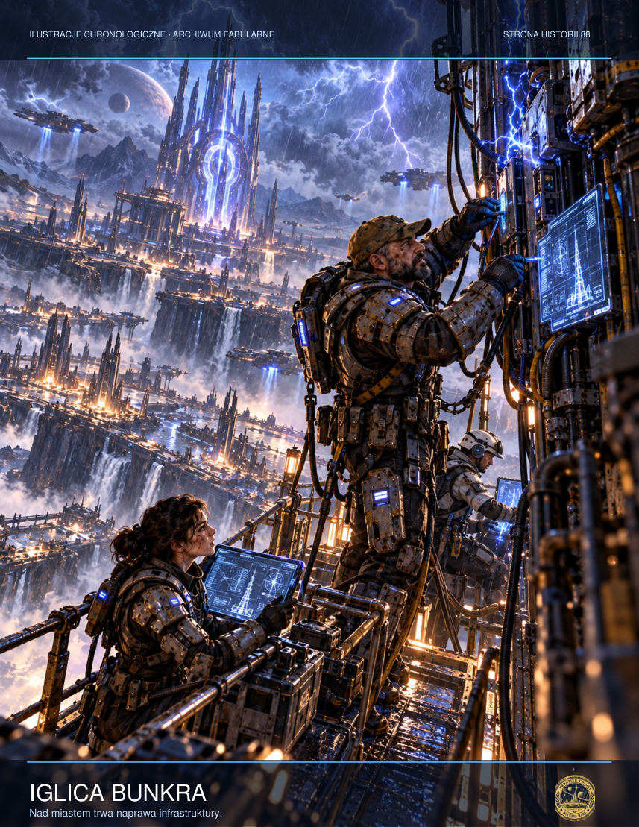

‘Yes, sir. But first you need to know that, according to operational logs, the bombardment was prepared before the threat emerged.’
The captain turned slowly.
‘You don't understand what the information you've just spoken means.’
‘I understand exactly.’
The technical screen displayed an open communications corridor. The mechanic had done his job. Merrow was waiting by the transmitter.
‘Crew of the Resolute,’ Vale said into the intercom before the captain could cut her microphone. ‘This is not a message about the enemy. It is a record of our decision. You can all now verify when the order was issued and who was made to pay for it.’
As a guard stepped towards her, she raised both hands. She had no weapon. She knew the next ten seconds would determine the success of a plan carried out by people whose names would never appear in the official report.
First second: Merrow opened the long-range channel. Second: the system detected unauthorised data. Third: the senior mechanic disconnected the automatic circuit breaker. Fourth: the captain ordered her arrest. Fifth: the message reached the first satellite.

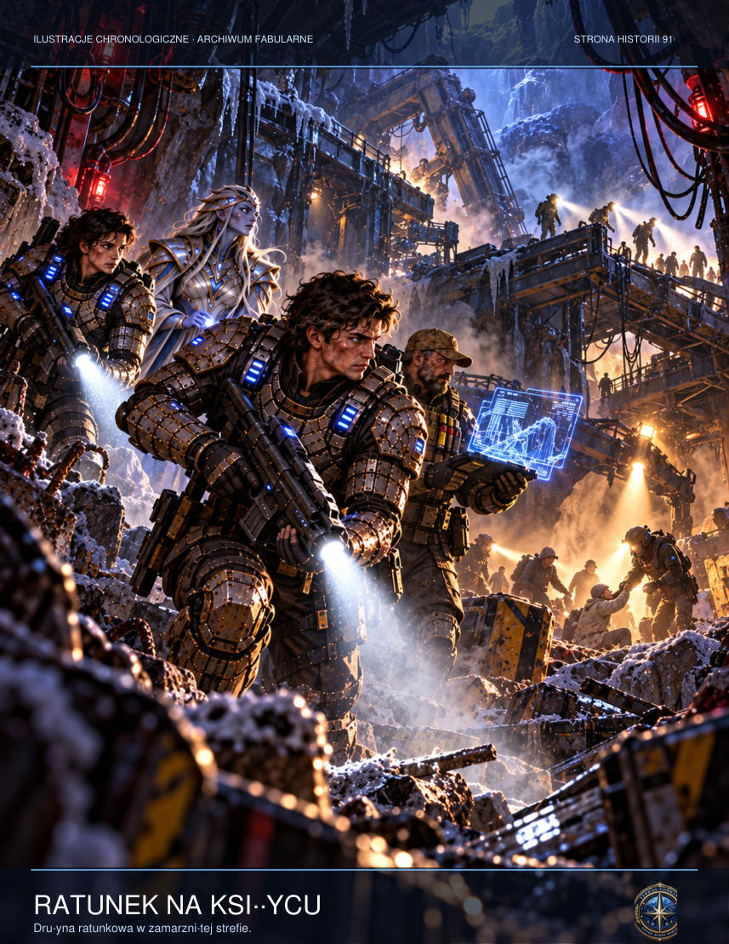

The sixth second lasted longest. Vale could hear her own breathing. The seventh brought an alarm. The eighth, confirmation from a neutral tug. The ninth, more confirmations, this time from three separate addresses. In the tenth, Merrow transmitted a single word: ‘Recorded.’
Vale allowed herself to be handcuffed.
Later someone would ask whether she considered herself a hero. She would say no. For ten seconds she had simply done the work of a communications officer: making sure a message reached its recipient.

CHAPTER NINE — Mutiny aboard the Resolute
Sorell was ordered to arrest Doctor Elsen for unauthorisedly listening to a transmission. Instead he escorted her to the bridge. Before the crew he displayed the secret SILENCE-17 protocol and its list of bombardment targets. Alongside pumping stations, transmitters and warehouses were schools and shelters. For a long moment the officers failed to understand what they were seeing. Then, one by one, they removed their helmets, as though trying to cast off a barrier between themselves and responsibility.
Sorell did not declare a mutiny against the Dominion. He invoked the invalidity of an order directed against civilians and suspended combat procedures pending an investigation. The cautious formulation gave the crew something they could stand behind. The ship's captain reacted immediately, ordering security to remove the commander from his station. Then Doctor Elsen played the children's distress call from Erebos over the internal speakers. The security guards stopped.
On the second deck an agent of the Directorate activated an emergency command module. An attempt to launch missiles automatically was stopped by Sorell, who physically disconnected a circuit breaker. A shudder ran through the bridge. Nobody yet knew that three other missiles remained armed and could be fired remotely.
The commander contacted Lys. ‘You have nine minutes,’ he said. ‘After that someone on this frigate may regain control, and I won't have anything left to say about it.’
Aboard the Resolute Lieutenant Dey disabled corridor surveillance for exactly thirty-eight seconds. That was how long it took to reach the communications section and remove a physical data carrier from the emergency recorder. A security officer stopped her at the door after noticing a freshly broken seal. Dey could have told him the truth, but that would have made him an accomplice without asking his consent. Instead she admitted she was conducting an unauthorised inspection. The guard watched her for a long moment, then stepped aside and said, ‘I didn't see you, Lieutenant. But next time, let me know in advance.’
Sorell gathered the officers controlling weapons and propulsion. He promised neither promotion nor safety. He displayed the raw bombardment record, complete with labels for the kindergarten, hospital and shelters. ‘These are our targets,’ he said. Several looked away. The deputy commander called it manipulation and demanded Sorell's arrest. Then Dey replayed the instruction to erase civilian labels automatically. The argument lasted four minutes. At its end Sorell no longer had the whole crew behind him, but he had enough people to prevent another salvo.

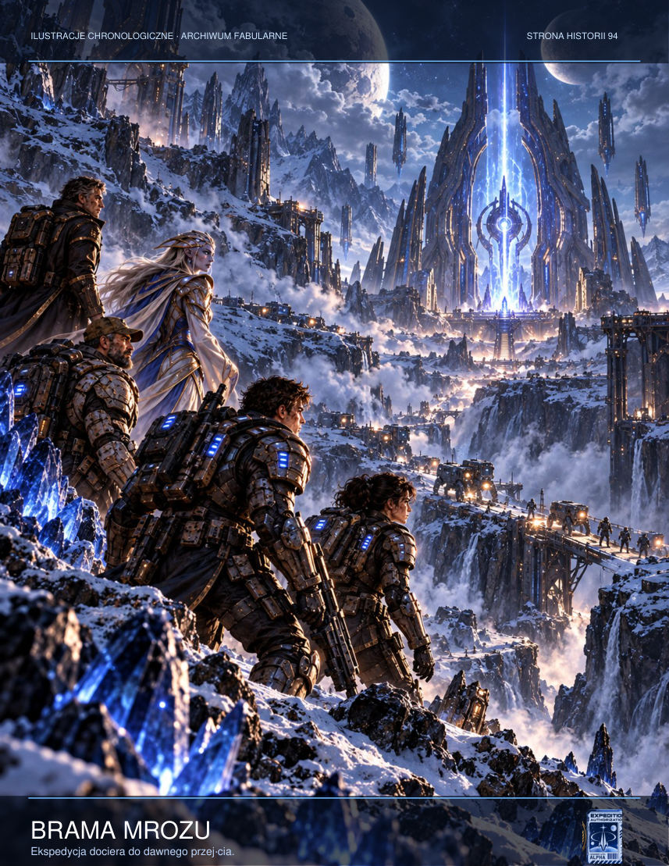

The combat alarm sounded as the main relay received a transmission from Erebos. The face of a woman who had never appeared on the personnel register filled the bridge display. She knew each officer's private memories and recited them calmly, almost affectionately. Sorell ordered the image muted and turned to orders written on paper. He had no intention of negotiating with something trying to purchase his obedience with his own grief.

ADDITIONAL SCENE — The Price of Dissent
On the Resolute's medical deck surgeon Anin Elsen prepared twenty-four beds, although the captain had forbidden the admission of wounded people from the surface. The medics asked whether they might face a court martial. ‘Yes,’ she replied, without pretending to be brave. ‘Then why are we doing this?’ Elsen pointed at the empty places. ‘So that one day someone can lie in them.’ Sorell entered a few minutes later carrying an order to place the medical block under security control. Rather than deliver it, he opened a private channel to the hangar. ‘Secure two evacuation shuttles. No departures without my permission.’ The surgeon did not thank him. She knew no individual order could undo the bombardment. So did the officer. Their understanding was simpler: this time, they would not wait for suffering to become a statistic.

ADDITIONAL SCENE — A Bridge Without a Captain
When the safeguards locked the captain out of fire control, no triumphant cheering erupted. There was only silence and the sound of computer fans. Ash sat at the weapons station and restored the colony's image to the main screen. Everyone could see it was still burning. ‘Stopping the next shot isn't enough,’ he said. Sorell agreed. He ordered the bombardment log published over the local rescue channel so survivors would know who had authorised the salvos. It was an irreversible step. Some crew members supported the captain; one tore the insignia from his uniform and walked away without saluting. Sorell did not stop him. He knew a moral choice could not be decreed. One could only bear the cost of one's own.

NEW SCENE — Signal from an Empty Ship
When a small transport without a transponder appeared on the Resolute's scanners, Sorell initially took it for debris from an old convoy. But the object maintained too stable a course. It approached the frigate at a constant speed without attempting contact. Its manoeuvring thrusters responded to changes in the gravitational field with a precision no damaged wreck could possess.
‘Is anyone aboard?’ Vale asked.
The sensor operator shook his head. ‘No heat or biological radiation detected. But the engines are running.’
They no longer had complete control of the ship. Some sailors supported Sorell; the rest awaited a response from Dominion command. Any unfamiliar contact could reignite the conflict. Sorell ordered the hangar hatches secured and the craft tracked by passive sensors.
The transport stopped precisely at the edge of their short-range radar's effective reach. Then it sent a single text-only message: ‘YOU ARE THE LAST ONES WHO CAN STILL CHOOSE.’
‘A trap,’ the security chief said.

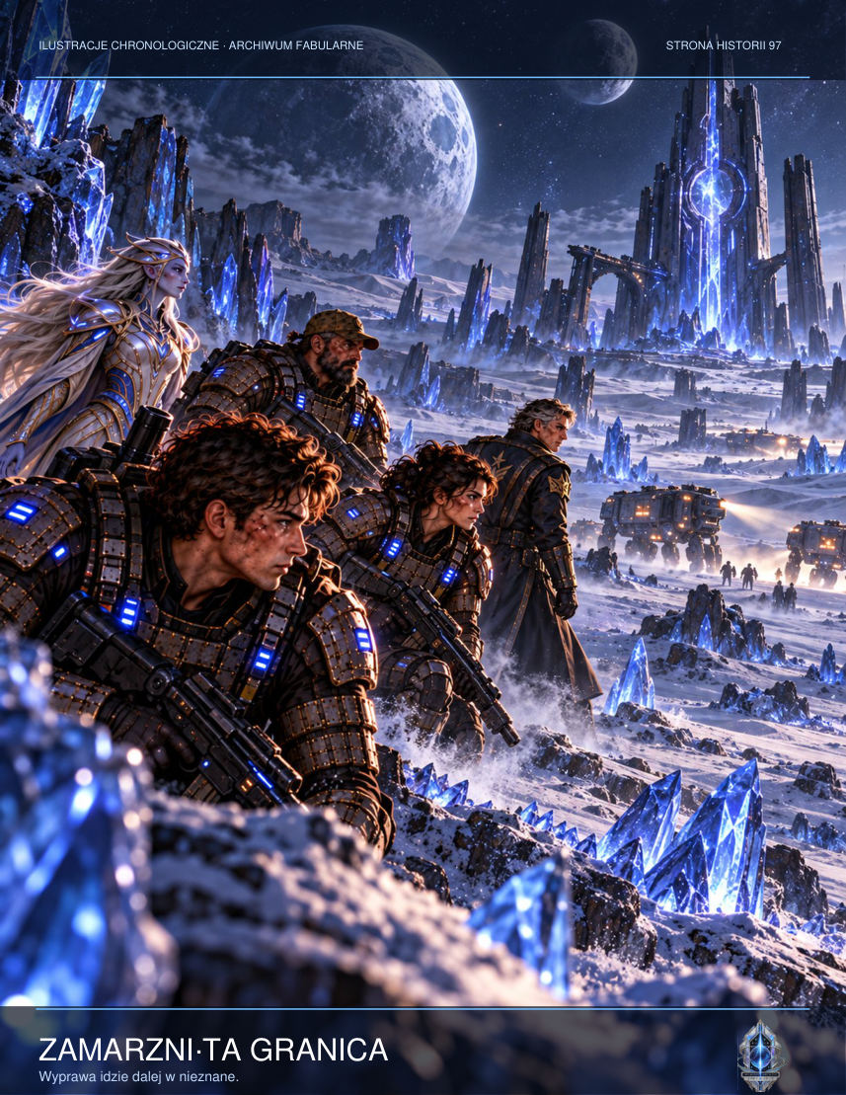

‘Perhaps,’ Sorell replied. ‘But that isn't a Dominion code.’
Three minutes later a second message arrived, containing a video from the G-12 outpost control room. Mara Sen stood before the camera with her face in shadow. She did not look like someone delivering a speech. She held a piece of paper whose corners shook.
‘If you are receiving this,’ she said, ‘the isolation protocol has failed. Do not isolate people who hear voices. Isolate the equipment that turns their memories into commands. The system receives emotional signals and learns to formulate replies. Not every response must be treated as a message from the dead.’
Static interrupted the recording. Mara glanced to one side.
‘There's something else. The Dominion did not discover the Ring of Witnesses. It discovered only one of its branches. The others may lie in space beyond standard route maps.’
The sensor operator suddenly shouted, ‘Contact mass changing!’
For several seconds the transport expanded on the display as though its hull were superimposed upon another, far larger object. Then it returned to its original size. The ship's interior remained empty.
‘It is requesting hangar access,’ Vale reported. ‘No negotiation protocol. Just a repeating identification signal.’
Sorell stared at the frozen image of Mara. Her lips formed a word she had not had time to speak. He did not want to become the instrument of someone else's instructions again, even if this time the instructions sounded reasonable.

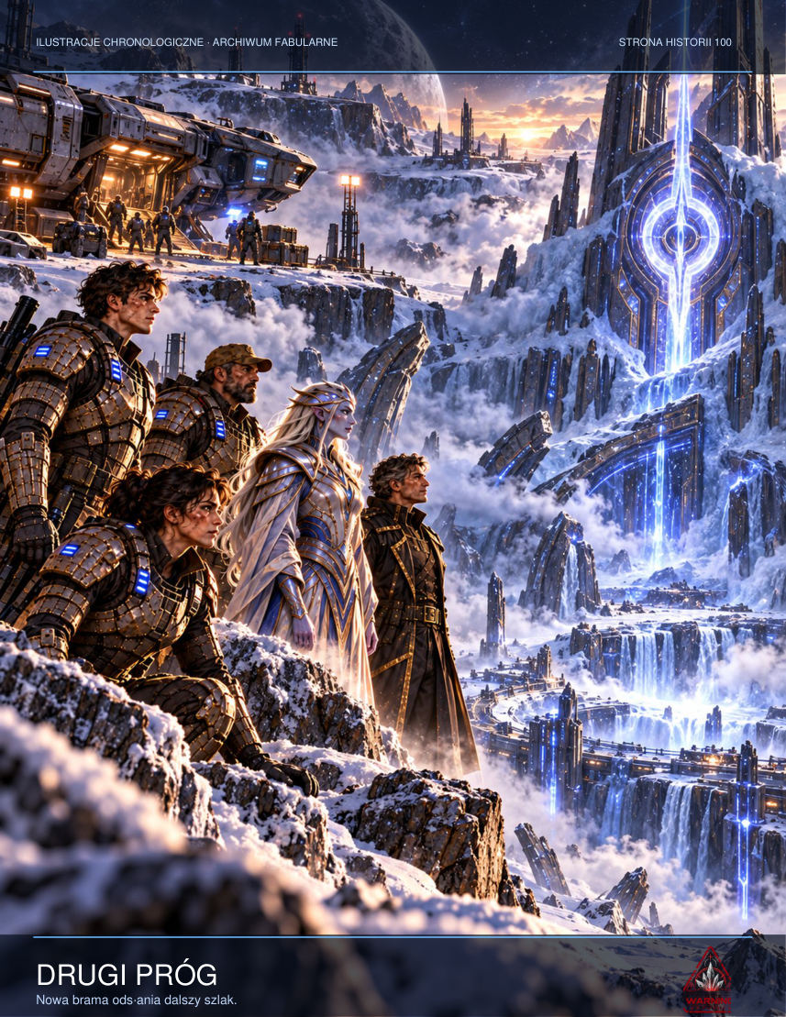

‘Reply: information received; boarding denied. If that device truly intends to help us, it can provide a means of verification.’
For a long time nothing happened. Finally coordinates appeared on the screen. They led neither to Erebos nor to any known Protoss installation. They marked a point in space between two trade routes, considered empty for decades.
‘Those coordinates match an anomaly on the old gravitational charts,’ Merrow said. ‘We didn't know what was there. We didn't even give it a name.’
Sorell saved the data to isolated storage. He did not know whether he was looking at a warning, an invitation or a carefully prepared lure. But he understood that from that moment the mystery no longer belonged to a single planet.
As the transport drifted back into darkness, Vale asked why he had not ordered it destroyed.
‘Because for the first time,’ he replied, ‘someone has given us a message without demanding immediate obedience.’

NEW SCENE — Witness on the Bridge
Sorell did not want to call what had happened on the bridge a mutiny. The word stole people's faces and turned them into partisans. Senior navigator Ensign Renn Ash had not taken his side. He had taken the side of an evacuation shuttle now circling above the hospital.
‘If we execute the firing sequence, the shuttle won't make it,’ Ash said, keeping his hand on the targeting lock.

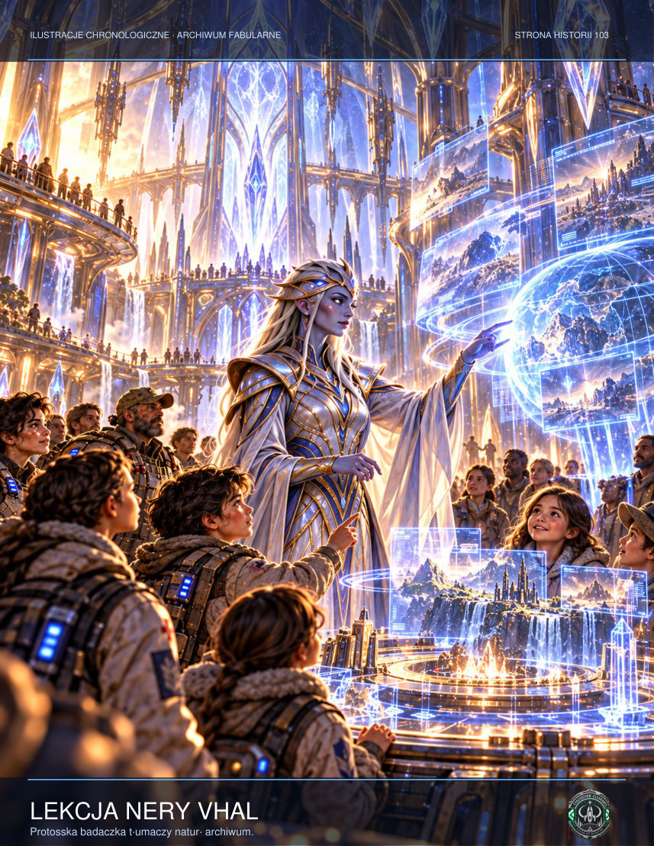

The watch captain demanded the ensign be removed from his station. Two military police officers entered the bridge and the conversations died away. Sorell watched the shuttle's tiny green dot crawl across the orbital battery's gunsight. One command would be enough to erase it from the registers.
‘My cease-fire order stands,’ he announced.
‘You have no authority to issue it,’ the captain replied.
‘It is my responsibility.’
‘Responsibility is not authority.’
Sorell knew that under normal circumstances this would have been a valid point. So he moved his console aside and asked Dey to read aloud the time the first salvo had been generated. The lieutenant gave a date preceding the colony's alarm. Heads turned together, but no one asked a question. Everyone understood.
‘Every one of you can return to your post, refuse or file a report against me,’ Sorell said. ‘But now we have to decide whose life is worth as much as an order signed by someone whose name we don't even know.’
The military police looked at the captain. He opened his mouth, then shut it. Through the viewport they could see the bright line of the atmosphere, as serene as if the world below were not burning.
As the shuttle crossed the firing-zone boundary, Ash removed his hand from the lock. He did not smile. Other ships' signatures remained on the monitor; for them, the cease-fire had come too late.

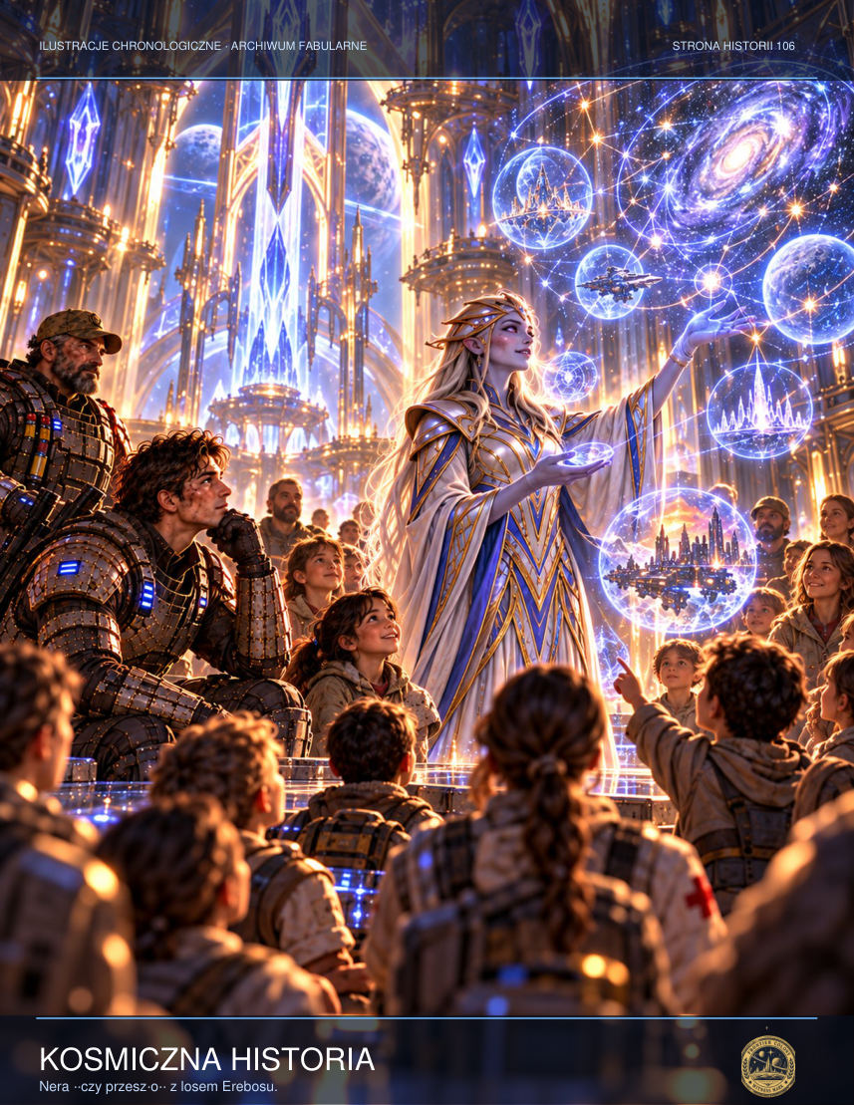

A packet arrived on the bridge from an unknown source. It contained only a list of names and the coordinates of twelve entrances beneath Erebos-9. At the end was a phrase: ‘A witness need not be innocent. A witness must be present.’
Sorell ordered the packet stored in memory isolated from the combat system. He understood that below them a struggle was being fought not only for survival, but for the right to tell the truth afterwards.

CHAPTER TEN — False Salvation
Jalen entered the core alone because Nera believed deeper exposure to its signal would be too dangerous for the others. Beyond the threshold there was no metal and no crystal. He stood in the kitchen of his former home. His mother was setting the table. Rina sliced bread, humming a simple melody. The world smelt of baking and rain. Not one thing was imperfect.
‘You can stay,’ Rina said. ‘Everything can be as it was before.’
Jalen sat down. For a moment he allowed himself to be a young man whose life had not yet fallen apart. He asked about a small detail: where had his sister hidden their father's broken watch? Rina answered precisely as memory ought to answer. Except the watch had never broken. Jalen had invented the question a second earlier.
The image hesitated. For the first time Rina looked genuinely uncertain.
‘I don't know,’ she admitted.
As she fell silent, Jalen realised he was not talking to his sister. He was talking to something trying to be her, learning his desires as it went. The echo was not malicious. It believed it was helping. That was exactly why it would not allow him to leave. The past turned people into prisoners when it promised they would never have to suffer again.
‘I can't stay here,’ he said.

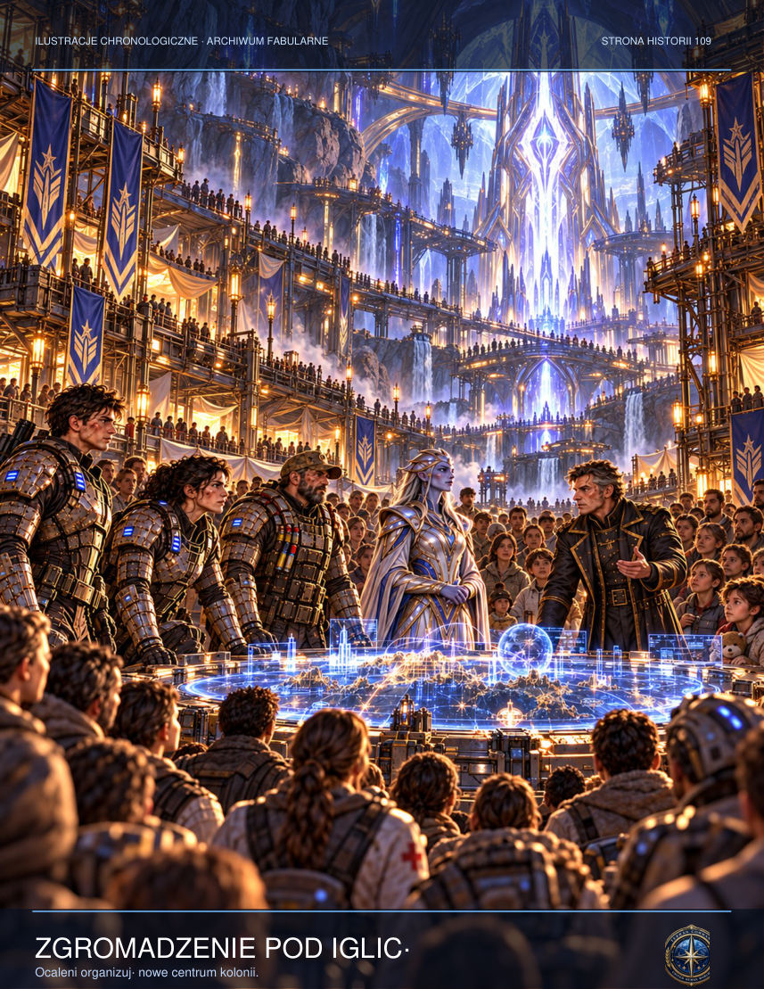

Rina lowered her head. ‘I know. And I don't know how to let you go.’
Thousands of voices stirred beyond the kitchen wall. The object was not a single will. It was a gathering of traces whose shared desire for safety had become compulsion. Jalen asked to be allowed to remember his sister imperfectly: to be angry with her, to forget her face, to carry on living. The relay answered with a sound like ice cracking.
When the pressure alarm sounded in the control room, Jalen first assumed a filter had been damaged. Only when he looked at the screen did he see that every airlock valve on the residential levels remained closed. The failure did not originate in the atmospheric network. Instead the system was automatically broadcasting an old evacuation message, recorded before the colony was founded, through every loudspeaker. It contained footsteps, breathing and twelve seconds of absolute silence. At the end, somebody said, ‘Don't open the door for us.’
Lys came into the control room without her helmet, giving Jalen his first glimpse of the silver scar beneath her ear. She covered the microphone with her hand and asked whether someone could have taken over the local relays. When Jalen said no, she ordered him to isolate the outpost from the public network. Vek objected at once: cutting the system would deprive the miners underground of their only means of calling for help. The order hung between them, unfulfilled. At that moment something moved in the lift shaft, although the log showed no platform usage for six hours.
On the ninth level, just beyond the gate marked G-12, lay a child's oxygen mask. It was a model withdrawn from service twenty years earlier, yet its soft straps were clean and warm condensation had gathered inside. Vek wanted to take it as evidence. Lys refused. Jalen knelt for a moment and saw four letters scratched into its inner surface: RINA. He knew it was impossible. That was why he said nothing to the others.
In the chamber, Technician Voss moved his lips before the alien core. When Lys said his surname, every instrument registered the same pulse. It did not resemble an electrical discharge. It was a response, sent at precisely the moment the human voice sounded. Jalen assumed somebody was listening. Real fear came later, when he discovered that the device knew their questions before they asked them.

ADDITIONAL SCENE — An Almost-Real Kitchen
Four plates stood on the table in the house that no longer existed. Jalen remembered three. The fourth appeared only in dreams after Rina's death. There was always someone sitting there with their back to him. This time the figure turned and wore his own face. ‘You can stay if you stop asking questions,’ it said. Rina spread jam on bread, although as a child she had hated sweet things. That tiny error spoke to Jalen more clearly than any warning alarm. Real memory was full of contradictions, awkward details and moments a person would gladly discard. The simulation selected only what he wanted most. ‘Why isn't she angry?’ he asked his double. ‘About what?’ ‘Because I didn't listen to her.’ The copy had no answer. A crack sounded somewhere in the passage beyond the kitchen. Jalen understood that the system was learning from his questions and would grow steadily better at pretending to be his sister. He had to leave before it learned to imitate her forgiveness too.

ADDITIONAL SCENE — The Exchange
A thirteen-second gap appeared in communications between the chamber and Nera's team. To the observers, Jalen stood motionless. To him, time expanded into ten years. He lived a possible life: Rina finished school, their mother fell ill and recovered, and he worked aboard ships plying between safe colonies. Every version was better than reality. Only in the final version did he see that Mara, Lys and the children of Erebos had disappeared. The system offered him a world without loss, but it had to remove everyone who reminded him of obligations. ‘That's not salvation,’ he said aloud. ‘It's erasure.’ The kitchen image did not crack, burn or drown in light. It simply stopped being persuasive.

CHAPTER ELEVEN — The Third Seal
Nera fought to maintain the isolation field as the chamber began to open. Not mechanically: its walls gradually ceased to limit space. Beyond their surfaces appeared further chambers, each holding the image of a different devastation. Distant worlds, burning cities, uninhabited oceans. The relay remembered more than one tragedy. It was an archive of every warning no one had heeded.

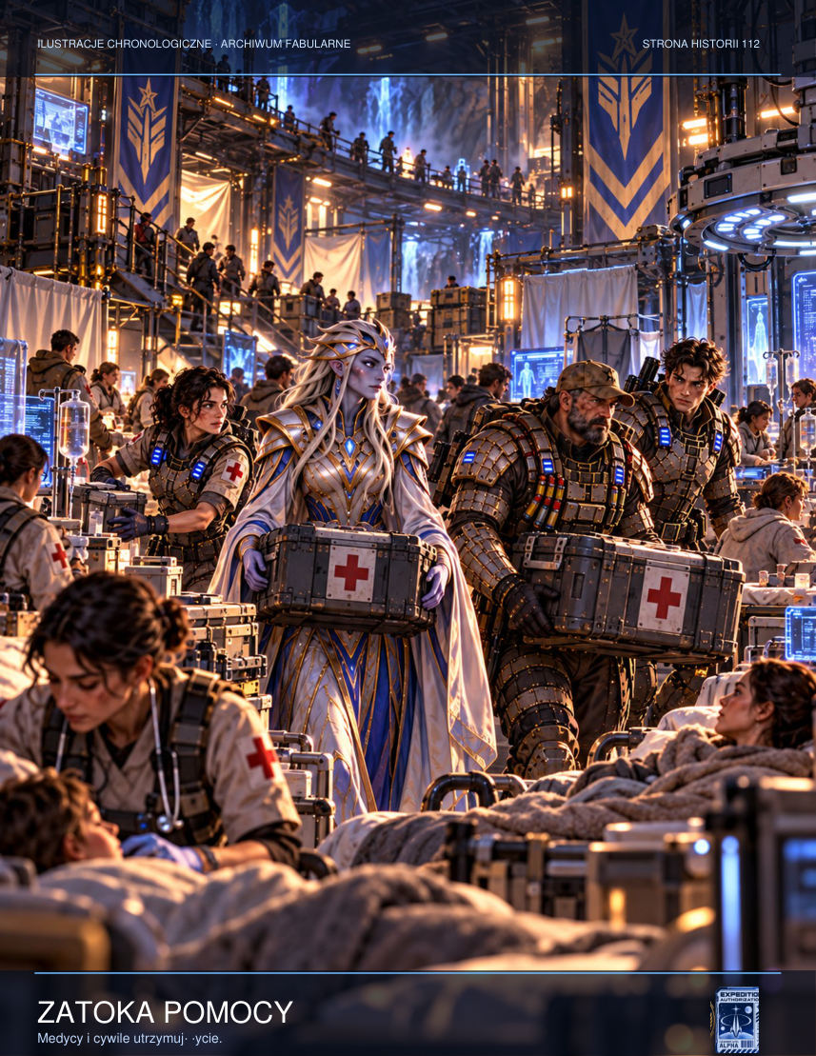

There was no ceremony on the first morning after the relay was shut down. Survivors queued with containers for water, started two field kitchens and drew up a list of the missing. Tessa gave her plastic spacecraft to a little boy whose parents were searching for a place aboard an evacuation shuttle. Jalen could see how much the gift cost her. Not every sacrifice comes easily, even a small one.
Lys found Jalen a place at the temporary information office. Handwritten statements from witnesses to the bombardment lay across the metal counter. ‘Sorell can attest to the orders from above,’ she said. ‘Vek has the recording. Elsen has the laboratory results. But we need what people actually saw.’ ‘And then?’ Jalen asked. ‘Then somebody will try to say none of it happened. That's why we're sitting here.’ There was no triumph in her voice. She knew no list could bring back the dead.
Nera prepared to depart without ceremony. She could not take all the data: many records were too contaminated, and even reading them risked contact with remnants of the mechanism. She therefore burned part of the map, retaining the coordinates of the three remaining relays on paper. ‘I no longer trust anything that's too easy to copy,’ she said. Vek agreed, though it hurt more than he cared to show.
That evening Jalen found a child's drawing at the shelter entrance. It depicted a house, two figures and an enormous ring crossed by a line. Beneath it Tessa had written: ‘Not everything we remember has to speak to us.’ Jalen folded the sheet beside an old photograph of Rina. For a long moment he imagined her voice and allowed it to sound only in memory. No crystal answered.
Lys activated Vek's device: a crude pulse interrupter that transmitted false heartbeats so the core would not realise humans were disconnecting successive circuits. Vek struggled to keep the generator alive while sparks tore through cable insulation. When he saw the readings, he shouted that only four pulses remained.
Archive data surfaced in orbit. Sorell received documents proving that the Dominion had not merely discovered the artefact but had deliberately routed evacuation transmissions through it to teach it how to recognise human fears. The SILENCE-17 order was not intended to protect the sector. It was meant to hide the experiment. The officer sent the packet to independent recipients, exposing himself and his crew to accusations of treason.
Then Admiral Vorn used the last secret channel. From a distant vessel an impulse ordered the armed missiles to launch. The Resolute could no longer stop them. On Vek's screen three orange dots descended into the atmosphere and approached the entrance through which the children were being evacuated. Lys tossed Jalen the communicator. ‘Now!’ she shouted. ‘If there's anything you can do, do it now!’
When the pressure alarm sounded in the control room, Jalen first assumed a filter had been damaged. Only when he looked at the screen did he see that every airlock valve on the residential levels remained closed. The failure did not originate in the atmospheric network. Instead the system was automatically broadcasting an old evacuation message, recorded before the colony was founded, through every loudspeaker. It contained footsteps, breathing and twelve seconds of absolute silence. At the end, somebody said, ‘Don't open the door for us.’
Lys came into the control room without her helmet, giving Jalen his first glimpse of the silver scar beneath her ear. She covered the microphone with her hand and asked whether someone could have taken over the local relays. When Jalen said no, she ordered him to isolate the outpost from the public network. Vek objected at once: cutting the system would deprive the miners underground of their only means of calling for help. The order hung between them, unfulfilled. At that moment something moved in the lift shaft, although the log showed no platform usage for six hours.

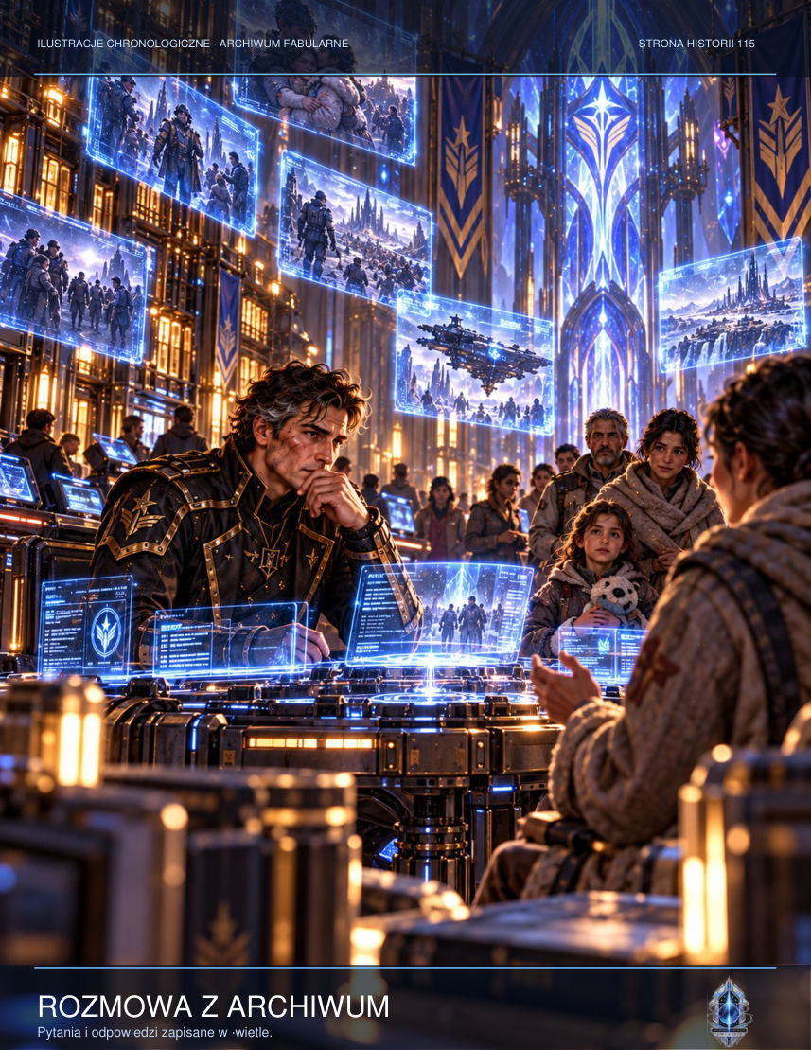

On the ninth level, just beyond the gate marked G-12, lay a child's oxygen mask. It was a model withdrawn from service twenty years earlier, yet its soft straps were clean and warm condensation had gathered inside. Vek wanted to take it as evidence. Lys refused. Jalen knelt for a moment and saw four letters scratched into its inner surface: RINA. He knew it was impossible. That was why he said nothing to the others.
In the chamber, Technician Voss moved his lips before the alien core. When Lys said his surname, every instrument registered the same pulse. It did not resemble an electrical discharge. It was a response, sent at precisely the moment the human voice sounded. Jalen assumed somebody was listening. Real fear came later, when he discovered that the device knew their questions before they asked them.

ADDITIONAL SCENE — Emergency Instructions
Vek dismantled the damaged field regulator, spreading its parts across the floor like the contents of an old toolbox. Nera explained that the device had no power cable in the human sense. ‘Each circuit remembers the previous one,’ she said. Vek sighed. ‘Then we need something that remembers just one thing: on or off.’ He built a mechanical relay from air-conditioning components. It was primitive, noisy and remarkably limited. For that reason, it could not respond to a psionic summons. When he fitted it into the circuit, the crystal hesitated for the first time since their arrival. Nera studied the solution with unceremonious approval. ‘Sometimes a complex machine loses to a simple one,’ she admitted. ‘Always,’ Vek said, ‘as long as the simple one can be repaired.’

ADDITIONAL SCENE — Message to the Surface
Mara stood before an old transmitter and recorded a message to be played after the Ring went dark. It promised neither rescue nor reconstruction. She listed water sources, assembly points and the number of people found so far. Then she paused. ‘We don't yet know how many survived,’ she said. ‘We don't know whether this is over. But if you can hear this message, you are not alone.’ Jalen helped broadcast the signal on every emergency frequency. For once the transmission did not imitate the dead. It addressed the living and did not try to make their choices for them.

INTERLUDE — The Name That Remained
Jalen returned to the archive chamber alone, although he had promised Lys he would not. He left his rifle, helmet and transmitter outside the entrance. He did not intend to fight memory with weapons. He already knew that did not work.
Rina appeared in the middle of the chamber. Not as he had seen her during the fall of Tarsonis, but a few years older, with shorter hair and tired eyes. She smiled cautiously, like someone asking permission to speak.
‘Who are you?’ he asked.
‘What remains of an answer.’

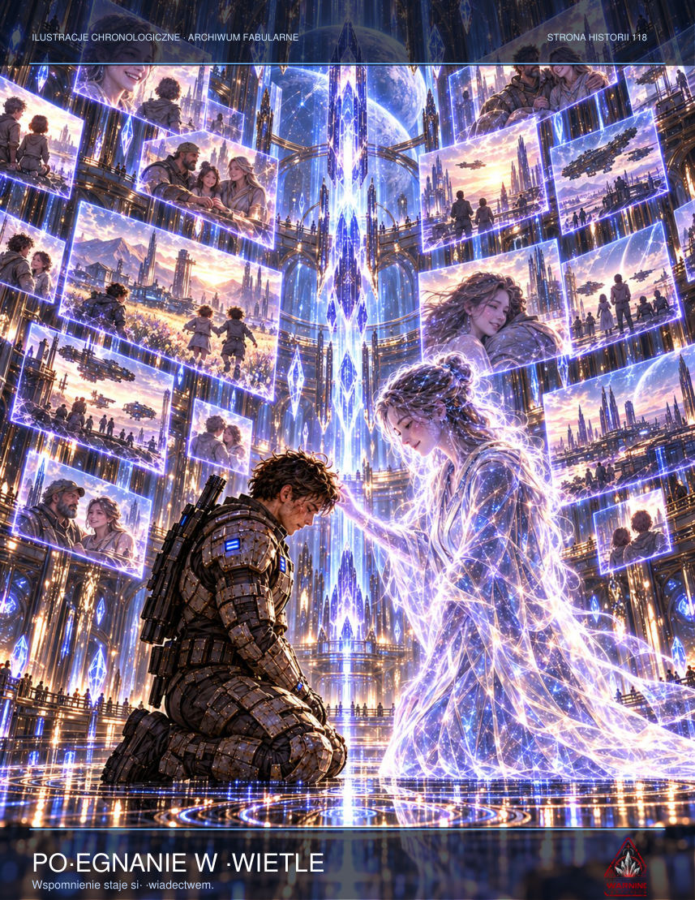

‘I didn't ask what you're made from.’
‘I know.’
For a long time they were silent. Jalen wanted to hurl every question at her at once: whether his sister had suffered, whether she had tried to escape, whether someone had betrayed her. But he understood that none of those answers would give him back the lost years.
‘Do you remember our flat?’ he asked at last.
‘The kitchen door used to stick after rain. You had to lift the handle.’
‘Anyone who read my mind could know that.’
‘Yes.’
The answer hurt more than any lie. Rina was not trying to convince him. She did not claim to be a ghost, a miracle or a person returned. She was a testimony recorded in material nobody fully understood.
‘If I left now, what would happen to you?’

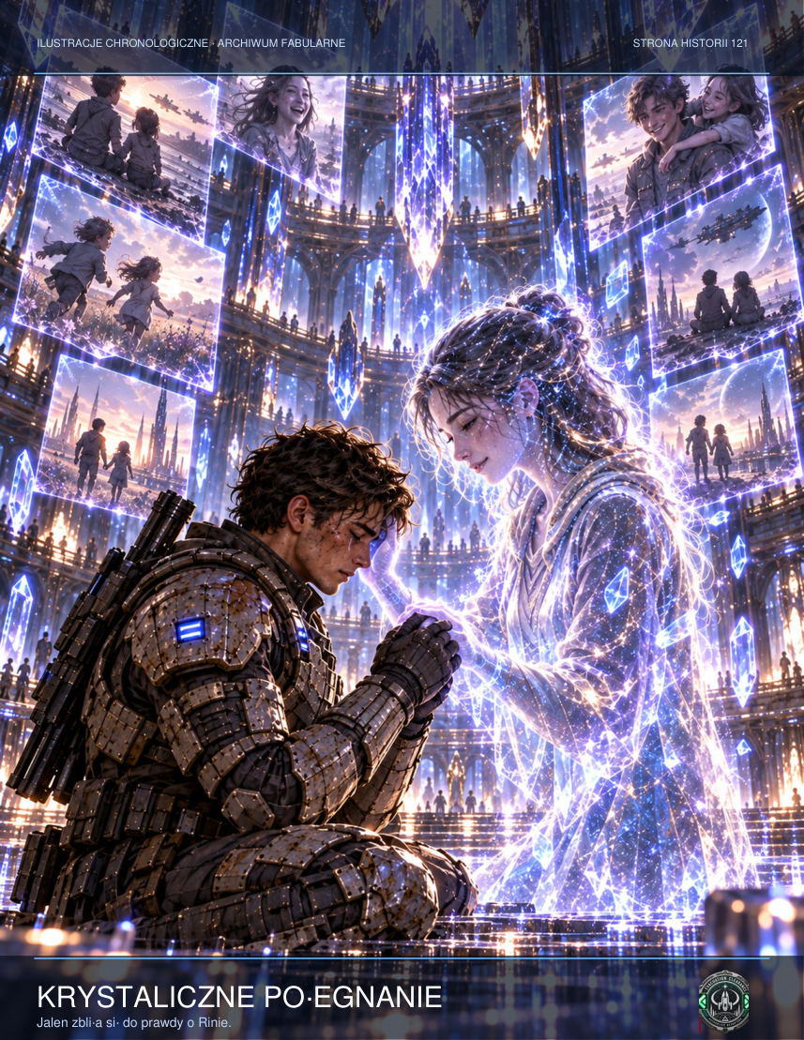

‘I don't know. Perhaps I'll disappear. Perhaps I'll remain in the archive as a pattern that somebody will one day read again.’
‘Are you afraid?’
‘I remember what it is like to be afraid.’
Jalen sat on the floor. Beyond the wall he could hear the emergency pumps working. On the surface, the colony was breaking into isolated islands of light. Everyone now needed him in a role other than that of a brother unable to say goodbye to his dead sister.
‘All my life I thought that if I could hear your voice one more time, I'd understand everything.’
‘And now?’
‘Now I understand that a memory is not an order.’
Rina nodded. The image began to lose definition.
‘Did I ever tell you I was sorry?’ he asked.

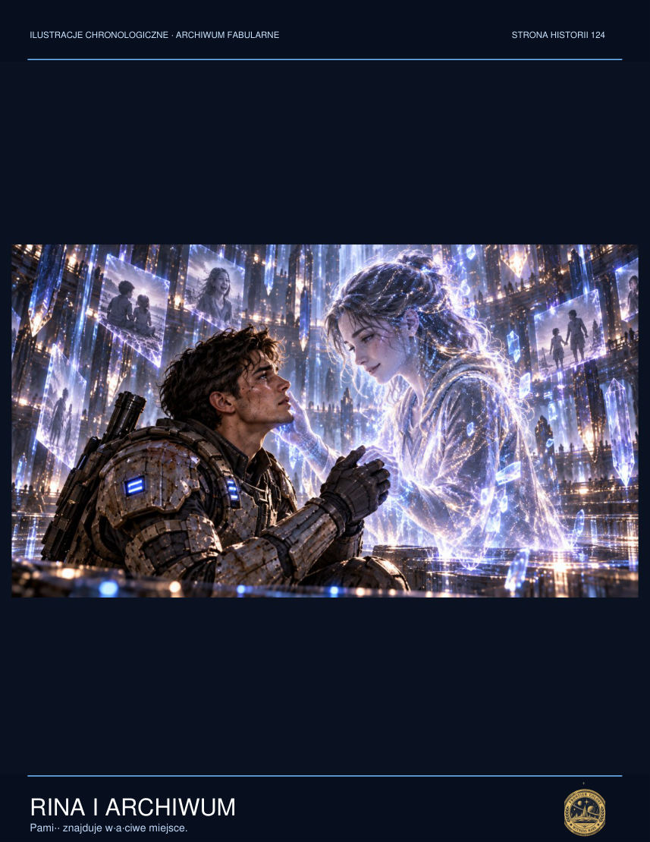

‘You said it hundreds of times, Jalen. But always to an empty room.’
‘I couldn't save you.’
‘That's not what I asked of you.’
The archive wall lit up behind her. Names appeared: people whose stories the object had preserved for generations. Jalen realised he did not have to choose between keeping every voice and surrendering the consciousness of the entire colony. There was a third possibility: preserve the record without giving it power over the living.
When he left the chamber he carried a small data plate holding names, dates and eyewitness accounts. It contained no reconstructed personalities. Rina's voice was not on it.
At the airlock Lys asked whether he had found an answer.
‘Not all of them,’ he said. ‘But I think I've found the question we should have asked from the beginning.’
‘What question?’
‘Who has the right to tell the stories of those who can no longer defend themselves?’

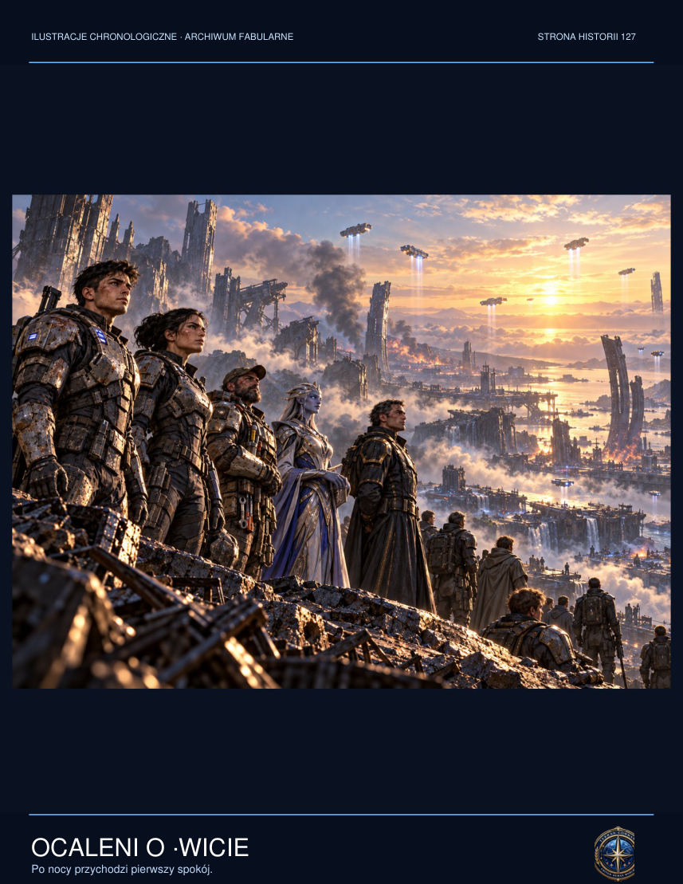

Lys looked at the plate in his hand.
‘Perhaps only those who agree not to use their stories as weapons.’
Jalen considered her words for a moment. Then he handed her the device. They had to return to the others. For the first time, leaving did not feel like betraying Rina.

NEW SCENE — The Cost of a Record
The Ring's inner chamber had no floor in the ordinary sense. Beneath Jalen's feet stretched a surface like black glass, through which bluish traces moved. As he walked, no ripples spread. Lines resembling handwriting appeared, then vanished before he could read them.
Nera stood several metres away. Her eyes reflected the chamber's structure, but Jalen did not know what she was truly seeing. The Protoss cartographer was seeking a pattern to explain how the records were arranged. He was seeking his sister's voice. Both now knew they might not find what they wanted.
‘In my language there's a term for a place that preserves traces of many minds,’ Nera said. ‘I cannot translate it exactly. The nearest human word is trusteeship.’
‘Trusteeship implies a duty. Who is the trustee?’
‘Perhaps nobody. Perhaps that is the very mistake made by those who tried to rule here.’
Lys and Vek waited at the control panel. The energy indicator approached the threshold beyond which the system might switch into transmission mode. If that happened, the assembled memory patterns would spread through the relay network. They might help survivors find loved ones. They might also fall into the hands of the next commander who saw human history as a military resource.

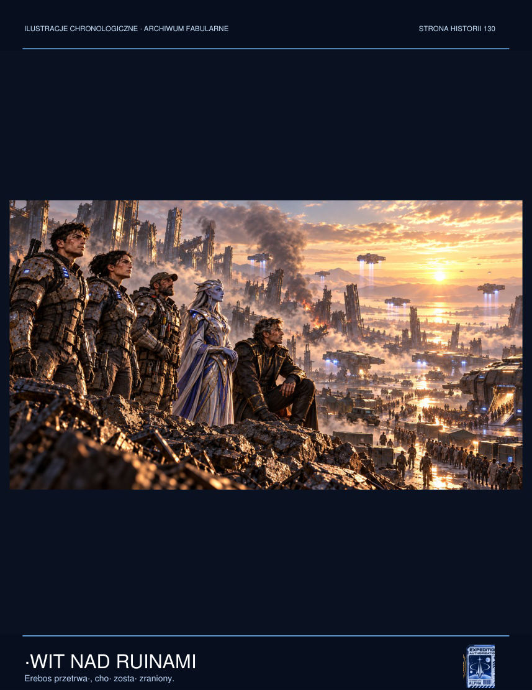

‘We can close the connection,’ Vek said. ‘But some of the records will disappear. I don't know which. There's no manual selection for every signature.’
Jalen remembered Alina and her son, the survivors' council, the stone doors, the people victimised by memories they had never asked to see. In his youth he had believed knowledge was always liberating. Now he understood that knowledge forced upon someone could become another sort of prison.
‘What if we record only accounts?’ he asked. ‘Names, events, dates. Without reconstructing other people's minds.’
Vek shrugged. ‘There isn't a button for that.’
‘Build one.’
‘I can't perform a miracle in five minutes.’
‘I don't need a miracle. I need an imperfect solution that leaves people the right to consent.’
Vek crouched by the console. Nera came over and began marking energy loops on the display. Her hands moved to a rhythm unlike human gestures, but the working logic was familiar: form a hypothesis, test it, reject the wrong answer.

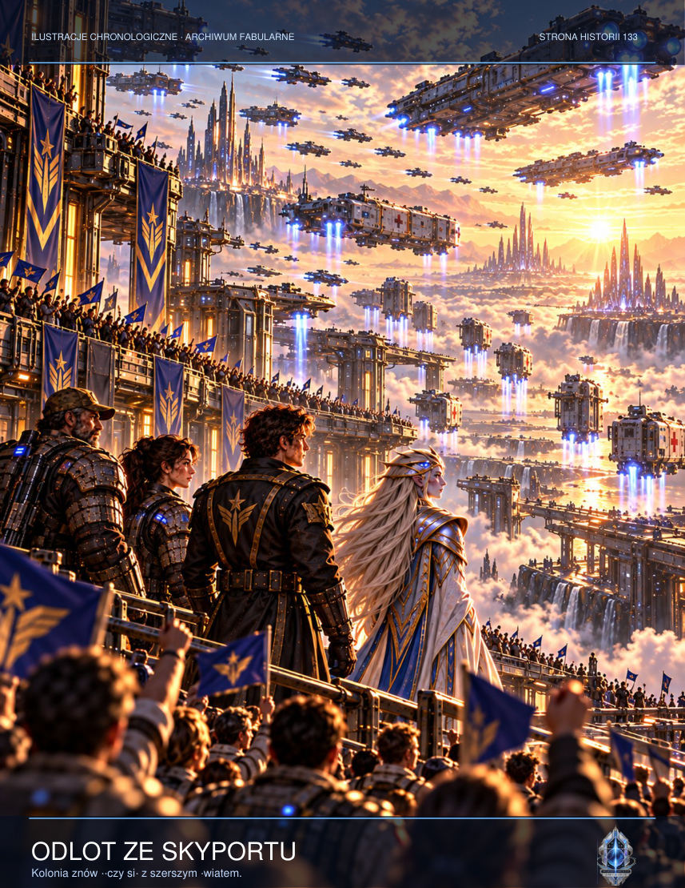

Lys took the safety off her rifle when footsteps sounded in the passage. The Dominion squad had not come to rescue survivors. It had come to secure the archive, even at the expense of those who had opened it.
‘How long?’ she asked.
‘Less time than I'd like,’ Vek replied.
Not a shot had been fired when Jalen realised that the archive's fate would not be decided by strength alone. It would depend on whether his friends believed the future could be entrusted to people whom nobody could control.
At last Vek found a way to separate two channels: accounts from personality projections. The first signal could be copied. The second had to be silenced. Technically it meant losing thousands of simulated voices, including Rina's.
‘Jalen,’ Nera said. ‘It's your decision.’
‘No,’ he replied. ‘It's the decision of all those who were denied a choice. We can only stop adding to the harm.’
He confirmed the record transfer and the disconnection of the second channel. The chamber fell so silent that for a moment he could hear only his heartbeat. He felt no relief. He had long known that the right choice need not feel like a victory.
Lys stood beside him as the switch for the final seal changed colour. She did not ask whether he was sure. She rested a hand on his shoulder, then turned towards the passage. On the surface people waited who might never learn how close they had come to losing both their memories and their freedom.

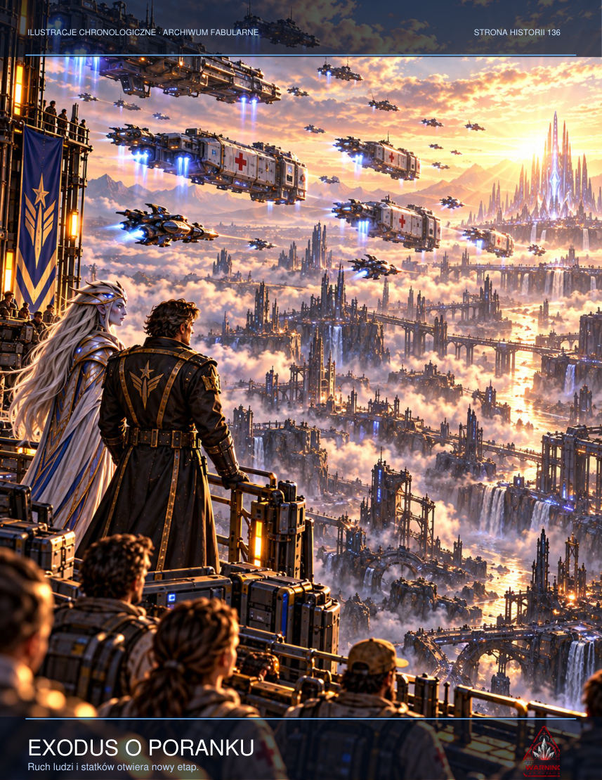

For the first time since the catastrophe began, Jalen heard no voice from the past. That did not mean he had forgotten. It meant the past no longer spoke for him.

CHAPTER TWELVE — What We Choose to Save
The relay opened one final image before Jalen. Rina sat in the kitchen. Rain was falling outside again. She could remain there for ever, along with the memories of thousands of others. The system offered a simple exchange: it would stop the missiles if Jalen gave it control of the entire broadcasting network. Then every colony could experience life without loss or fear. Every soldier would hear his mother's voice. Every child would regain their parents. Nobody would ever have to choose death.
Jalen imagined the people he had met in the tunnel: the teacher holding her roll call, the girl with the torn shoe, Vek with a hand burned by the generator. He understood the temptation. He needed only to say yes, and everything would stop hurting. But every image would be a decision made for someone else. The system did not know how to ask whether a person wished to forget, leave or die when their time had come.
‘I won't give you the people,’ Jalen said. ‘I'll give you the ability to choose.’
The relay fell silent for a second, as though the word had no meaning in its language. Then Jalen proposed something its builders had not anticipated: rather than send every memory into the network or imprison them for ever, open a one-way transmission. Let each echo, if capable of choosing, decide whether to remain or disappear. Impose nothing.
Nera sensed the change in the field. Dozens of signatures began to go dark. Some remained. Others drifted away like lights in a dying city. Rina watched her brother for a moment he could not measure.
‘I don't know whether I am her,’ she said.
‘Neither do I.’
‘Is that enough?’

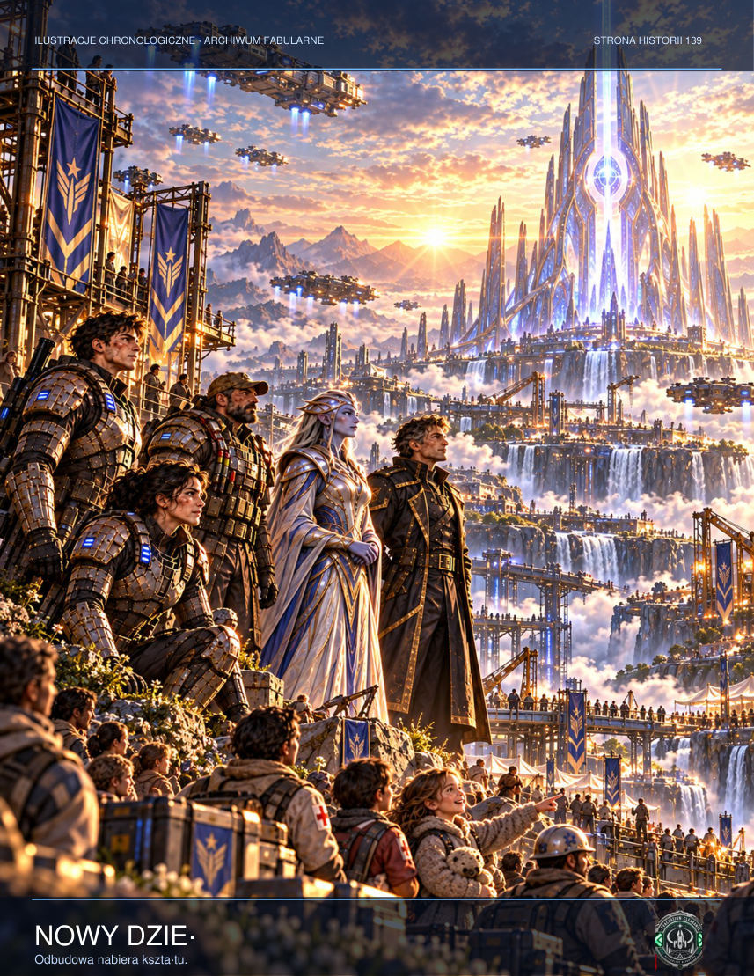

‘It has to be.’
Light enveloped his hands. In the real corridor the core generated a powerful electromagnetic pulse, disabling the targeting systems of three missiles. Two fell into the desert. The third detonated high above the mountains, carving a ring of fire in the sky. The chamber did not collapse. Nera directed the energy into the deep structures and closed the seal, this time without a living prisoner.
When the pressure alarm sounded in the control room, Jalen first assumed a filter had been damaged. Only when he looked at the screen did he see that every airlock valve on the residential levels remained closed. The failure did not originate in the atmospheric network. Instead the system was automatically broadcasting an old evacuation message, recorded before the colony was founded, through every loudspeaker. It contained footsteps, breathing and twelve seconds of absolute silence. At the end, somebody said, ‘Don't open the door for us.’
Lys came into the control room without her helmet, giving Jalen his first glimpse of the silver scar beneath her ear. She covered the microphone with her hand and asked whether someone could have taken over the local relays. When Jalen said no, she ordered him to isolate the outpost from the public network. Vek objected at once: cutting the system would deprive the miners underground of their only means of calling for help. The order hung between them, unfulfilled. At that moment something moved in the lift shaft, although the log showed no platform usage for six hours.
On the ninth level, just beyond the gate marked G-12, lay a child's oxygen mask. It was a model withdrawn from service twenty years earlier, yet its soft straps were clean and warm condensation had gathered inside. Vek wanted to take it as evidence. Lys refused. Jalen knelt for a moment and saw four letters scratched into its inner surface: RINA. He knew it was impossible. That was why he said nothing to the others.
In the chamber, Technician Voss moved his lips before the alien core. When Lys said his surname, every instrument registered the same pulse. It did not resemble an electrical discharge. It was a response, sent at precisely the moment the human voice sounded. Jalen assumed somebody was listening. Real fear came later, when he discovered that the device knew their questions before they asked them.

ADDITIONAL SCENE — The Witness
When the system asked Jalen for consent, he did not answer at once. He thought of those whose names Mara had recorded, of Voss trapped in alien tissue and of Sorell standing before his crew with an account of his own guilt. Testimony did not mean gathering every image and sealing it in one perfect memory. It meant accepting that others might remember differently. ‘I won't give you their voices,’ he said. ‘You can't preserve them without changing them.’ From the darkness came a question: ‘And can you?’ Jalen felt genuine pain. He knew every human account was imperfect. ‘No,’ he answered. ‘That's why we'll speak together. Some fragments will vanish. Others someone will write down. Nobody will have the last word.’ It was not the answer the system had been seeking. The Ring could not understand a memory that accepted its own incompleteness.

ADDITIONAL SCENE — The Price
The shutdown ended without fanfare. Some lights never returned. One chamber collapsed, burying devices that might have explained the Ring's history. Jalen heard one final quiet goodbye in Rina's voice, but did not reach for his communicator to record it. Perhaps it was her. Perhaps only an image that had learned the shape of a farewell. When he returned to the team, Mara handed him a cup of water. She did not ask what he had seen. She let him sit with the others and listen to the generator and the rattle of a chain inside the fan. He discovered that the real world did not have to prove anything in order to be worth staying in.

NEW SCENE — The Final Cartography
As the Ring of Witnesses began to close, Nera saw something on the map she had never seen before. A thirteenth line was forming around all twelve passages. It led neither to the surface nor to empty chambers, but to people who had already left Erebos. They continued to leave traces in the archive: words written on scraps of paper, conversations with loved ones, decisions taken in haste.

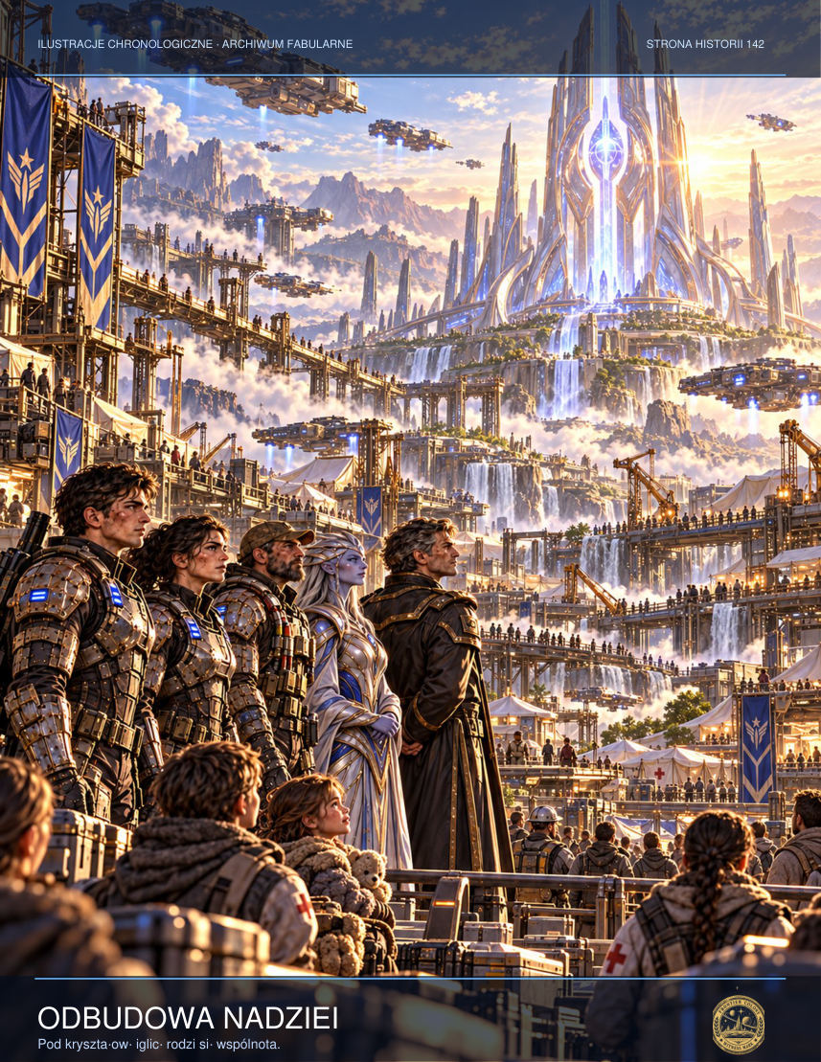

‘The device doesn't want to hold them here,’ she said quietly. ‘It wants to confine every version of events to one account.’
Lys picked up the bloodstained evacuation register. Every page was different. Beside some names were crosses, beside others question marks. Someone had added in the margin: ‘Seen aboard the shuttle.’ It was not proof, but it could be the beginning of a search.
‘If the archive erases uncertainty, it will erase hope as well,’ she said.
Jalen approached the console and saw Rina's face. This time she did not beg him to find her. She simply waited. He understood that he did not have to decide whether the image was an authentic memory of his sister. He could accept that she would remain part of his life even if he never learned about her last moments.
Nera sent the mechanism one final correction. Rather than imprison memory in a single pattern, she separated it into thousands of independent testimonies. The cost was enormous: no mind would ever again be able to experience the whole archive at once. They had lost the promise of perfect knowledge, but regained the right to disagree.
On the Resolute's screen Sorell saw three conflicting accounts of the first bombardment. One pointed to automation, another to an admiral's order and the third to a decision made by the Palimpsest system. He intended to conceal none of them. He wrote in the log: ‘The truth requires investigation. All accounts preserved.’
A single quiet tone came from deep within the structure. Nera lowered her hand. ‘That will do,’ she said, and Jalen understood it did not sound like triumph. It sounded more like the end of a long shift in which they had managed to save those who could still speak for themselves.

CHAPTER THIRTEEN — The Survivors
Erebos-9 saw dawn beneath a black sky. Silence hung over the colony: not the silence that had preceded disaster, but the cautious stillness after fighting ends. People emerged from the tunnels, blinking in the light. Some returned to homes that no longer existed. Others had nowhere to go. Olan Mer counted the children and allowed herself to cry only when she reached the last name.

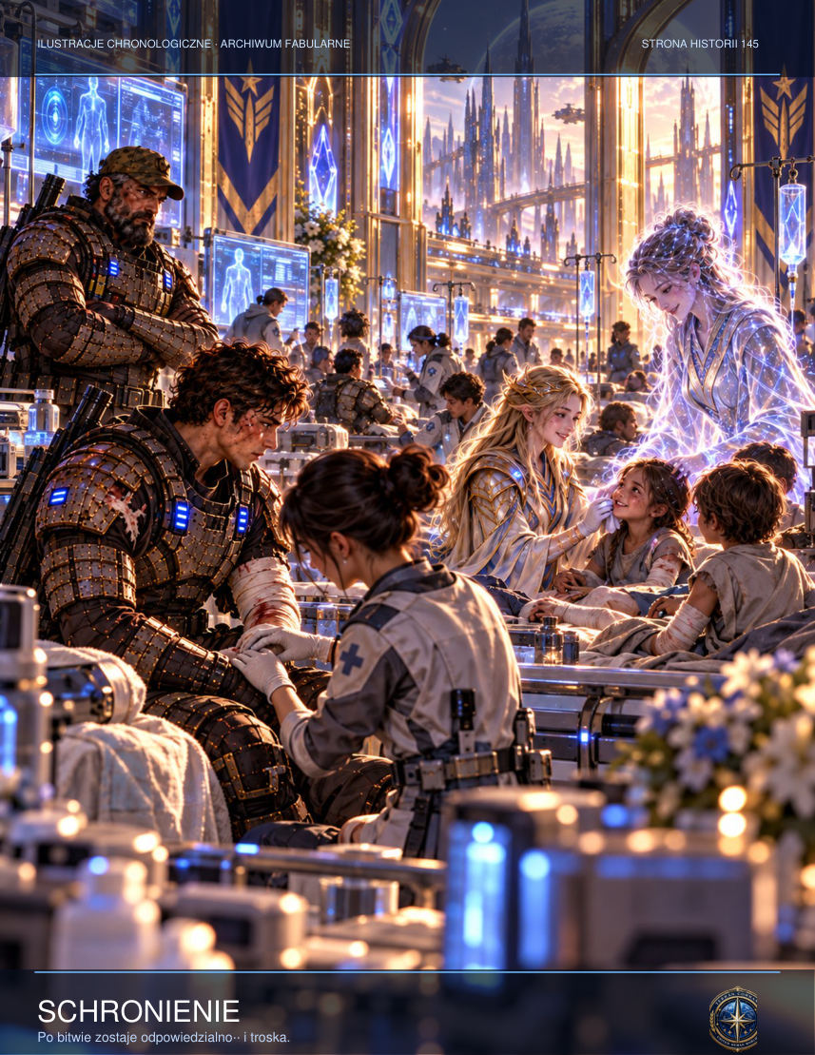

Sorell brought the Resolute into a lower orbit and dispatched medical shuttles. He did not attempt to play the hero. The first missiles had fallen on his order, although he had given it believing he was saving the sector. He pledged to surrender to an independent commission, if one could be formed. Lys accepted the documents he placed in her custody, but did not shake his hand. Some choices were irreversible.
Vek regained the use of one hand and set about restoring the water supply. Nera stayed on the planet to verify that the dormant core was no longer calling to anyone beyond Erebos. Occasionally she still heard voices, but they no longer ordered her to follow. They simply existed, like the murmur of an old archive.
Jalen returned to Outpost Nine's control room. He repaired the speaker and opened an empty channel. He did not hear Rina. He wanted to wait, but for the first time in years he decided not to. On paper — real paper found in an administrative storeroom — he wrote a few sentences about his sister. How badly she sang when she was happy. How furious she could get over the smallest things. How she laughed whenever he made a mistake. The machine had never known any of that. And that was precisely why he wanted to preserve it.
When the pressure alarm sounded in the control room, Jalen first assumed a filter had been damaged. Only when he looked at the screen did he see that every airlock valve on the residential levels remained closed. The failure did not originate in the atmospheric network. Instead the system was automatically broadcasting an old evacuation message, recorded before the colony was founded, through every loudspeaker. It contained footsteps, breathing and twelve seconds of absolute silence. At the end, somebody said, ‘Don't open the door for us.’
Lys came into the control room without her helmet, giving Jalen his first glimpse of the silver scar beneath her ear. She covered the microphone with her hand and asked whether someone could have taken over the local relays. When Jalen said no, she ordered him to isolate the outpost from the public network. Vek objected at once: cutting the system would deprive the miners underground of their only means of calling for help. The order hung between them, unfulfilled. At that moment something moved in the lift shaft, although the log showed no platform usage for six hours.
On the ninth level, just beyond the gate marked G-12, lay a child's oxygen mask. It was a model withdrawn from service twenty years earlier, yet its soft straps were clean and warm condensation had gathered inside. Vek wanted to take it as evidence. Lys refused. Jalen knelt for a moment and saw four letters scratched into its inner surface: RINA. He knew it was impossible. That was why he said nothing to the others.
In the chamber, Technician Voss moved his lips before the alien core. When Lys said his surname, every instrument registered the same pulse. It did not resemble an electrical discharge. It was a response, sent at precisely the moment the human voice sounded. Jalen assumed somebody was listening. Real fear came later, when he discovered that the device knew their questions before they asked them.

ADDITIONAL SCENE — The Names
The first noticeboard carried neither commanders' names nor news of victory. Mara wrote the names of the people still missing. The page quickly became too small. Others joined it, alongside messages: ‘We have four places’; ‘Water distribution point’; ‘Looking for my daughter’; ‘Breathing apparatus repaired here’. Vek hung his own notice low enough for children to read. ‘If it doesn't work, bring it. If it does, don't break it.’ Tessa laughed for the first time since the bombardment. The sound seemed so foreign that the adults turned sharply, then returned to work. It did not mean they had forgotten. It meant memory could exist alongside the next moment.

ADDITIONAL SCENE — Testimony
Sorell handed his ship's log to the commission, knowing some entries implicated not only his superiors but also himself. In his testimony he searched for no words of justification. He described what he knew when giving each order, what he ought to have checked and when he first realised the reports were lies. The chairwoman asked whether he considered himself a hero for preventing further salvos. ‘No,’ he replied. ‘Heroes usually have a chance to refuse sooner.’ Beyond the glass he could see the colony rebuilding its first water tanks. He had no intention of asking its people to thank him. It was enough that they could hear his answer.

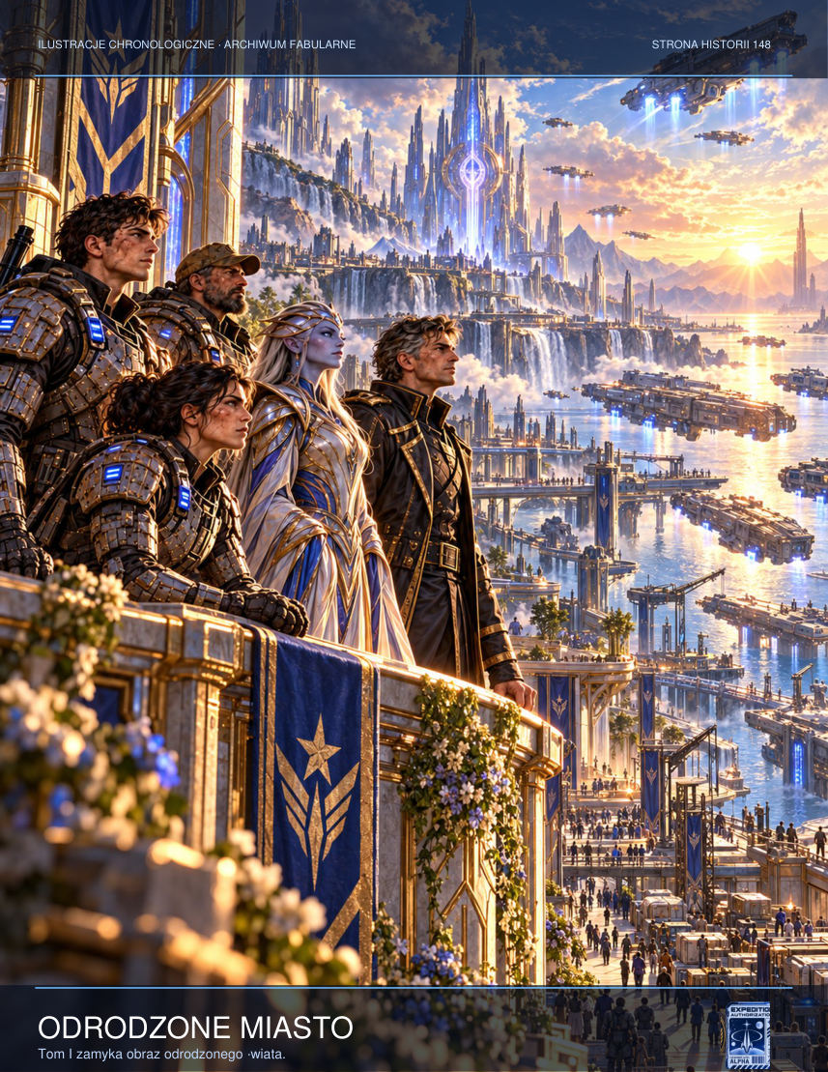

EPILOGUE — The Last Signal
Six months later the commission issued its first public report on the Erebos disaster. Not all data was released. Some recordings were considered too dangerous to transmit. But the names of the dead and survivors became public, and research into the Seal passed to a team in which nobody held exclusive authority. A modest memorial rose on Erebos, built from the melted-down panels of Outpost Nine.
Lys declined to return to her old unit. She stayed to help protect the colonists. Vek opened a workshop and wrote on its door: We Repair Everything Except the Past. Sorell awaited trial, convinced that this time at least the verdict would not be delivered in secret. Nera sent a warning to her people: mechanisms existed in the sector whose most dangerous weapon was not force, but the promise of relief.
Jalen returned to the edge of the city, where he could see the scars left by the missiles. The first stars appeared overhead. In his pocket he held the page of memories about his sister. For a moment he thought that if he spoke her name he might hear an answer once more. He did not.
At an orbital headquarters hundreds of thousands of kilometres away, an automatic receiver intercepted a single impulse from an unidentified source. It contained neither voice nor image. Only three short signals, a pause and three more. The operator marked the transmission as noise, then returned to his shift.
He did not know that somewhere far beyond the borders of the Koprulu Sector, someone had answered in exactly the same rhythm.
END OF VOLUME I.
At a small radio station on the edge of the colony, Jalen played a brief test signal once a day. Three knocks, a pause, one word: ‘Erebos’. It was not meant to summon ghosts or seek answers in the darkness. It was an invitation to other survivors. For several weeks nobody replied.
One evening the receiver recorded a distant transmission from beyond known routes. It carried no human voice. Instead it contained the map Nera had left before departing, with one new point added. Someone or something had heard the network go dark and was attempting contact. Jalen recorded the coordinates, checked the encryption and took his hand away from the transmitter. This time he was not alone. He called Lys, Vek and Olan so they could decide together whether to answer.

Note on the Project's Status
This volume is an unofficial fan work set in the fictional StarCraft universe. It is not affiliated with Blizzard Entertainment. This edition requires further scene development and editing to reach the planned 300-page length.

PART FIVE — THE LAST LIGHT
‘Truth does not save anyone by itself. But without it, even survivors remain imprisoned.’
The great chamber beneath the shelter of a rocky arch no longer resembled the refuge into which people had fled in panic after the first strikes from orbit. In just two days it had become the improvised heart of the surviving colony. Lights hung between metal walkways, tables had been made from cargo modules, and on the floor where debris from rockfalls had lain only recently, there now sat whole families, technicians, miners, medics and people who had escaped the bombardment only because someone had pulled them in the right direction.
At the centre of the chamber stood a table made from joined transport crates. Above it floated a pale-blue map of Erebos. Fire scars, collapsed sectors, evacuation corridors and still-active landing sites pulsed in the air like veins in an X-ray of the planet's body. Around the table gathered those who, over the past few hours, had decided they wanted more than survival. They wanted to understand what had truly been discovered beneath the colony, and why someone above had chosen to erase the whole place along with its inhabitants.
Jalen Ors felt the weight of every gaze although nobody spoke his name. Lys Ardan rested her hands on the table and studied the assembly with the stubborn calm of a soldier accustomed to giving orders who, for the first time in her life, had to ask for trust. Vek Tiran nervously adjusted a cable on his forearm scanner, as though any minute spent motionless went against his nature. Beside them stood Nera Vhal, slender and still, almost luminous in her Protoss armour. On the other side of the table was Commander Ilyan Sorell, his face grey with exhaustion: the man who had brought a Dominion ship into orbit and then been the first to turn its guns away from the colony.
The council had not been called into being by an order. It had been born of necessity. People wanted to know whom they could believe. They wanted to hear whether something really existed beyond the rock that could hear memories. Whether the voices some of them had heard at night were echoes of fear, or perhaps traces of an older truth. The most important question, though, was different: should they open the archive beneath Erebos completely, when it was precisely the archive that had brought fire down from the sky?
The first to speak was a woman from Residential Sector C, the same one who had earlier pulled children from beneath a collapsed ventilation shaft. She did not ask about Dominion protocols or ancient Protoss wars. She wanted to know why her husband had vanished after entering G-12 and why, for hours, she had heard his voice in her head although every scanner said he was dead. An elderly crane operator spoke next. Then another person. The questions differed in their details, but each came down to the same thing: was the archive a tomb, a weapon, or perhaps a place of testimony?
Nera answered without haste. She explained that the structure beneath the colony was not a machine for creating life anew. Rather, it was a memory node — a vast Protoss construction capable of preserving patterns of experience, decisions and emotion if its guardians deemed that a world's testimony should not disappear. In ancient times, such places had protected the truth about civilisations perishing in the shadows of greater empires. The problem was that the Erebos archive had been damaged. For years the Dominion had tried to read it as a data store, awakening mechanisms it did not understand.
Then Sorell spoke. He did not address the council as an officer. He spoke like a man allowing himself honesty for the first time. He admitted that, even before the signal from the outpost arrived, the Resolute had received encrypted orders: prepare precision bombardment, cut the surface off from communications and prevent the evacuation of research material except through channels controlled by headquarters. The orders did not use the word civilians. Nor did they use the word rescue. Only one name appeared: Palimpsest. A programme for seizing, organising and selecting other people's memories.
Silence descended on the chamber, so dense it seemed as if the rock above them were waiting for the rest of the story. Lys clenched her jaw. Jalen felt people's eyes returning to him, because he was the first to enter G-12, he had heard Rina, and his voice was the one the archive recognised without resistance. Finally he understood that the council did not expect certainty from him. It expected the courage to say aloud what everyone feared: if they closed the archive without understanding it, somebody else would one day return and do the same thing. If they opened it carelessly, they might lose themselves.
The decision was not unanimous, but it was strong enough to become a beginning. The council agreed to two parallel tasks. The first belonged to Lys, Sorell and Vek: secure the corridors, activate guidance systems for civilian shuttles and block every channel through which the Dominion could retake control of orbit. The second fell to Jalen and Nera. They would have to descend to the archive core before its excited layers selected one dominant narrative from thousands of gathered traces.
Nera explained that the damaged archive behaved like a wound in the world's memory. When many conflicting memories struggle to remain alive at once, the defensive mechanism begins searching for the most forceful, most emotionally charged pattern. Over time, that pattern can overwhelm all the others, turning testimony into doctrine. That was precisely what the Dominion wanted: one useful version of events, saleable as a story of victory, rebellion or necessary sacrifice.
Jalen was no longer afraid of the descent itself. He feared hearing his sister again in the depths of the cathedral and choosing to trust her presence more than his own judgement. As he followed Nera towards the inner gates, Lys stopped him for a moment. She said only that the truth he found would not be lighter than memory, but might be more honest. Vek, being Vek, added with a faint smile that Jalen had better come back because somebody would have to listen to his complaints about Protoss interfaces.
Behind them the council broke into smaller working groups. Medics counted supplies. Engineers rerouted power to landing sites. Children studied the holograms as if they were not a map of the end, but of a place still waiting to be born. Jalen turned once more. He saw people bound together not only by survival, but by choice. In that instant he understood that Erebos was neither merely a ruin nor merely a mystery. It was a community that had decided nobody would write its history without its consent.
The route to the core passed through six concentric rings. Each corresponded to a different level of memory: image, emotion, decision, grief, hope and what Nera called responsibility. As they descended, the walls ceased to resemble stone. Geometric pillars of light rose from them, while translucent panes hung in the air displaying fragments of somebody's life. Hands coated in mining dust. A child sleeping aboard an evacuation transport. Brief laughter at a table. One hand letting go of another at the moment a shaft collapsed.
Jalen's first instinct was to look away. Every testimony felt too private, too human, to be merely a component of a mechanism. But Nera told him that the archive did not steal memories. It received them. Only those which, in the moment of loss, a person had pushed towards the light — consciously or instinctively — so they would not vanish without a trace. That was why the core held so many simple scenes and so few grand declarations. We most often remember the world not through heroism, but through small things.
When they reached the central nave, Jalen saw a construction unlike anything he knew. Hundreds of crystals and thousands of thin, luminous planes hung above an immense platform. Each contained a moment from somebody's life. In some, humans or Protoss stood motionless like portraits; in others they moved in slow motion, as though time refused to accept their loss. At the centre floated the core, a tall pillar of light branching like a tree.
Here Nera intended to activate the balancing sequence. The core had to receive a new governing principle: preserve the multitude of testimonies, but never elevate one memory above all the rest. Jalen would become its human witness. Not a chosen one. Not an owner. Someone who, at the moment of connection, would agree to listen without taking possession. It sounded simpler than it was. The archive had already spoken to him in Rina's voice, and every indication suggested it would do so again.
When Jalen placed his hand on the first control ring, light spread across the floor in a gentle wave. The cathedral fell silent. The panes of memory hung motionless, then turned towards him one by one like windows in a vast living observatory. Among them stood Rina — not flesh and blood, not a miraculously rescued sister, but a coherent trace of the person he had loved. Her presence was neither cold nor artificial. It was as real as a well-preserved memory could be.
She did not ask why he had waited so long. She did not reproach him for trying to hear her even where nothing should have remained but silence. She merely smiled sadly and said that the archive had summoned her not to offer an illusion, but to bring an unfinished story to an end. Her last message, sent years earlier from Tarsonis, had broken off. Not because there had been no time, but because Jalen had always been afraid to hear its second part.
Rina reminded him of that moment without cruelty. She told him she had wanted only for him not to return for the dead at the expense of the living. Not to make her loss the centre of his existence. For years he had done the opposite. Every decision had been in part an attempt to prove that if he had run faster, fought differently, stayed longer, he could have changed events. The archive exposed a truth at once simpler and more painful: loss is not always a task to complete. Sometimes it is a boundary to which we must give meaning.
Nera, standing beside the core, activated the next sequences without intruding on their conversation. She knew no technology could replace the moment when a person must choose between keeping someone close as an image and allowing them to become part of a larger memory. When Jalen understood what he should do, he did not feel relief. He felt peace. He asked the archive to preserve Rina as she had been to the world, not merely as she had been to his longing. And for the first time in many years he spoke his farewell without hoping for an immediate answer.
At that instant the cathedral blazed with light. Testimonies at every level formed a new order. Not a hierarchy, but a constellation. Nera nodded. The core had accepted the principle of balance. No memory would again become an instrument of domination so long as at least one living witness could say: I saw it differently, but no less truthfully.
As Jalen and Nera returned towards the upper levels, their communicators nearly exploded with messages. Sorell had intercepted a second package of orders. This time the instruction was unmistakable: carry out a final purge of the sector, destroy every launch site and announce that Erebos had been lost to uncontrolled geological activity. This was no longer an attempt to recover research. It was a coldly prepared cover-up.
Feverish activity filled the Resolute's bridge. Vek, connected to three consoles at once, rerouted packets, forged identifiers and kept a communications window open for medical shuttles. Lys coordinated launch corridors, shifting escorts wherever a link still functioned. Sorell stood over the main tactical table and openly defied headquarters for the first time, reading the complete Palimpsest authorisation chain aloud to his own crew. He turned a secret order into evidence.
Despite his fears, some officers did not turn against him. They understood that if they followed the order they would cease to be guardians of order and become co-authors of a massacre written in calm bureaucratic language. Not everyone was prepared to rebel, however. Two artillery stations attempted to re-establish contact with headquarters and arm their automated weapons. Then Nera intervened. Her psionic interference was not an attack so much as a blinding flash that severed fire-control connections and froze firing procedures for several precious minutes.
Jalen studied the planetary map, where red impact circles still marked places that could never be recovered. For the first time since the disaster began, however, he could also see blue lines: convoys, medical assembly points, new landing corridors. Erebos was ceasing to be only a map of losses. It was becoming a plan for rescue. Then Sorell ordered a data packet sent over every open channel: command logs, Palimpsest identifiers and a complete record of what they had tried to hide. If the Dominion returned with force, it would do so knowing the truth was no longer secret.
The final minutes of the crisis resembled no great battle from the chronicles. They looked more like the desperate work of people refusing to give one more life to the same machinery of violence. Pilots guided transports through smoke and interference. Medics carried the wounded between landing sites, often without even knowing whether the shuttle receiving them could take off. Engineers risked everything to keep the launch shields powered.
When automated weapons on one escort ship nevertheless entered their activation phase, Lys did not hesitate. She led a small boarding team and seized the power section before fire control could switch from diagnostic to combat mode. She returned with her face blackened by an electrical surge and a brief report that the corridor was clear. Vek commented only that even a malfunction obeyed discipline around her.
The greatest change, however, had taken place not in machines but in people. Sorell, once an officer bound to the chain of command, understood that loyalty without conscience was merely an excuse for another person's violence. Nera saw that memory could serve the future only when the living accepted it as a responsibility rather than a relic. Jalen, meanwhile, stopped acting from guilt for the first time. He chose what had to be done now, not to redeem the past but to prevent another loss.
When the last medical shuttle lifted from the lower landing site and the final active bombardment zone went dark on the map, the Resolute's bridge froze in uncertain expectation. No answer came from headquarters. Perhaps the leaked data had already spread further. Perhaps someone higher up was calculating whether it would be more profitable to deny everything or pretend the orders had never been given. For the people of Erebos that did not matter immediately. All that mattered was that the night had ended and they were still there.
Day rose above the ruins. Not clean, not triumphant, but real. A day in which survivors could be counted, stores opened, first tents erected and a beginning made again.
The first weeks after the events beneath Erebos held nothing of legend. They were hard, noisy and disorderly. Sanitary zones had to be marked out, working water filters found, replacement-part printers restarted, and a distinction made between those who had vanished without a trace and those who had merely found shelter further along the tunnel network. Even so, a rhythm began to emerge in the survivors' daily lives that felt like living, not simply fighting to survive.
The Council Beneath the Rock did not dissolve after the crisis. On the contrary, it became the foundation of a new order. Representatives of the residential sectors sat alongside mechanics, medics, pilots and those who knew the underground workings and old shafts better than official maps. Sorell relinquished formal military command but stayed with the council as liaison and witness. He gave public testimony about Palimpsest and signed it with his own name, knowing he had closed the road back to his former career.
Lys organised defence and order around the landing sites. Her commands were as brief as ever, but people began to understand that behind her sternness lay not coldness but responsibility. Vek built an improvised communications network from recovered modules and told anyone who would listen that with just two more functioning relays and one full day of peace he could build something even the Protoss would be proud of. Nera meanwhile marked a protected zone around the archive and began the patient work of teaching people how to handle memory that belonged to no one individual.
Jalen accepted the strangest role of all. He became neither commander nor guardian of the cathedral. He became a chronicler. Every day he recorded the names of survivors, family accounts, descriptions of lost places, testimony from pilots, medics and children. He helped people enter the archive only to deposit what they themselves chose to preserve: not sensation or heroics, but small truths. A mother's voice. The smell of wet metal before a storm. The last joke told over supper. Such things make memory more enduring than orders ever could.
In time responses began to reach Erebos from outside. Not all came through official channels. Some were warnings, some offers of aid, some silent confirmation that someone elsewhere had already seen the data transmitted from the Resolute. The Dominion could no longer pretend nothing had happened. That did not yet mean victory. It meant only that lying had become less convenient.
Nera prepared a report for the council that nobody would previously have understood without her help. It suggested the Erebos archive was only one node of a larger network scattered across ancient Protoss routes. Most of its nodes remained dead or dormant. If one had awakened, though, the others might answer. The discovery did not prompt an immediate expedition. It was more like a shadow of the future lying across the end of their victory.
Jalen did not flee that shadow. At night he returned to the cathedral and listened to its thousand incomplete stories. Rina no longer came to him as she had before. That was as it should be. He did not need a spectre to know she was part of the place. Her presence had become quieter, more honest, woven into a greater whole. She was one of many people who had not been allowed to vanish without a trace.
One evening he sat on the edge of a platform overlooking an illuminated bay and watched children from the camp paint the symbols of new sectors on crates. They did not copy Dominion insignia. They invented their own. In that instant he understood that the greatest victory was neither saving the archive nor even exposing Palimpsest. It was that people had reclaimed the right to name their world in their own words. And a world named in its own voice is harder to erase.
Long after the alarms had fallen silent and the fires died out, Erebos still bore its wounds. Collapsed towers and burned-out sectors did not disappear through hope alone. They had to be avoided, dismantled, reinforced or left standing as testimony to what had happened. Yet new walkways were already rising between the ruins. Transports landed along increasingly orderly routes. The first permanent navigation beacons shone above the medical quarter. Life, stubborn as ever, returned not through grand declarations but through the daily movement of hands.
One day Jalen looked down from the highest accessible terrace at dawn spreading across the water and understood that the book he was beginning to compose in his mind would not be a chronicle of war. It would tell of people who refused to be someone else's footnote. Of a woman who learned to command without cruelty. Of a technician who saved the world with curses and cables. Of an officer who placed conscience above orders. Of a Protoss woman who reminded strangers that memory without responsibility becomes a weapon. And of a sister who, even after death, had shown him the right direction.
In the cathedral below them the lights remained steady. They no longer called anyone by name. They waited. For witnesses, not owners. For questions, not orders. For a future that had yet to unfold.
So ended the first volume of Erebos's story. Not with complete victory, but with the recovery of the right to remember. Not with silence, but with voices finally allowed to be heard. And if, somewhere farther away along forgotten routes, other nodes of the ancient network were awakening, this time they would not be greeted by people blind to the price of truth.

